1. [Roman to Integer](https://leetcode.com/problems/roman-to-integer/)

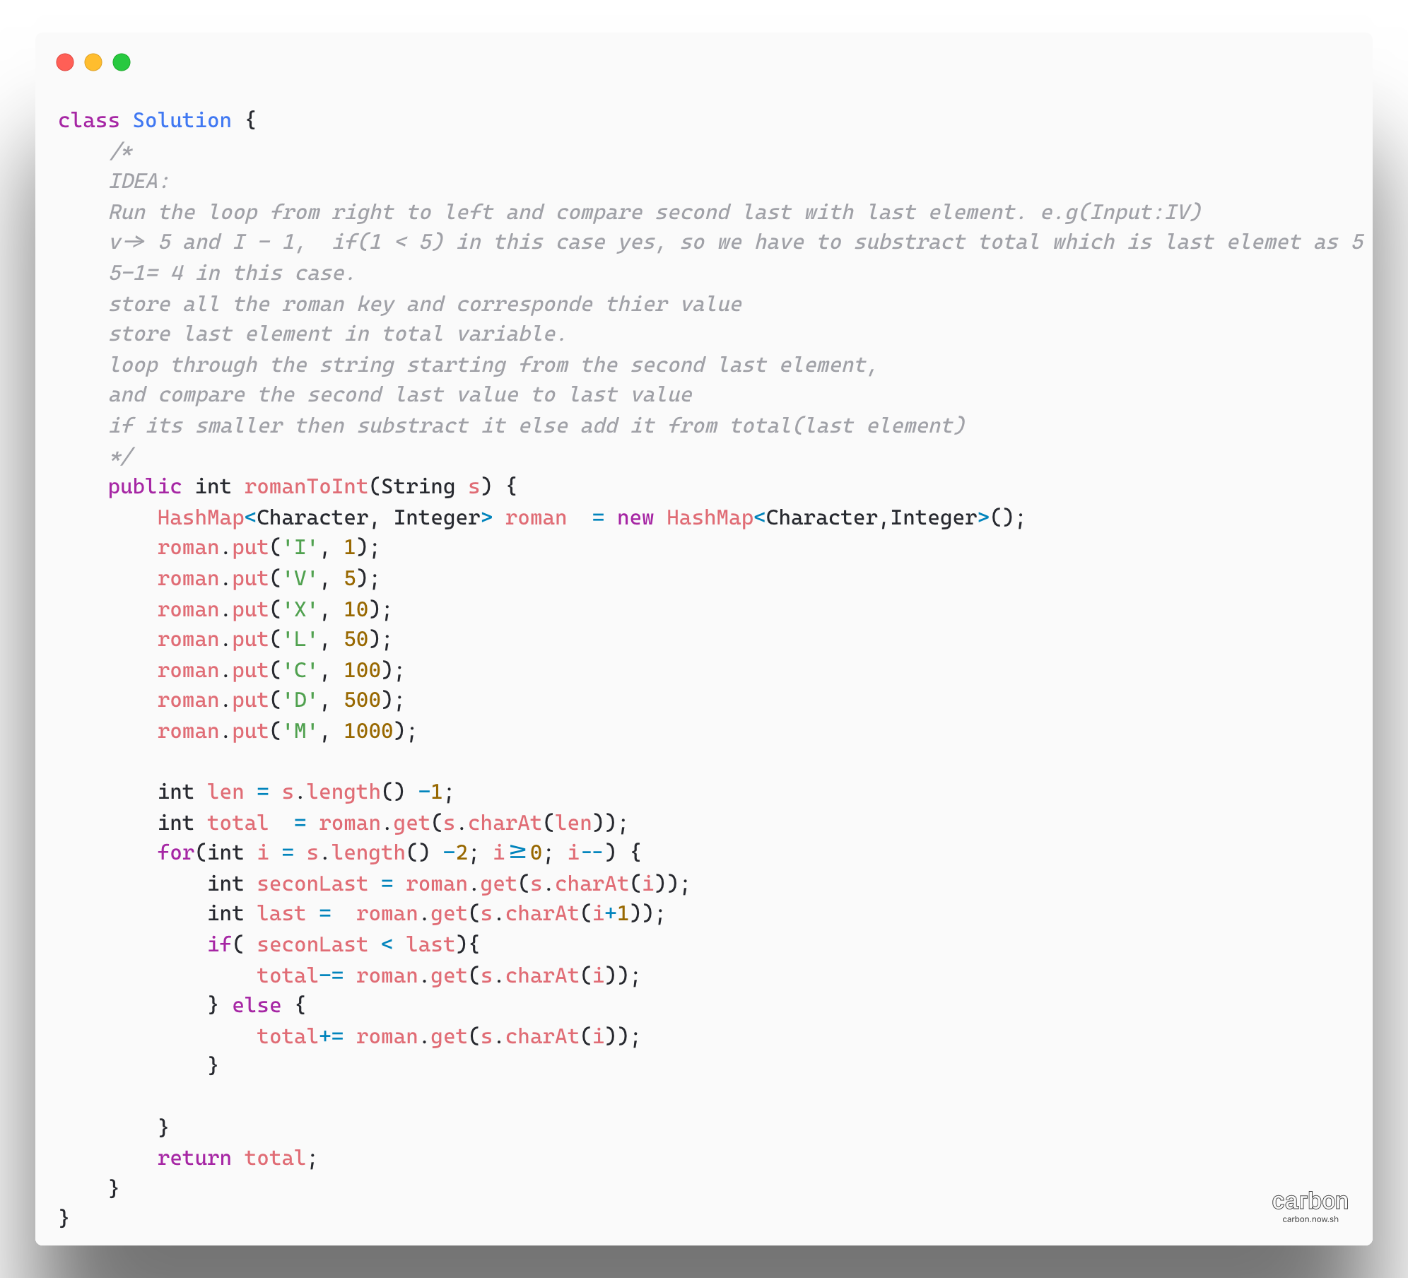

1. Merge Sort Top Down – [Sort an array](https://leetcode.com/problems/sort-an-array/)

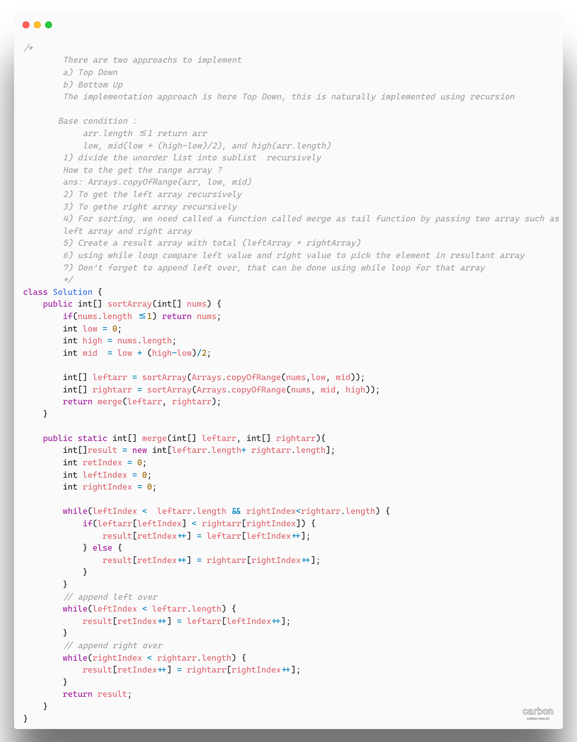

1. [Hamming Distance](https://leetcode.com/problems/hamming-distance/)

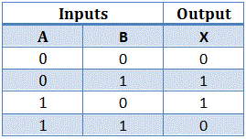

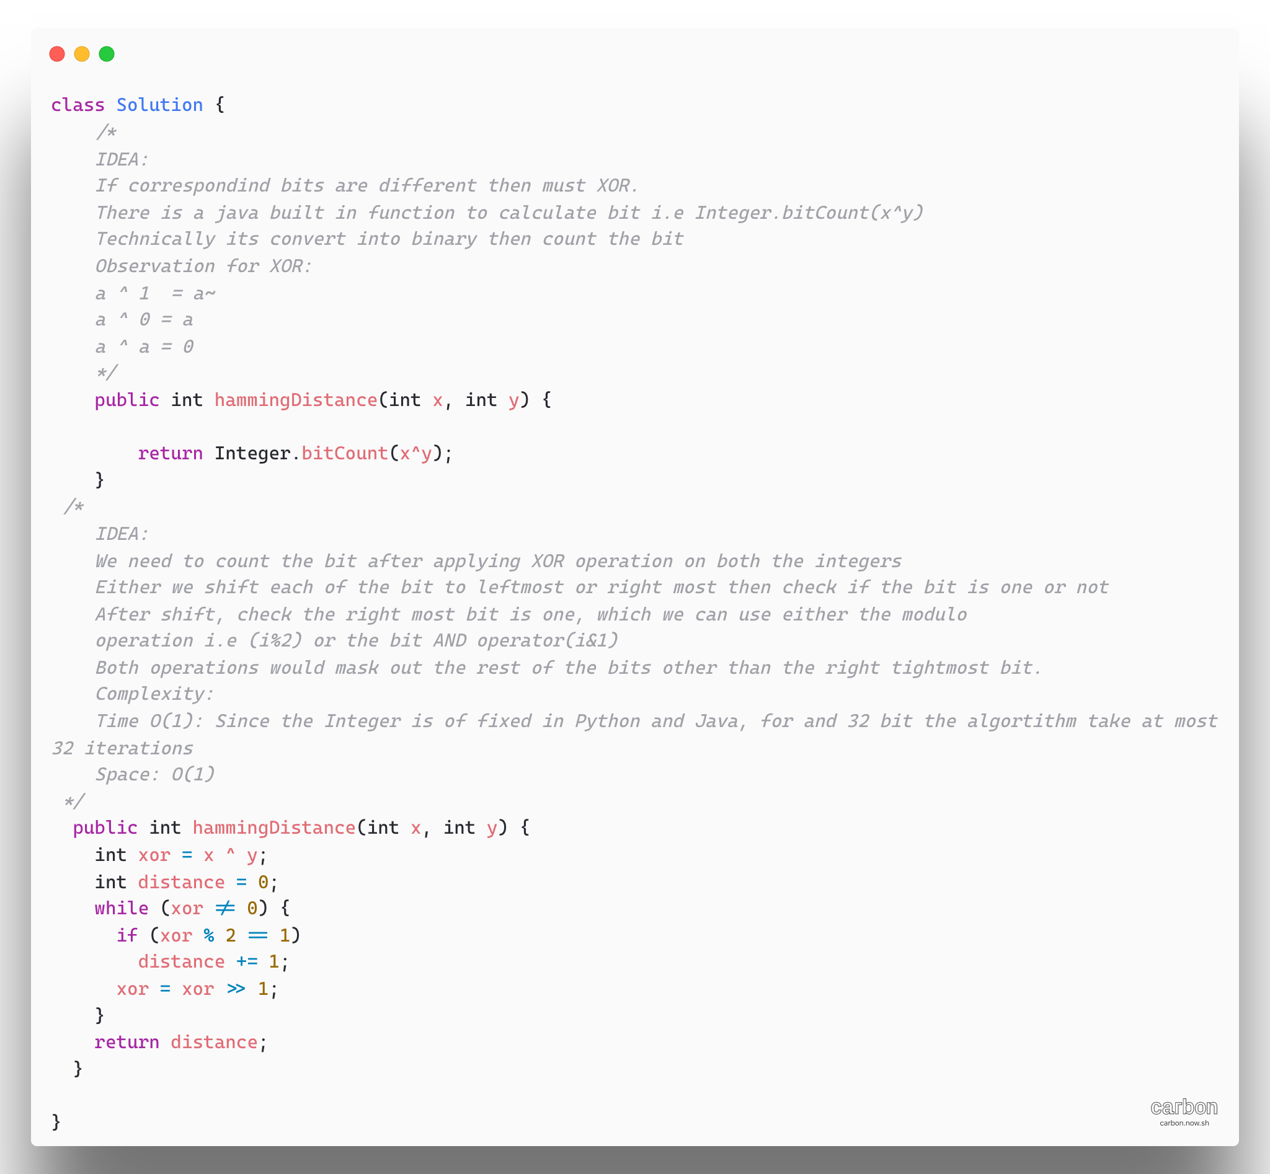

1. [Delete Node in BST](https://leetcode.com/problems/delete-node-in-a-bst/)

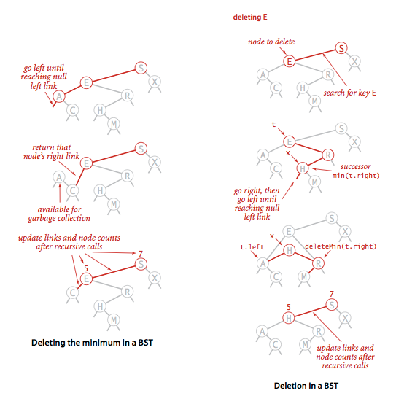

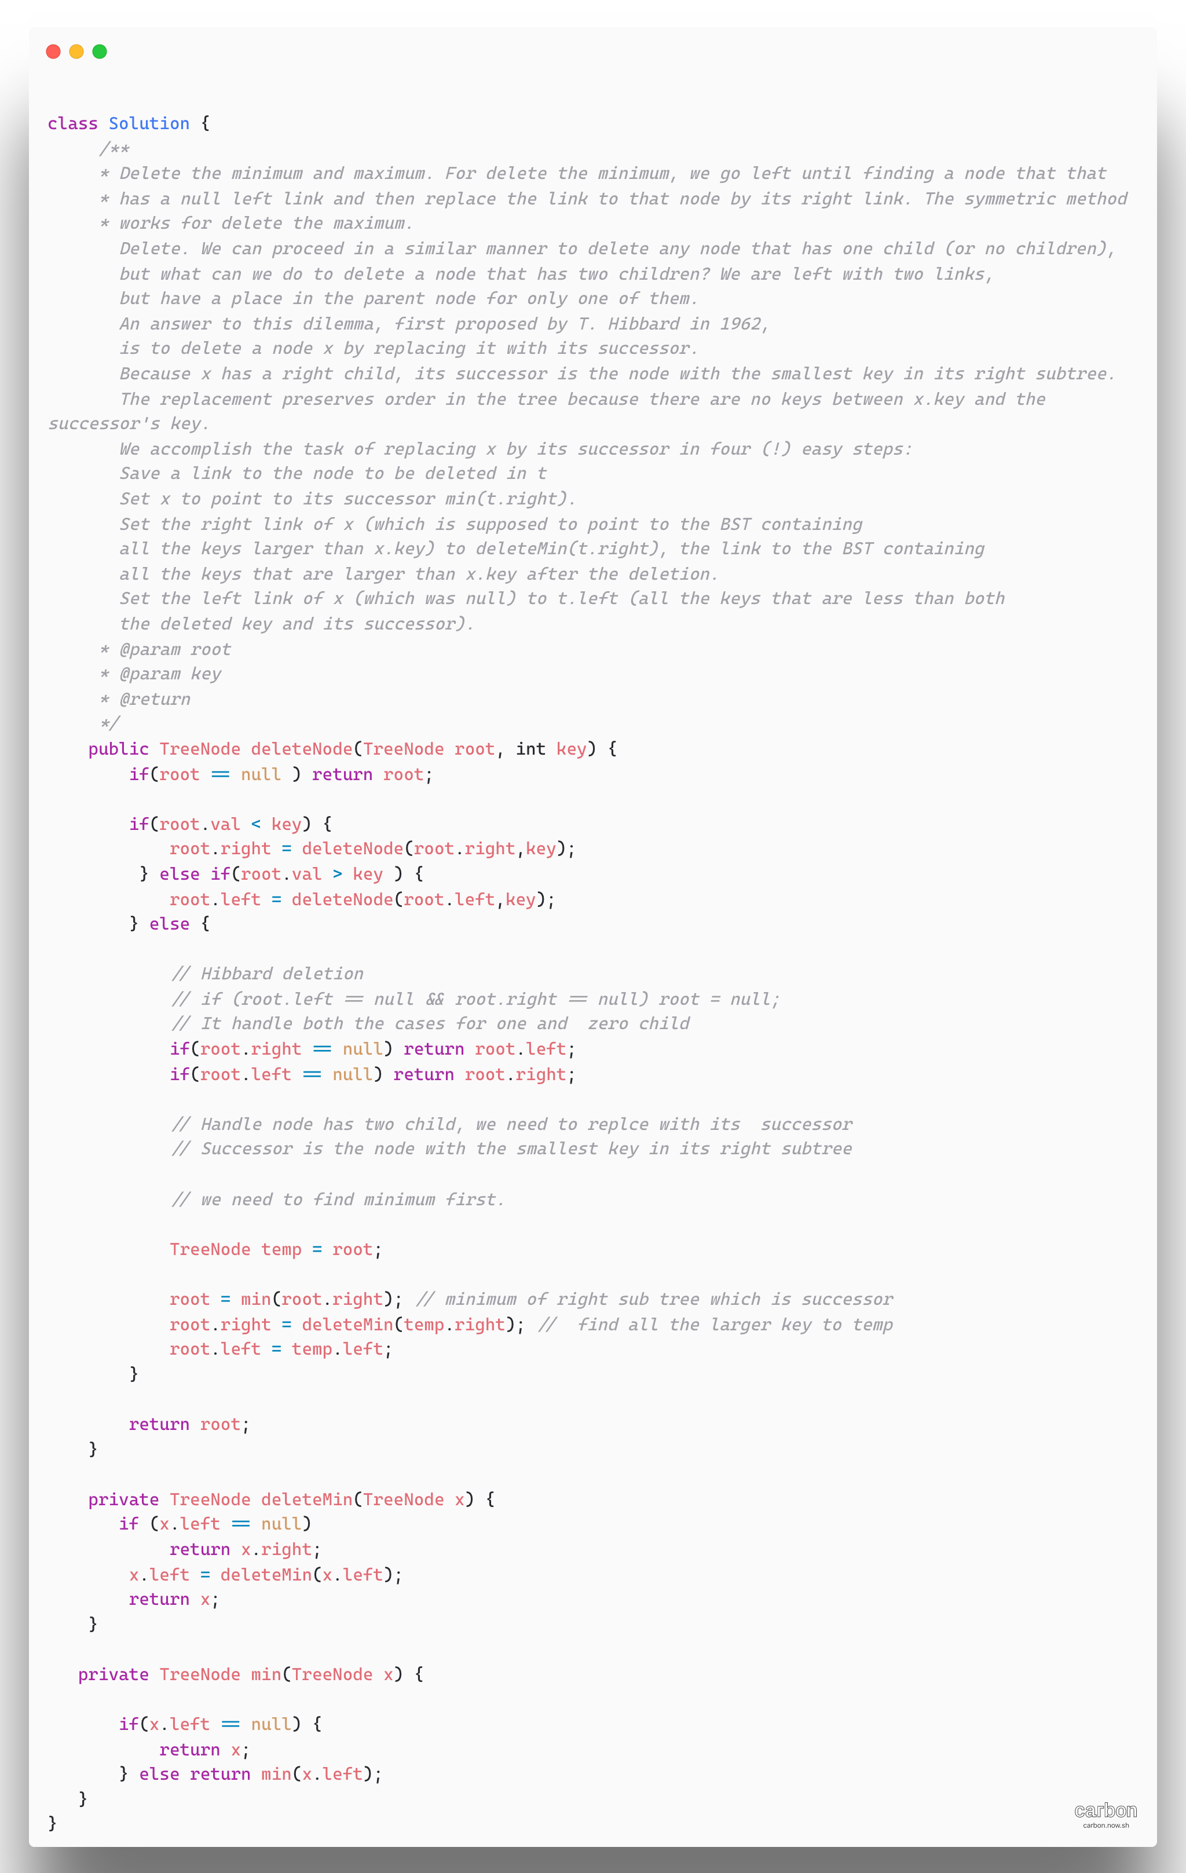

1. [Container with Most Water](https://leetcode.com/problems/container-with-most-water/)

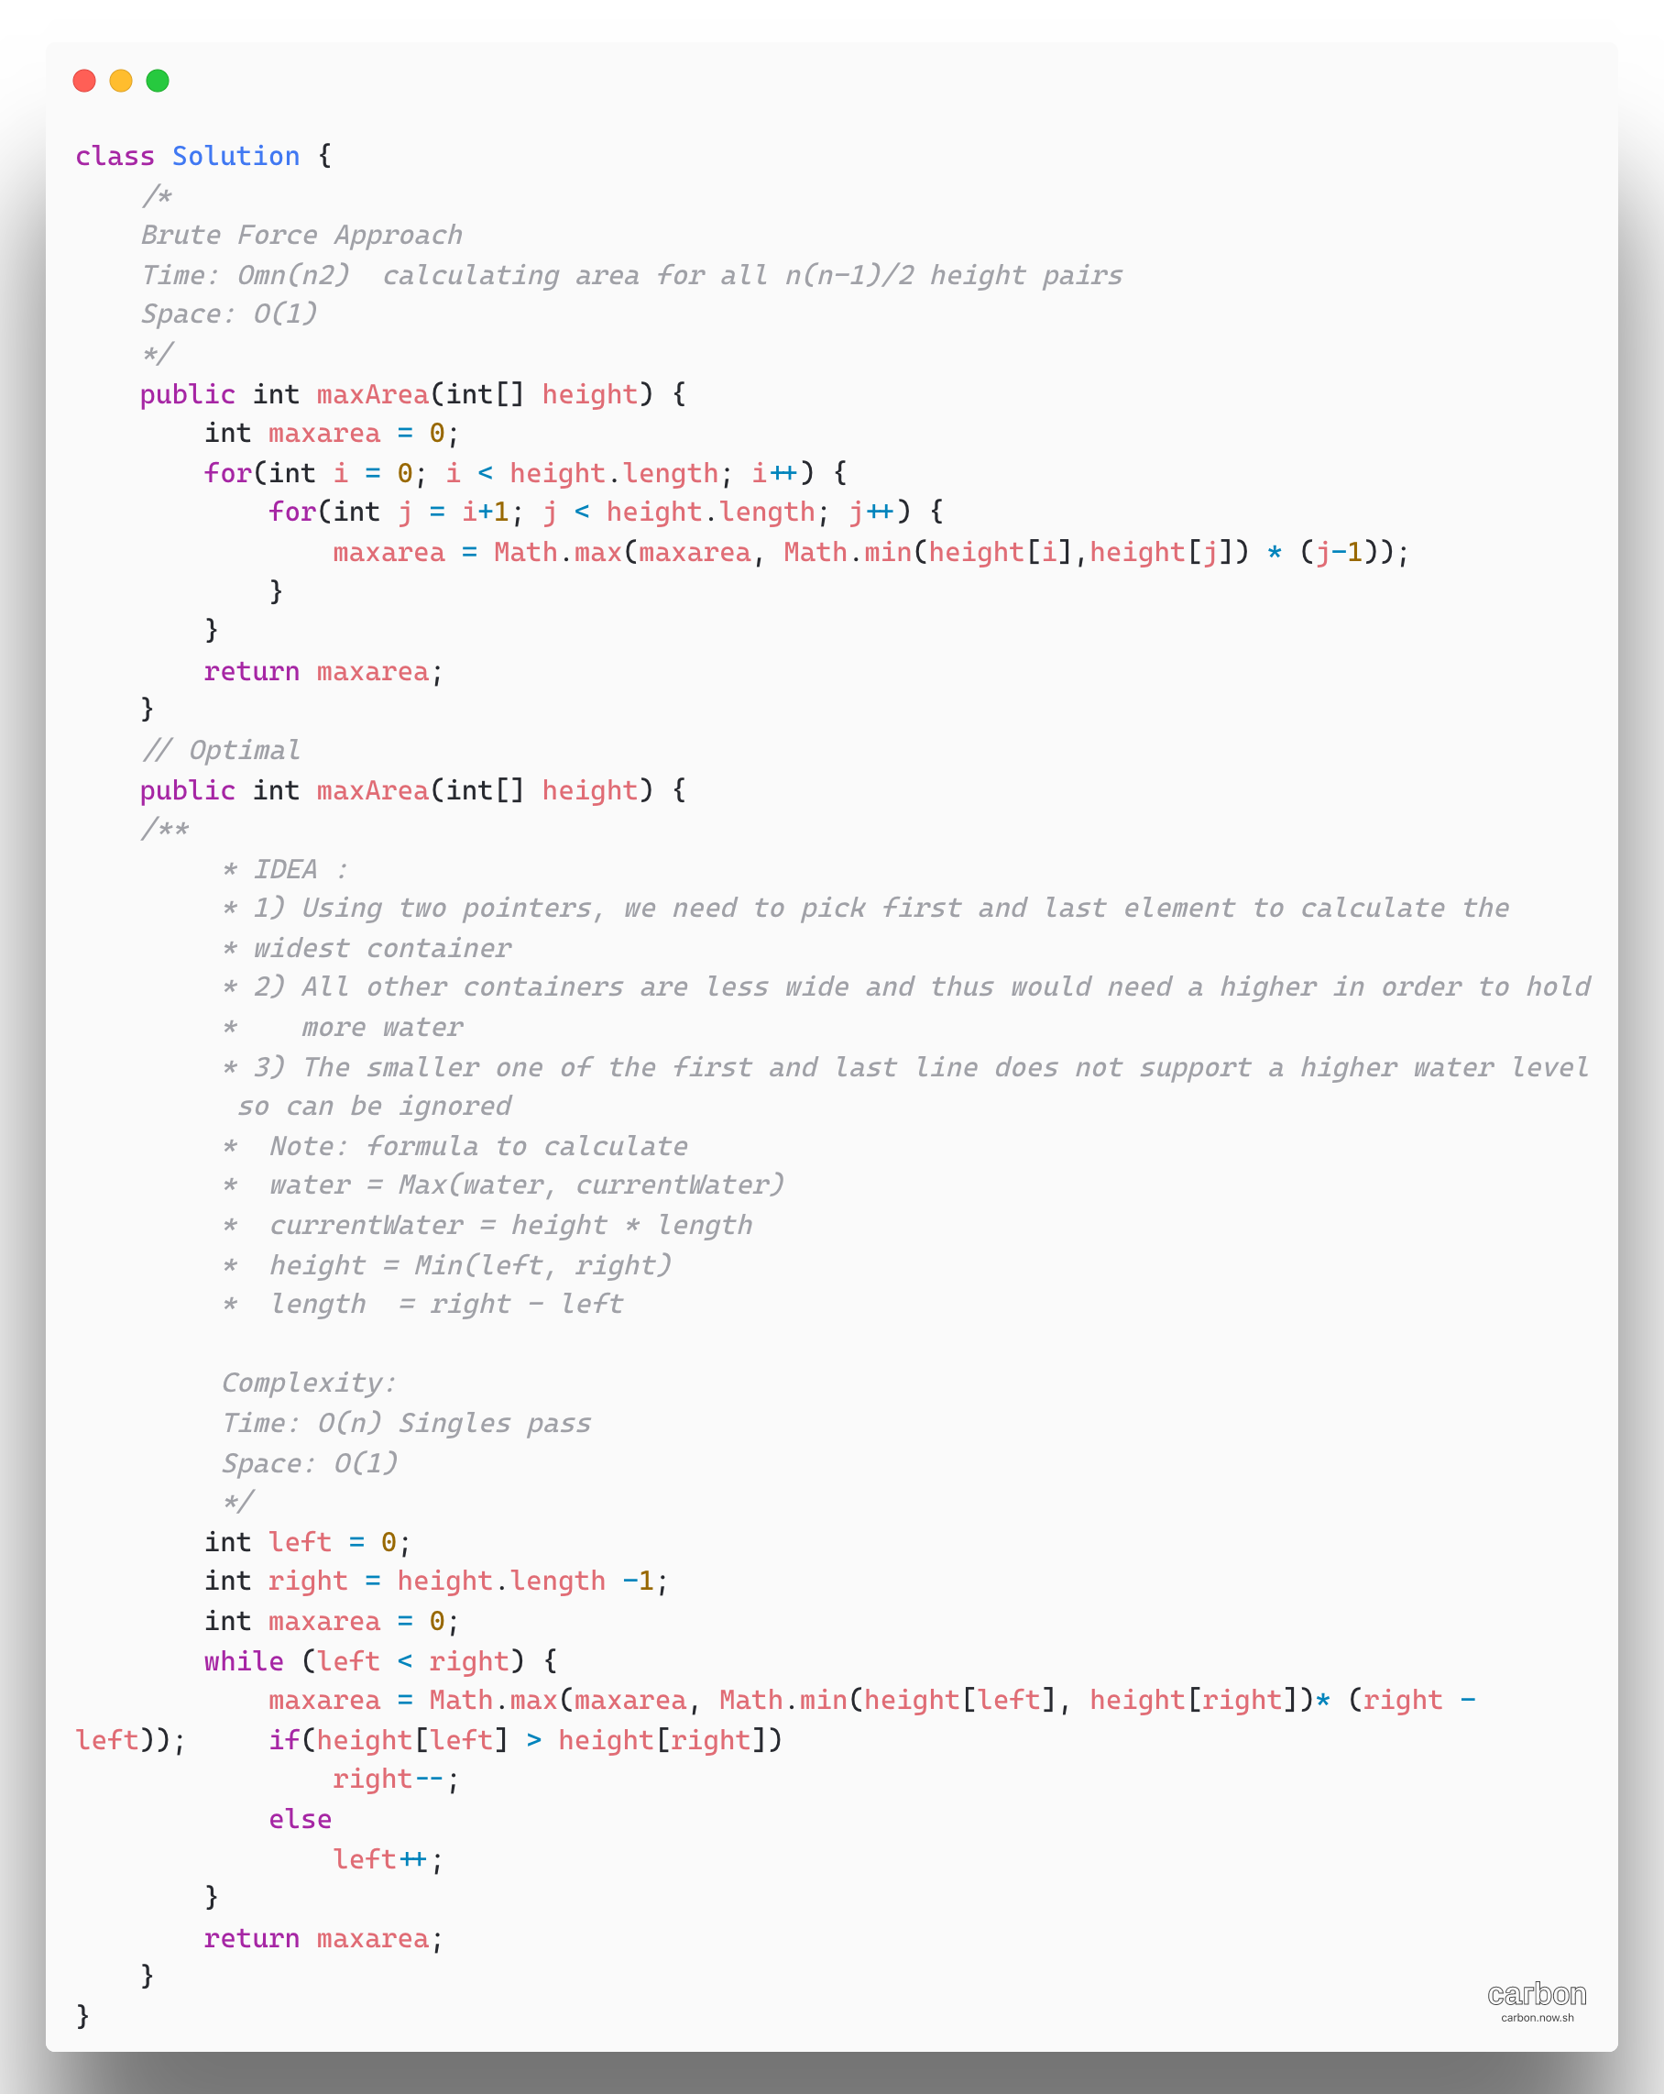

1. [**1362. Closest Divisors**](https://leetcode.com/problems/closest-divisors/)

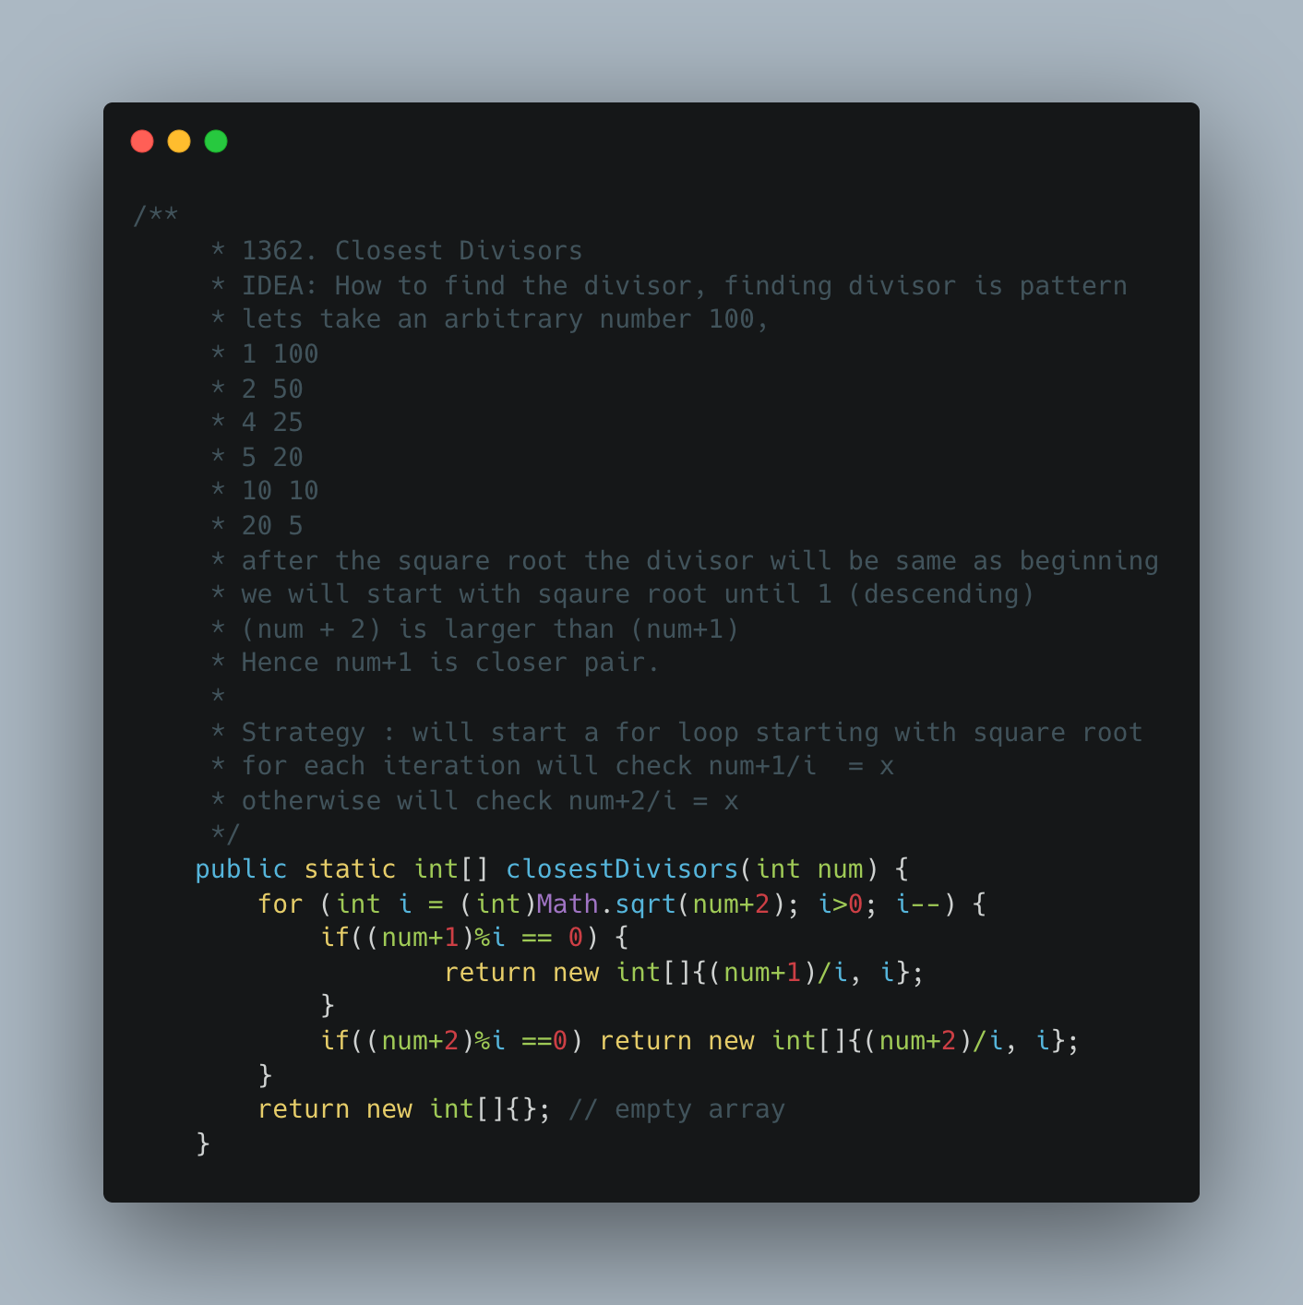

1. [**98. Validate Binary Search Tree**](https://leetcode.com/problems/validate-binary-search-tree/)

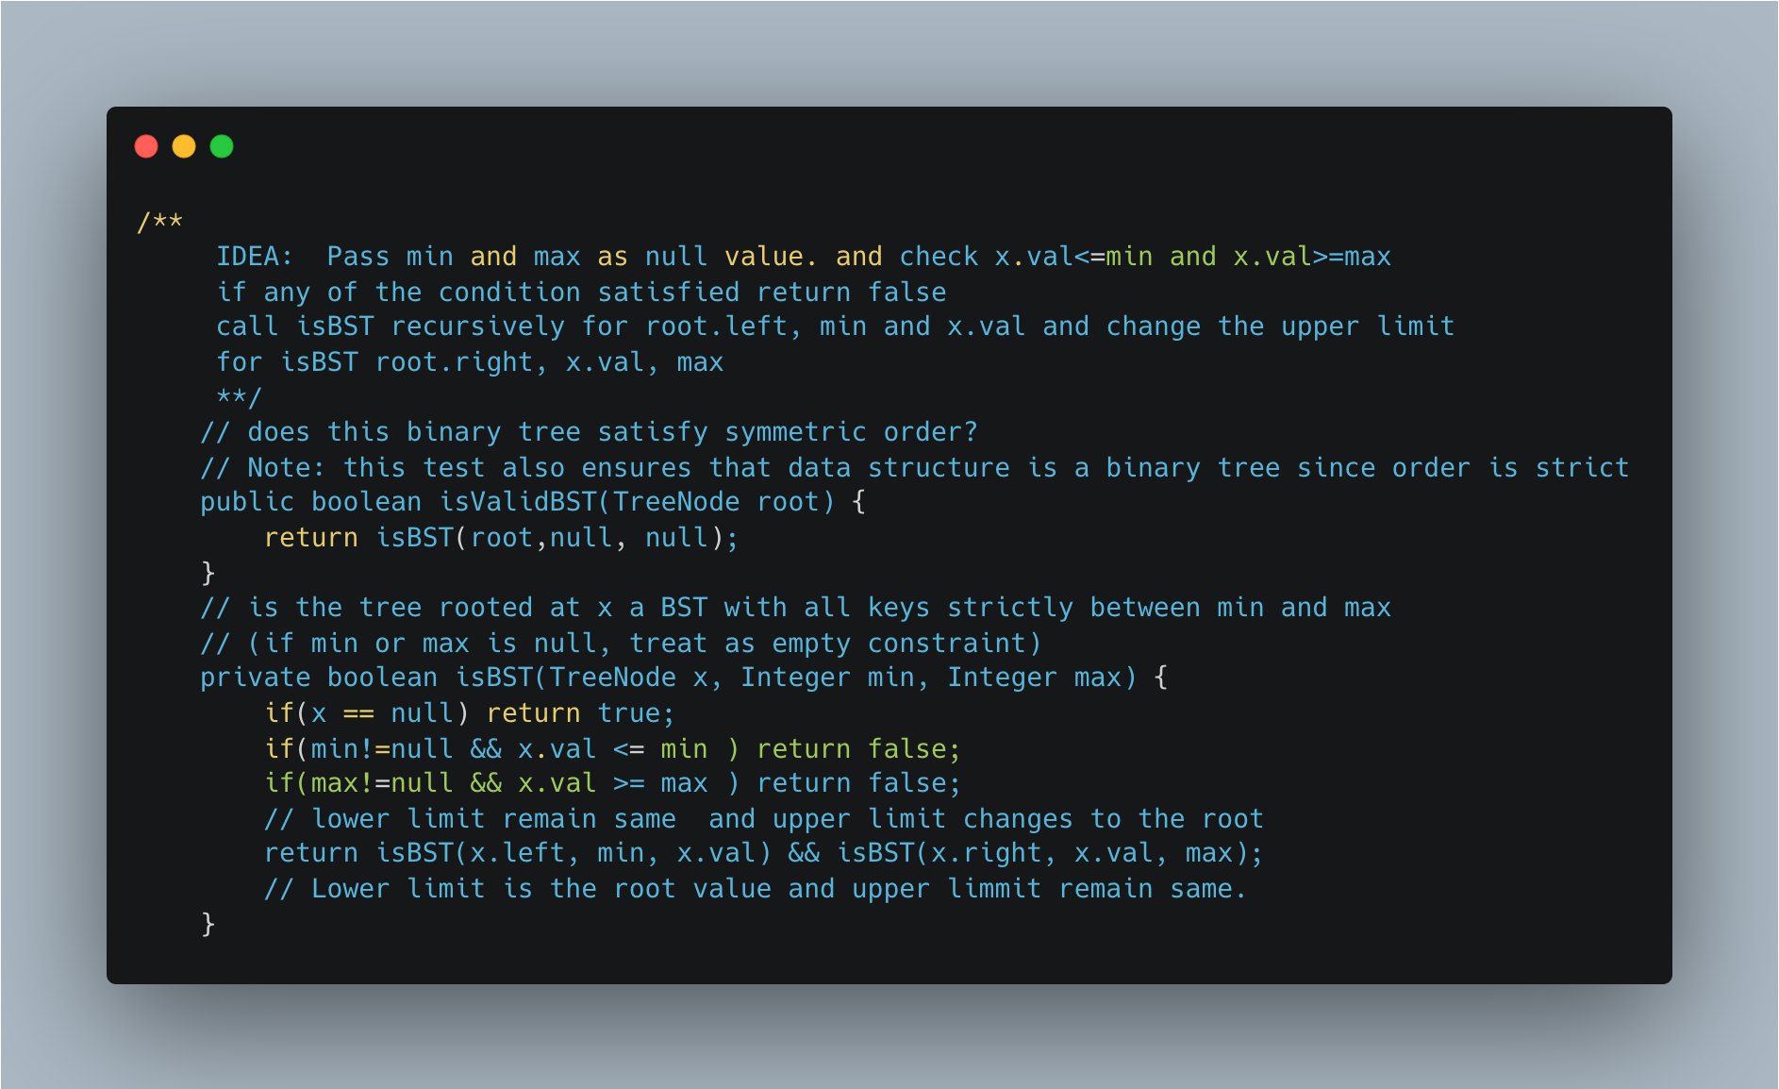

1. [Remove Sub folder from the file System](https://leetcode.com/problems/remove-sub-folders-from-the-filesystem/)

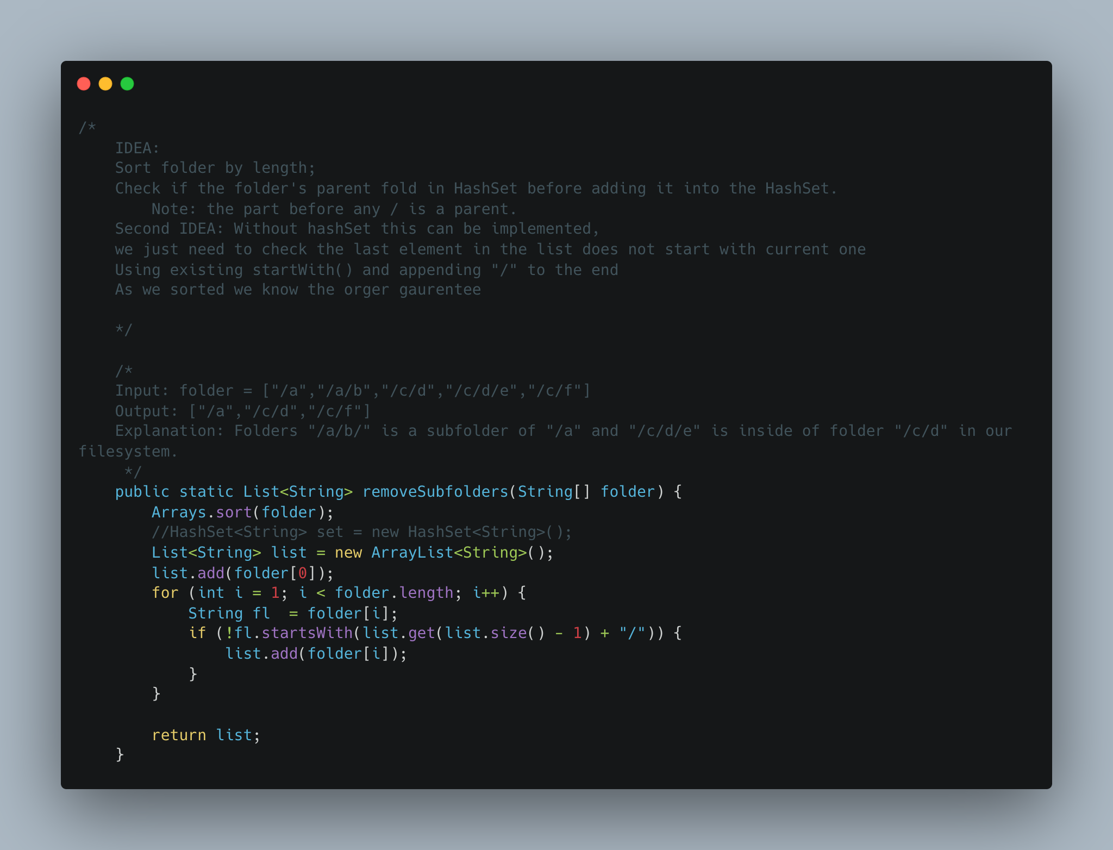

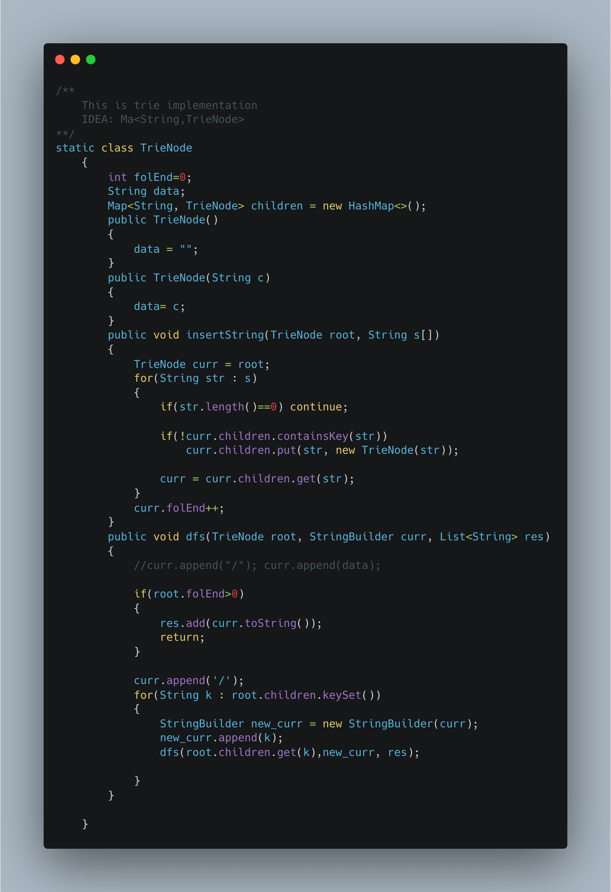

1. [**N-ary Tree Postorder Traversal**](https://leetcode.com/problems/n-ary-tree-postorder-traversal/)

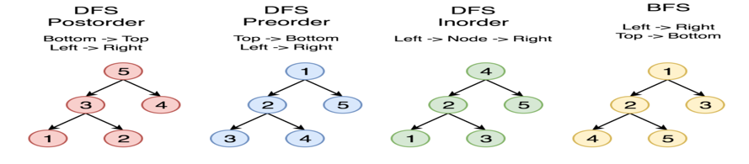

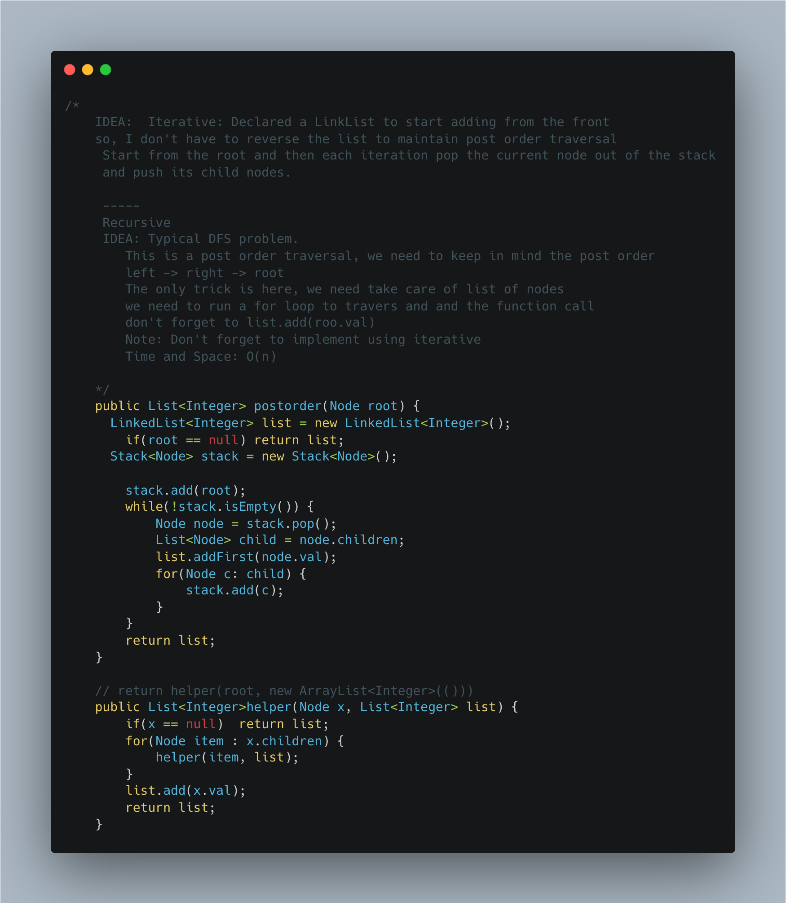

1. [Longest Substring Without Repeating Characters](https://leetcode.com/problems/longest-substring-without-repeating-characters/)

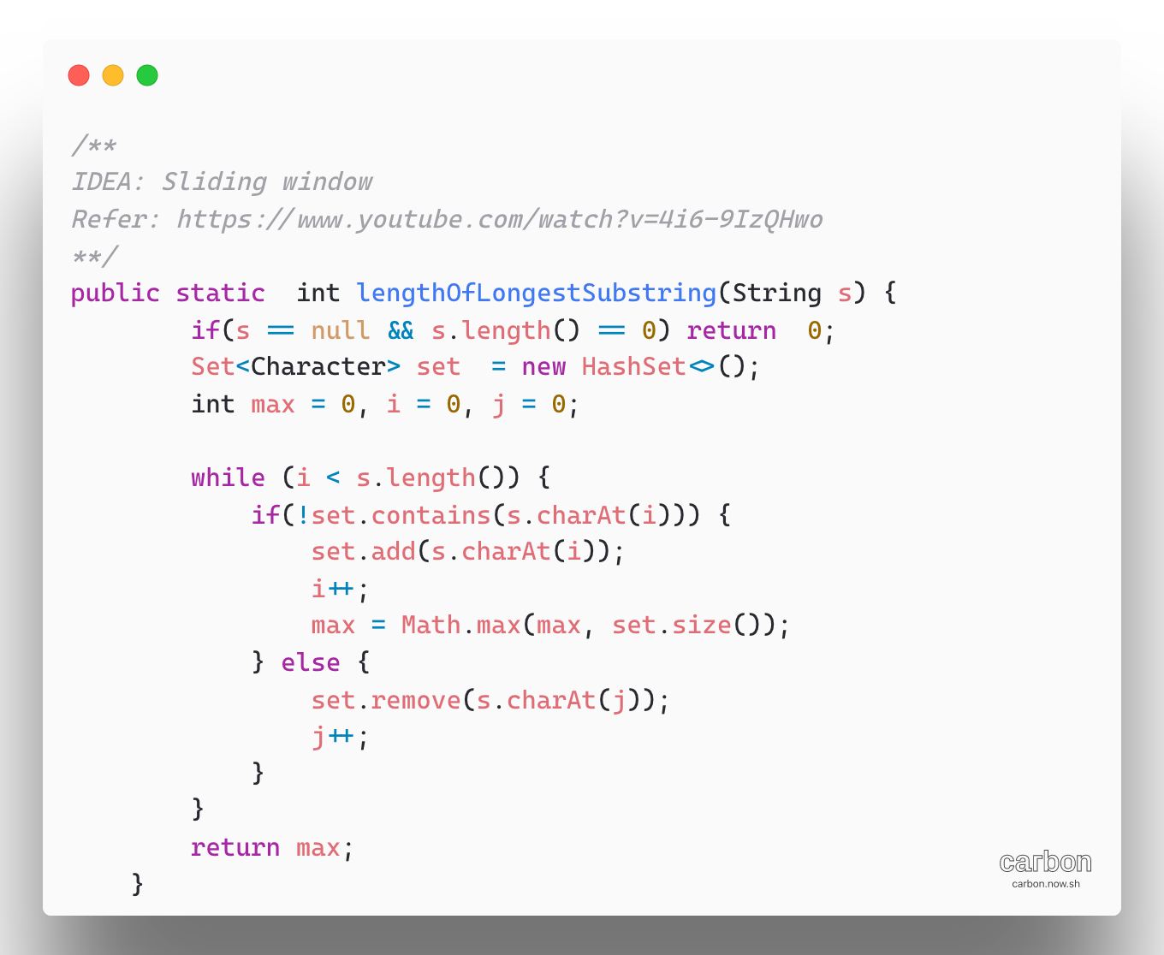

1. Palindrome String check using recursion.

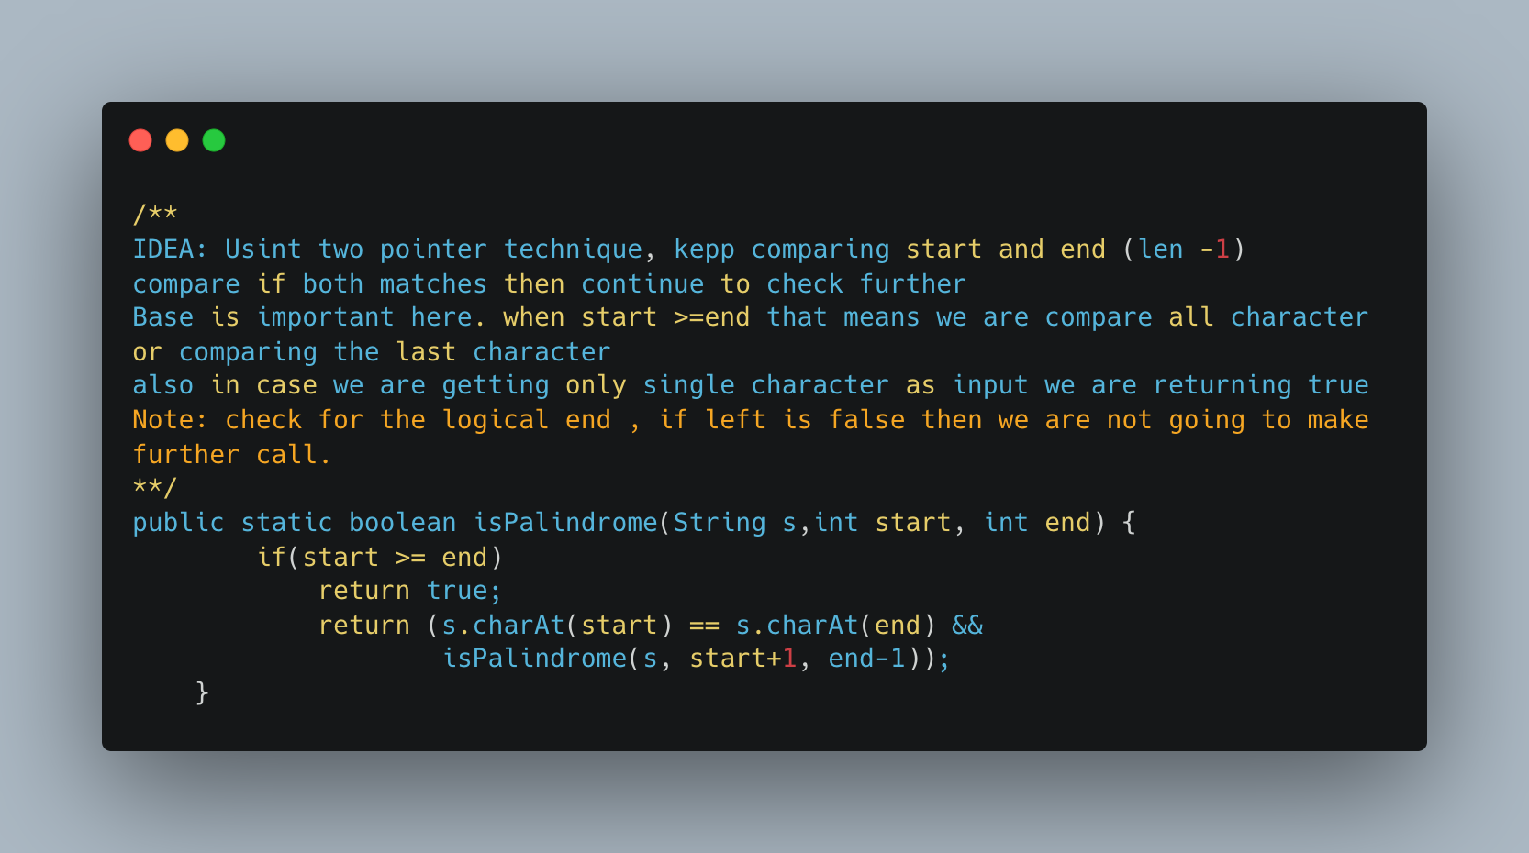

1. [Palindromic Substrings](https://leetcode.com/problems/palindromic-substrings/)

Palindromes are like onions, you remove the boundary characters and you’re left with another, smaller palindrome

Algorithm:

1. We choose all possible centers for potential palindromes:

* Every single character in the string is a center for possible odd-length palindromes
* Every pair of consecutive characters in the string is a center for possible even-length palindromes

1. For every center, we can expand around it as long as we get palindromes (i.e. the first and last characters should match)

**Complexity:** O(N^2) for input string of length N. The total time taken in this approach is dictated by two variables

* The number of possible palindromic center we process
* How much time we spend processing each center?

The number of possible palindromic centers is 2N-1; there are N single character center and N-1 consecutive pairs as centers.

Each center can potentially expand to the length of the string, so no time spent on each center is linear on average. Thus, total time spent is N.(2N-1) ~N^2

Space Complexity: O (1)

Refer:

* <https://www.youtube.com/watch?v=XmSOWnL6T_I>
* [Leetcode Solution Arrticle:](https://leetcode.com/problems/palindromic-substrings/solution/)

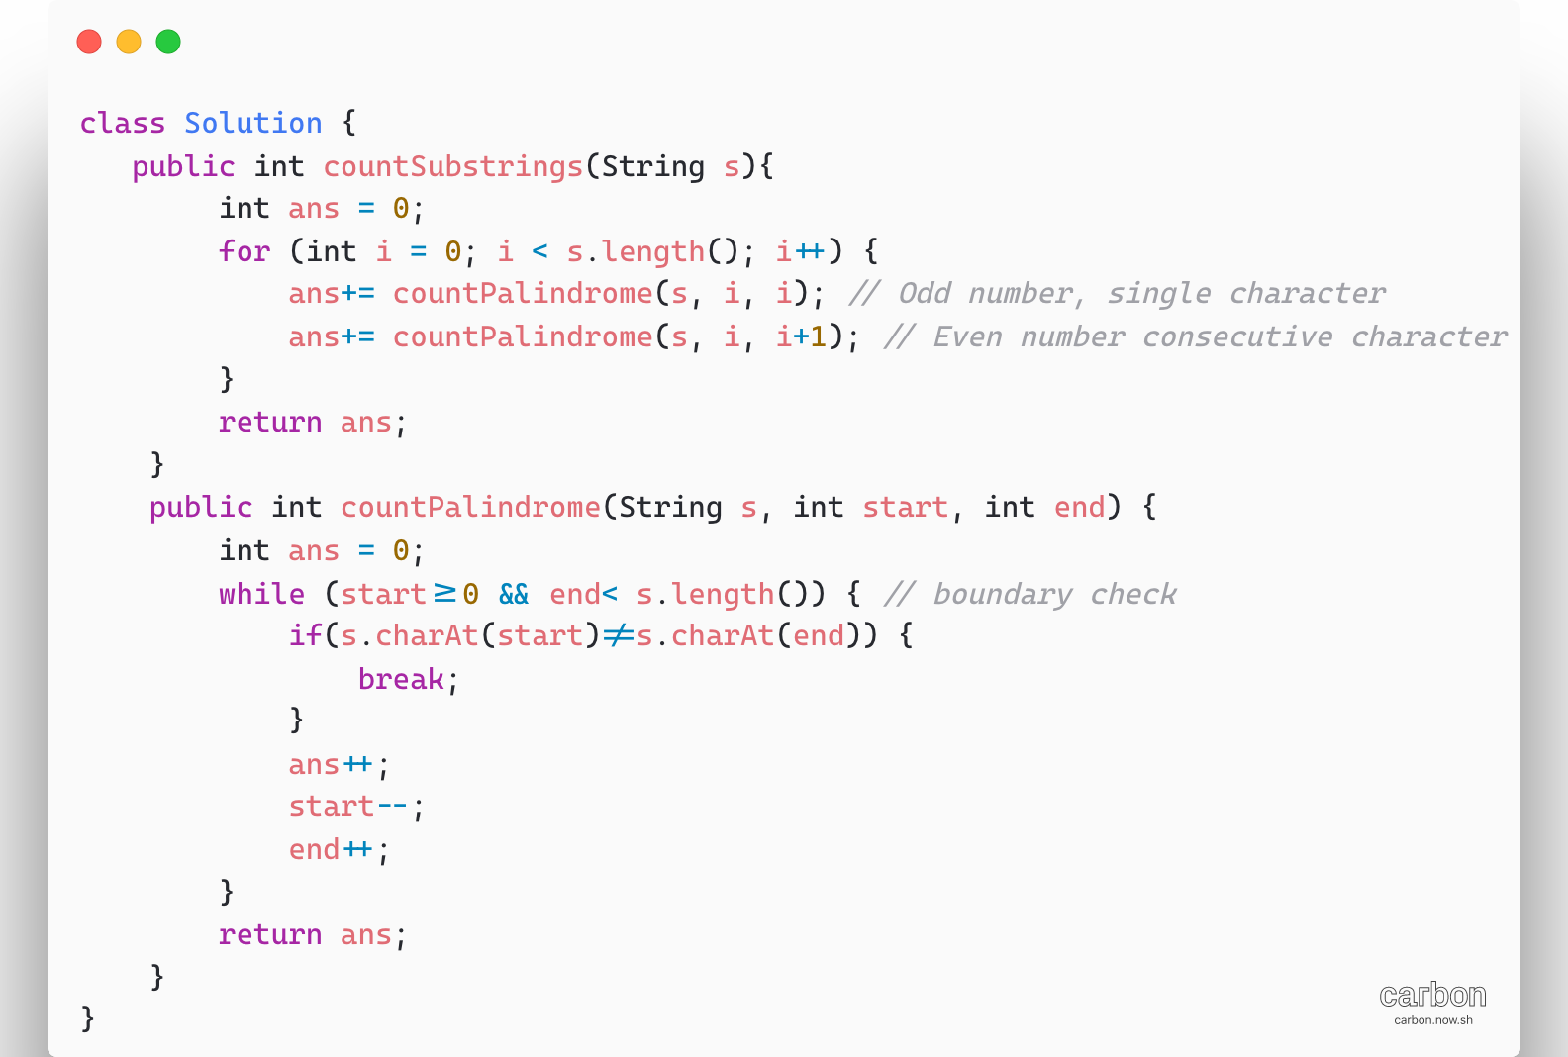

1. [Longest Palindromic Substring](https://leetcode.com/problems/longest-palindromic-substring/)

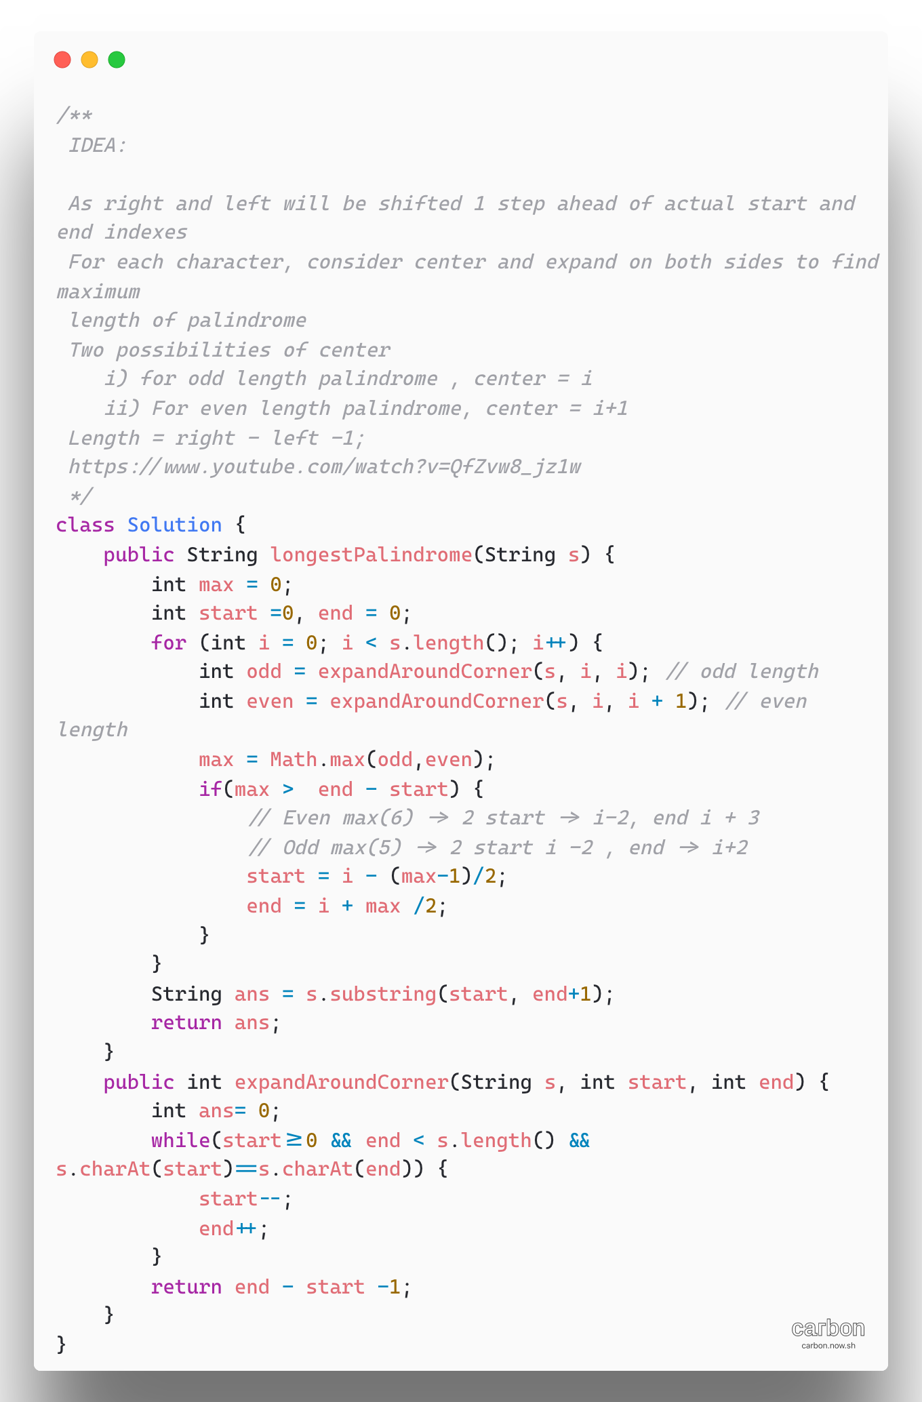

1. Cutting Rope Cutting

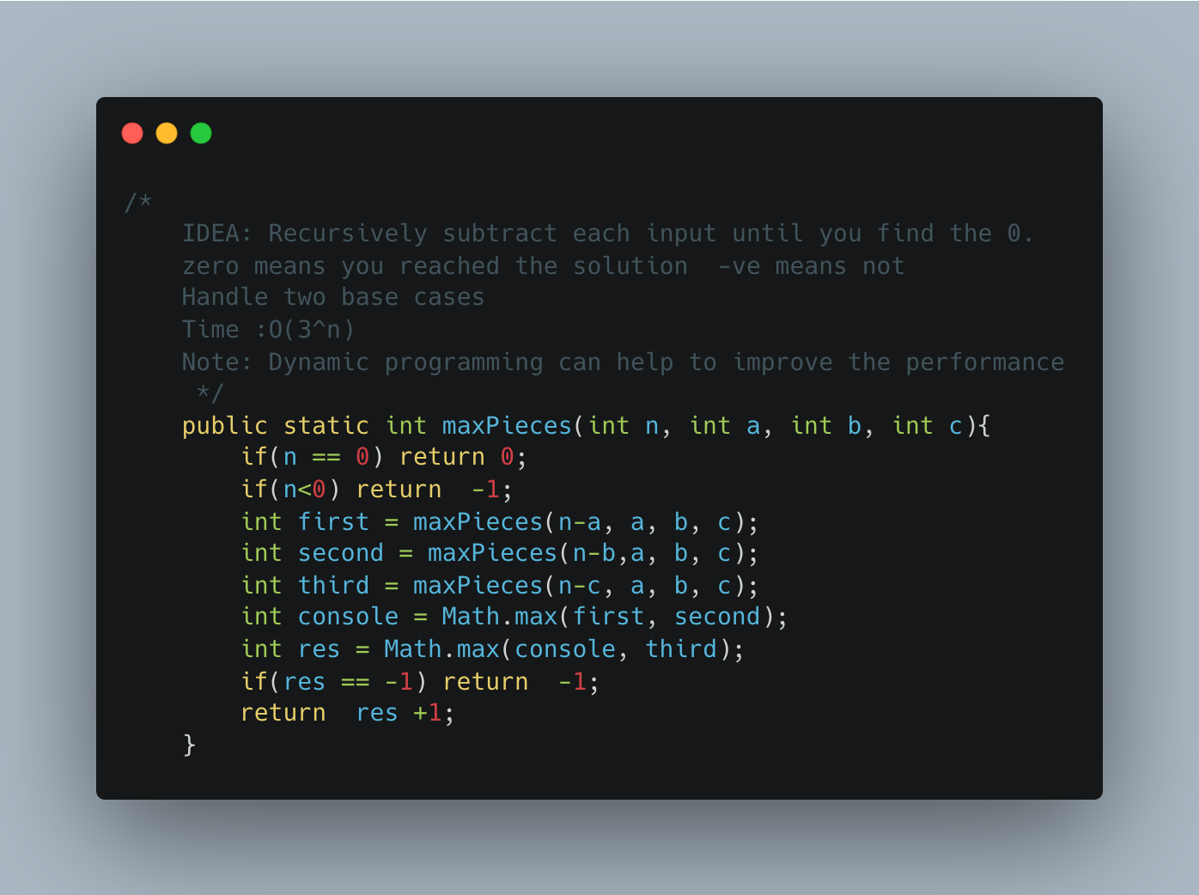

1. Generate Subsets of a given string

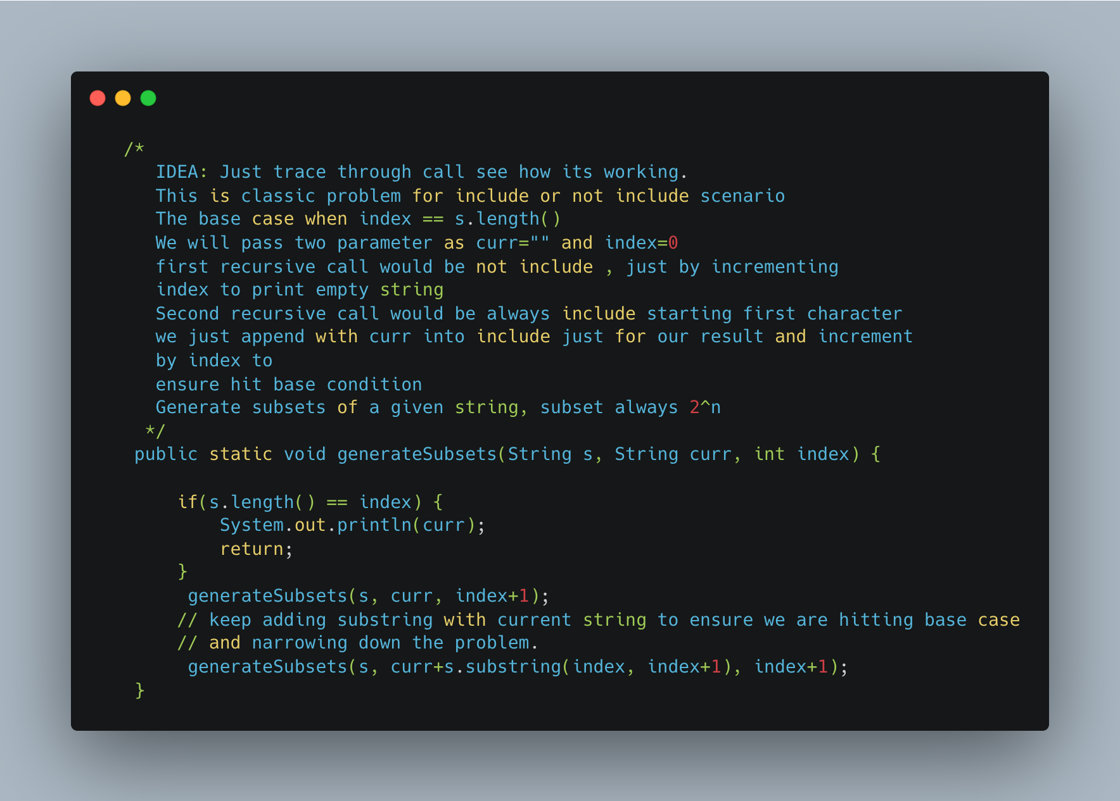

1. [Longest Repeating Character Replacement](https://leetcode.com/problems/longest-repeating-character-replacement/)

TBD- V.IMP

1. Array Dequeue

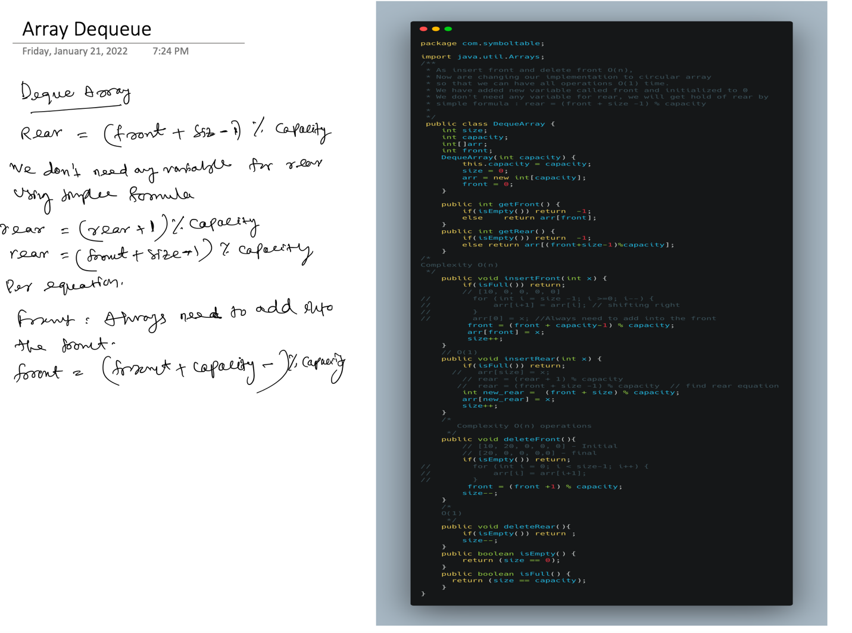

1. [Distant Barcodes](https://leetcode.com/problems/distant-barcodes/)

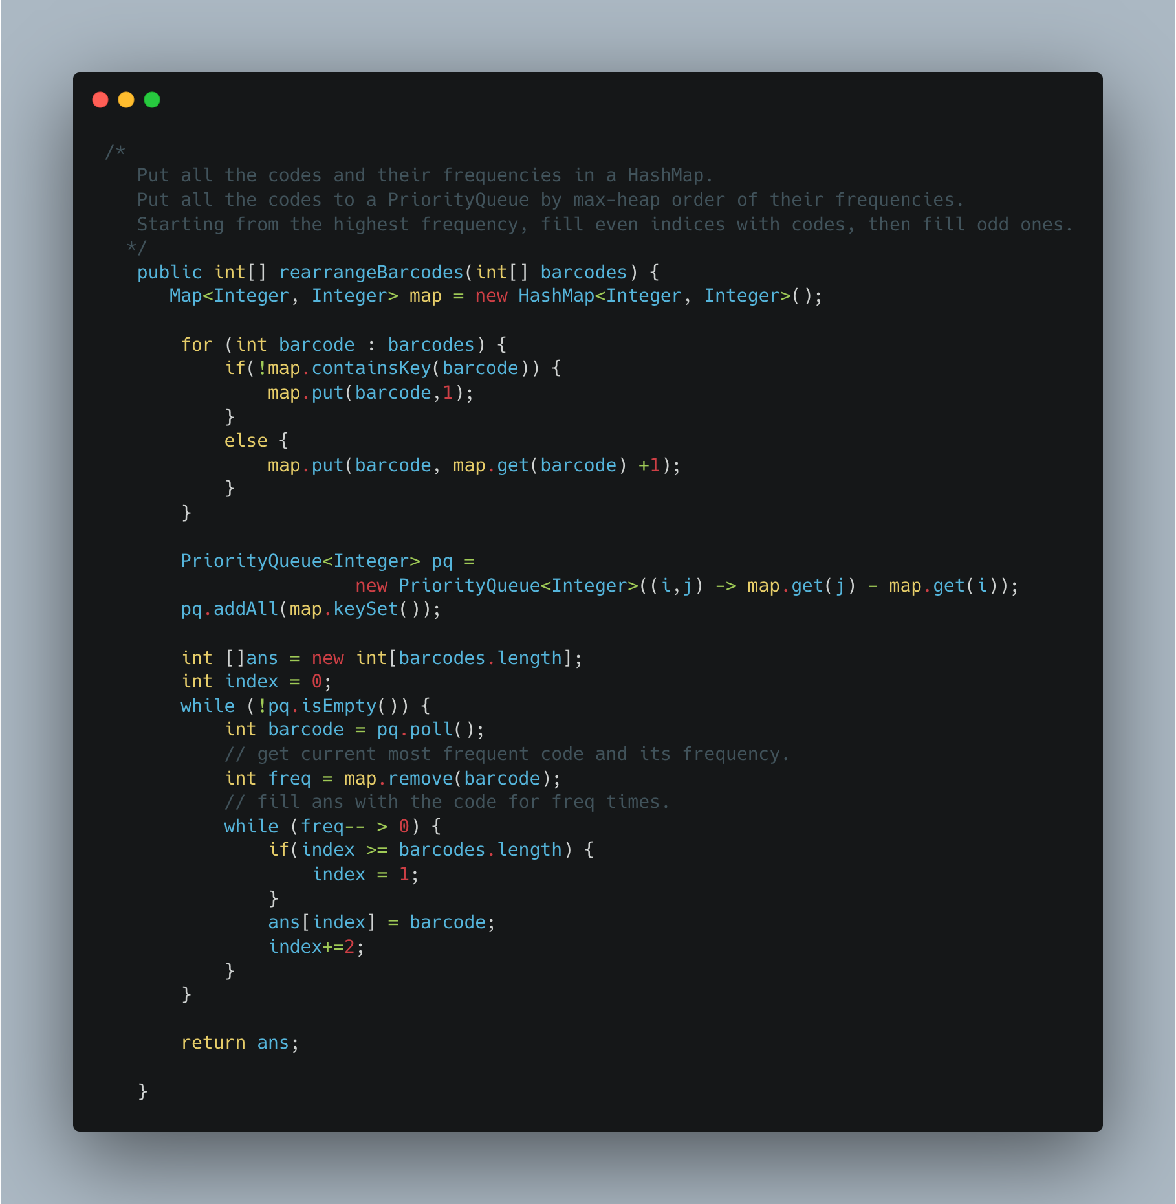

1. [Simplify Path](https://leetcode.com/problems/simplify-path/)

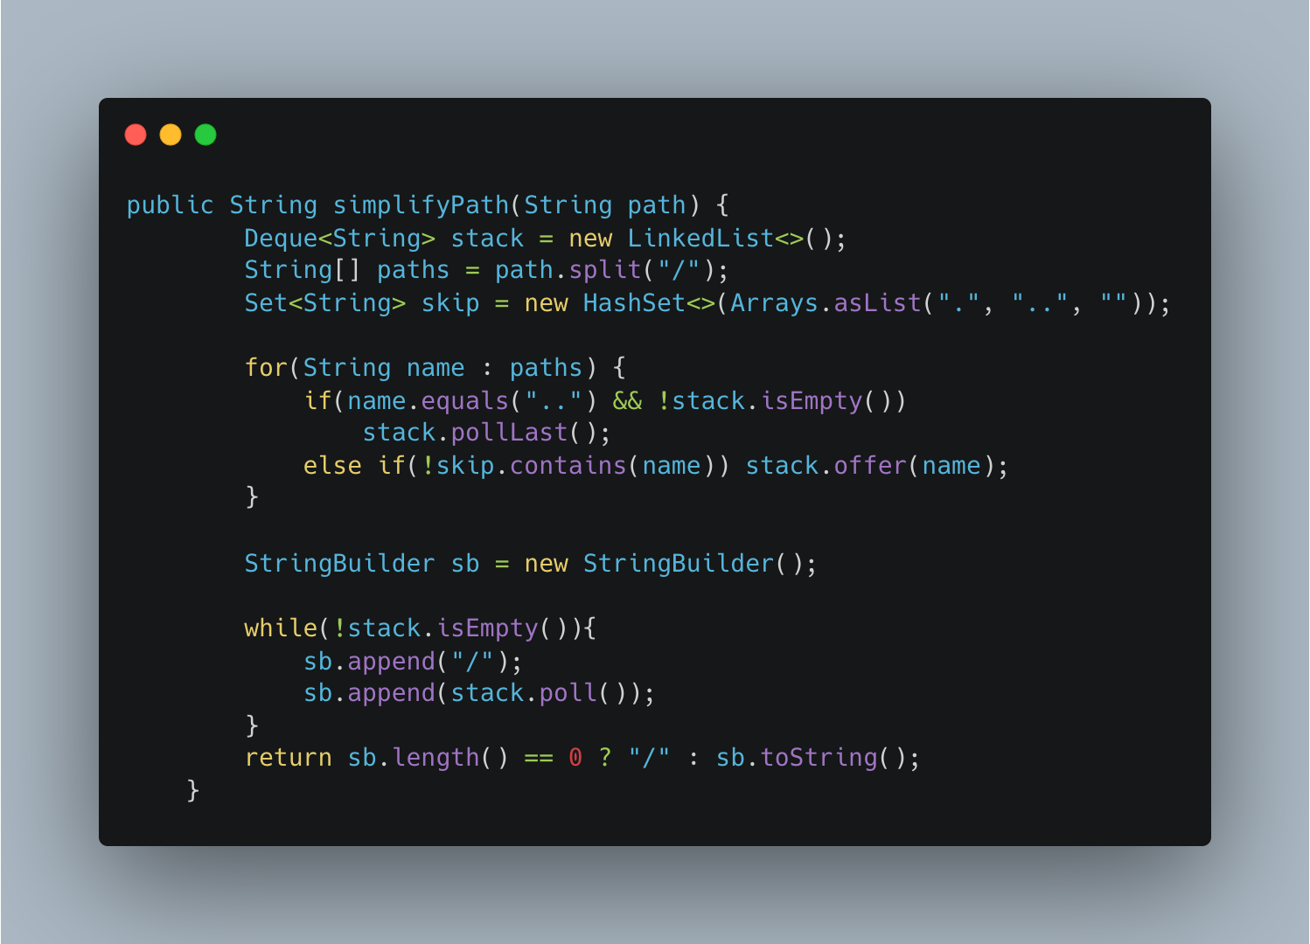

1. Maximum Activity – Greedy

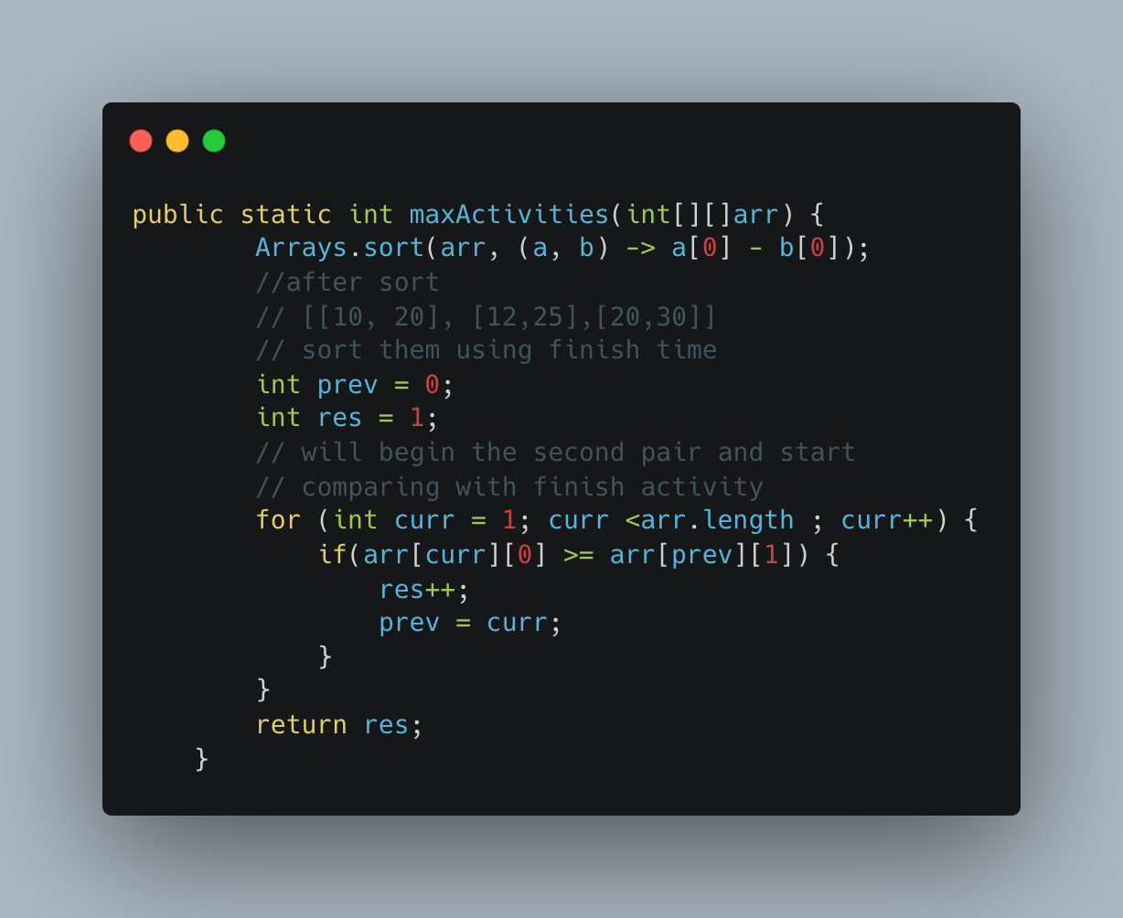

1. Another way of implementing

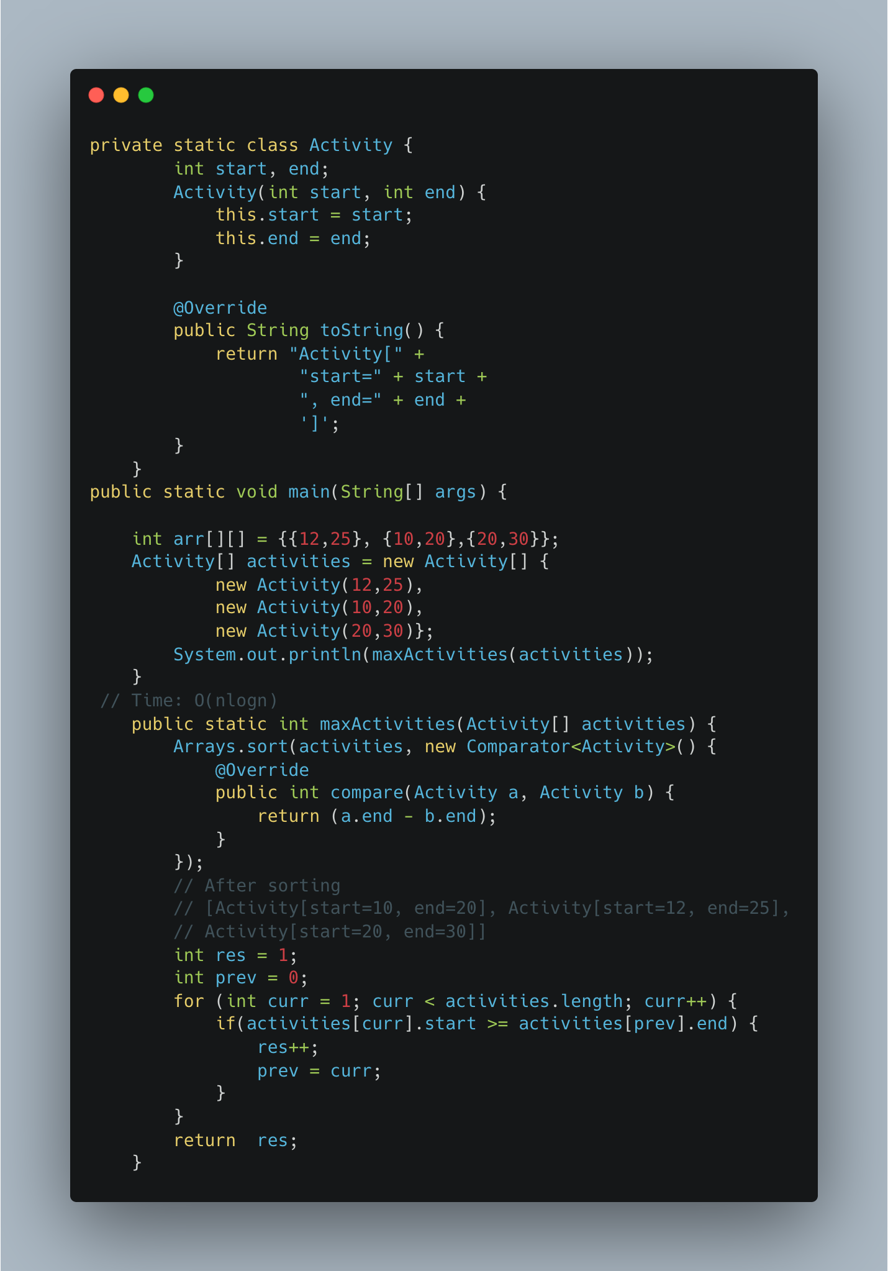

1. [Fractional Knapsack](https://www.geeksforgeeks.org/fractional-knapsack-problem/)

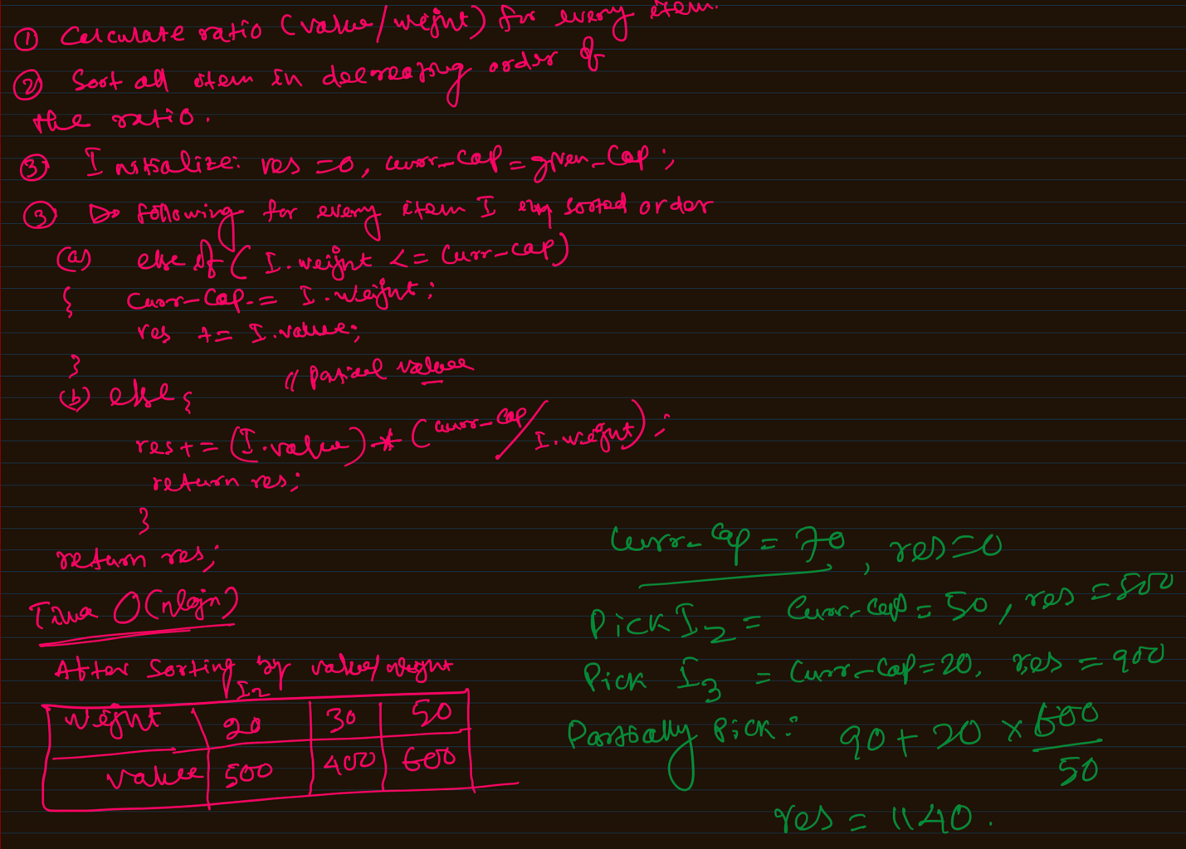

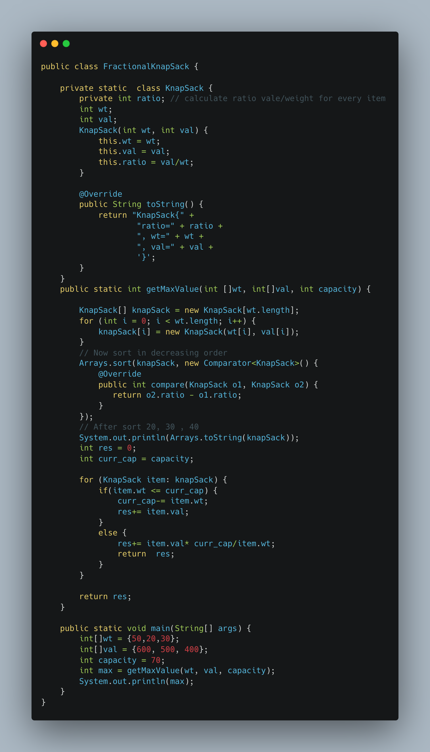

1. [Print Word Vertically](https://leetcode.com/problems/print-words-vertically/)

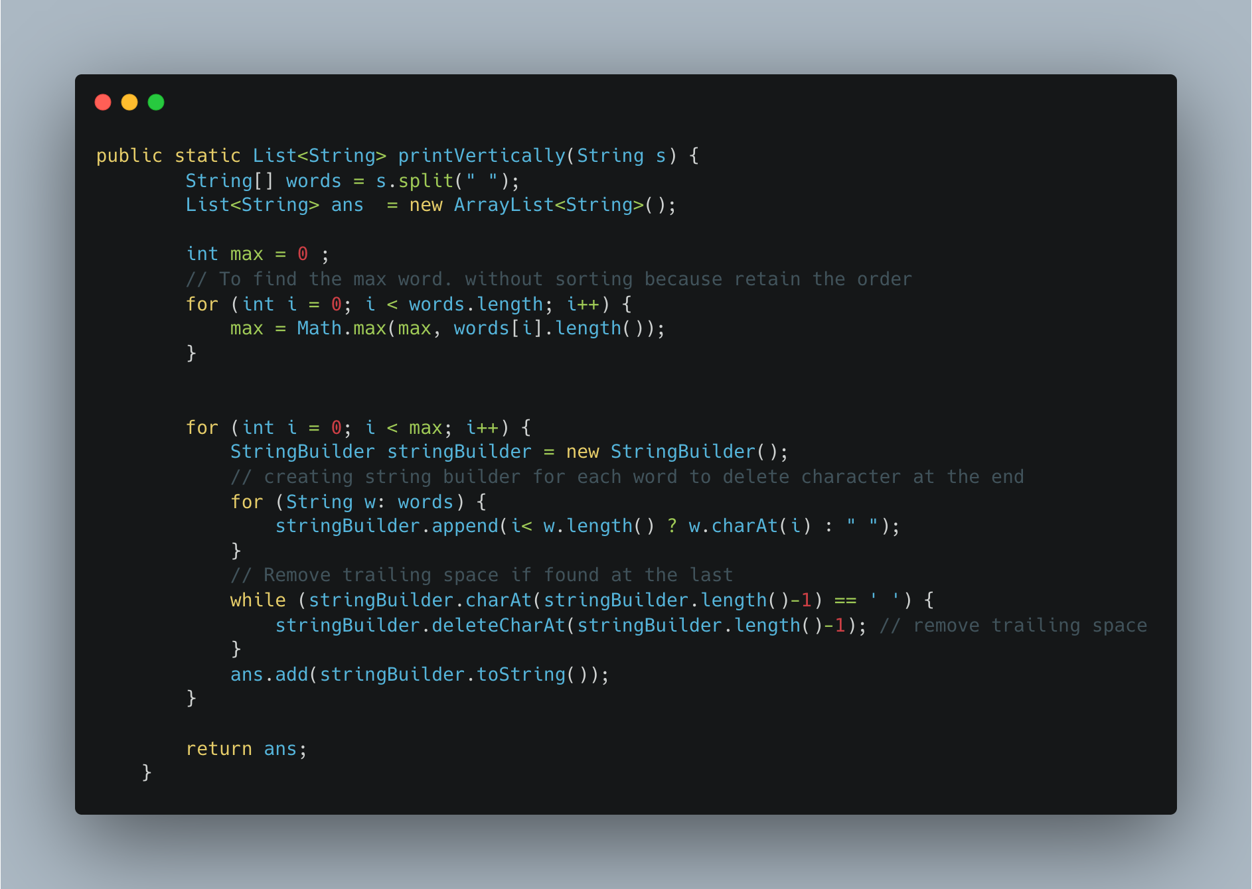

1. [Two Sum II Array is Sorted](https://leetcode.com/problems/two-sum-ii-input-array-is-sorted/)

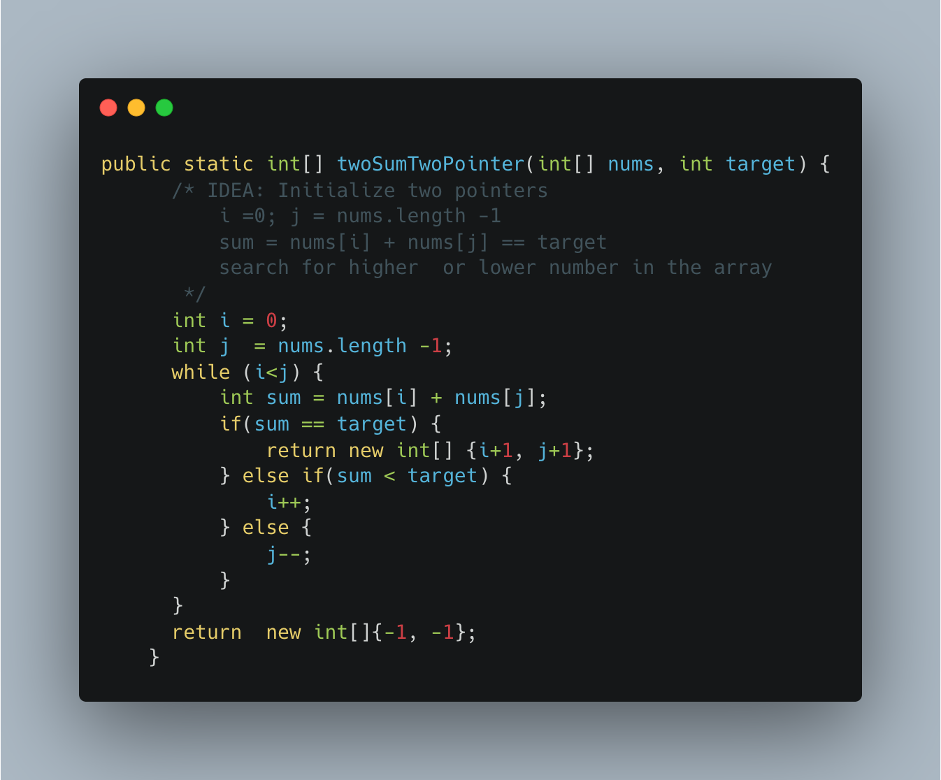

1. [Minimum Moves to Equal Array elements II](https://leetcode.com/problems/minimum-moves-to-equal-array-elements-ii/)

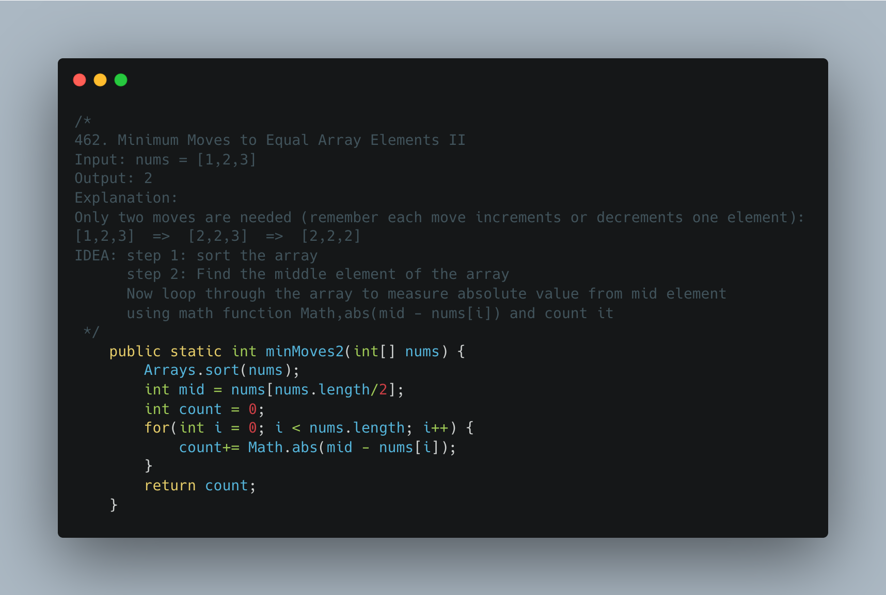

1. [Same Tree](https://leetcode.com/problems/same-tree/)

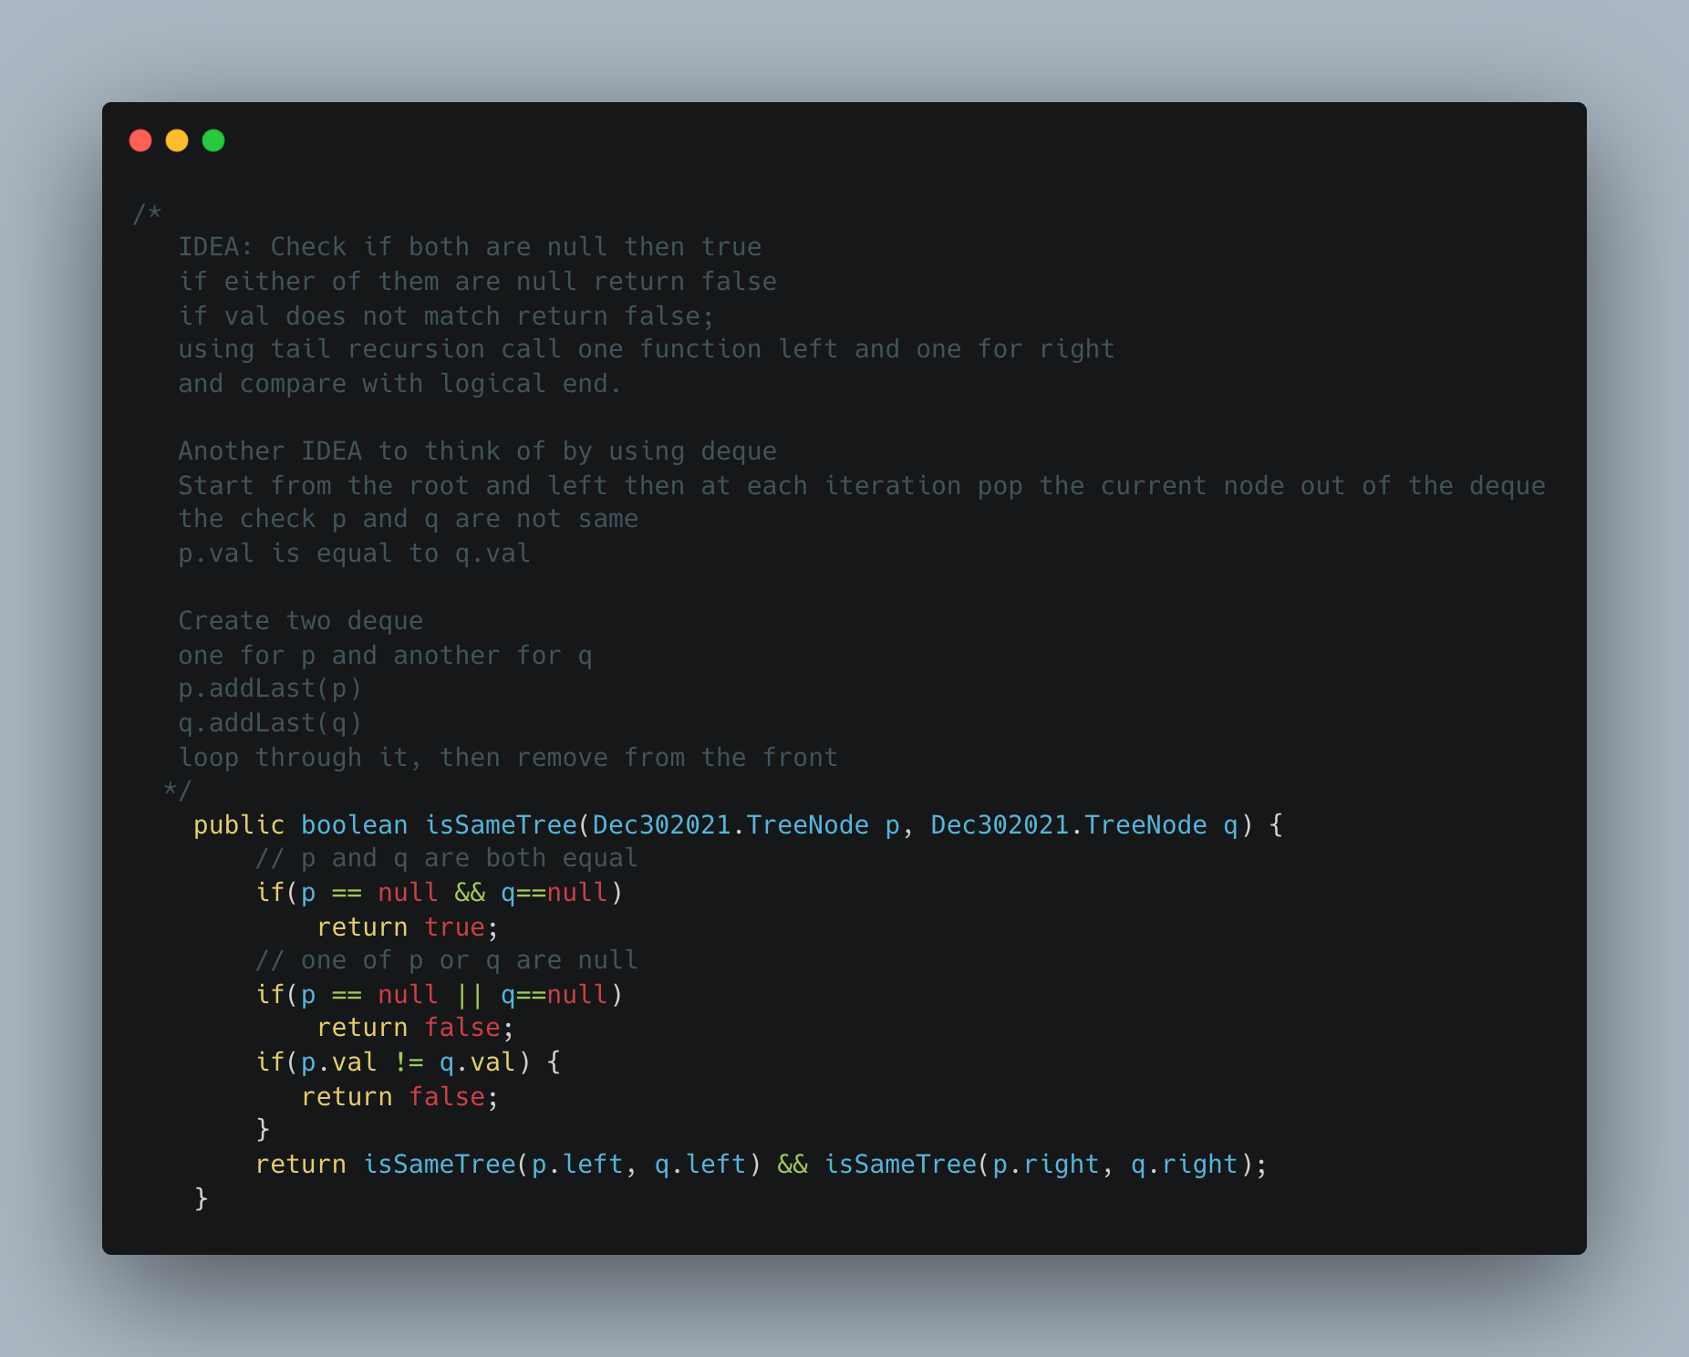

1. Maximize the number of toys that can be purchased with amount K using min Heap

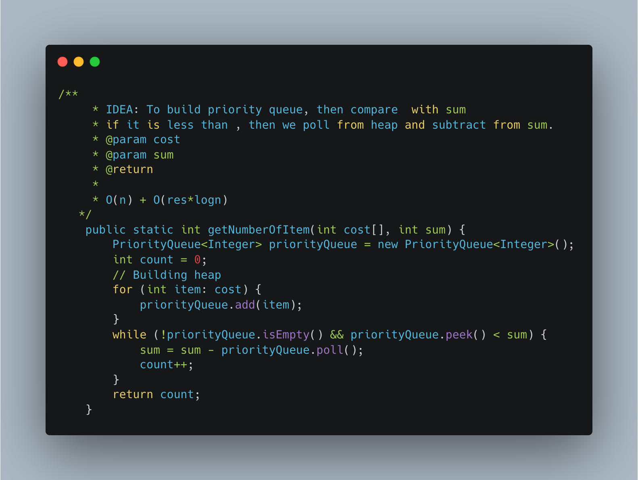

1. [Find K Closest Elements](https://leetcode.com/problems/find-k-closest-elements/)

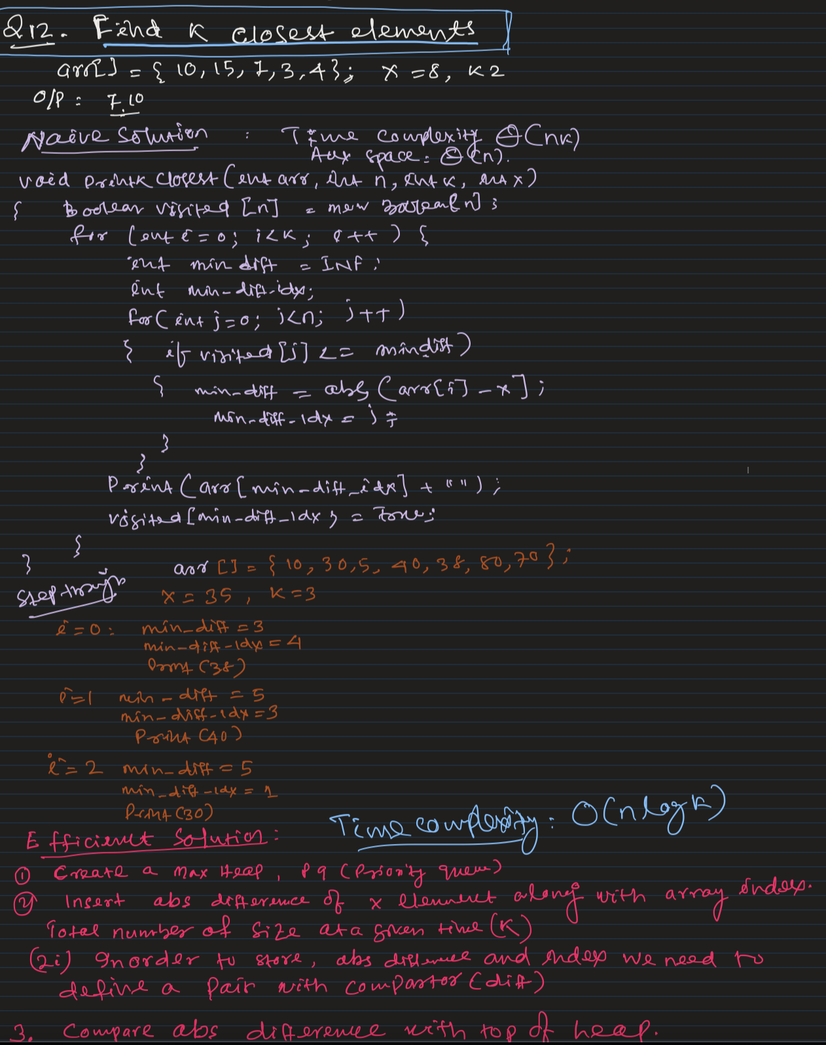

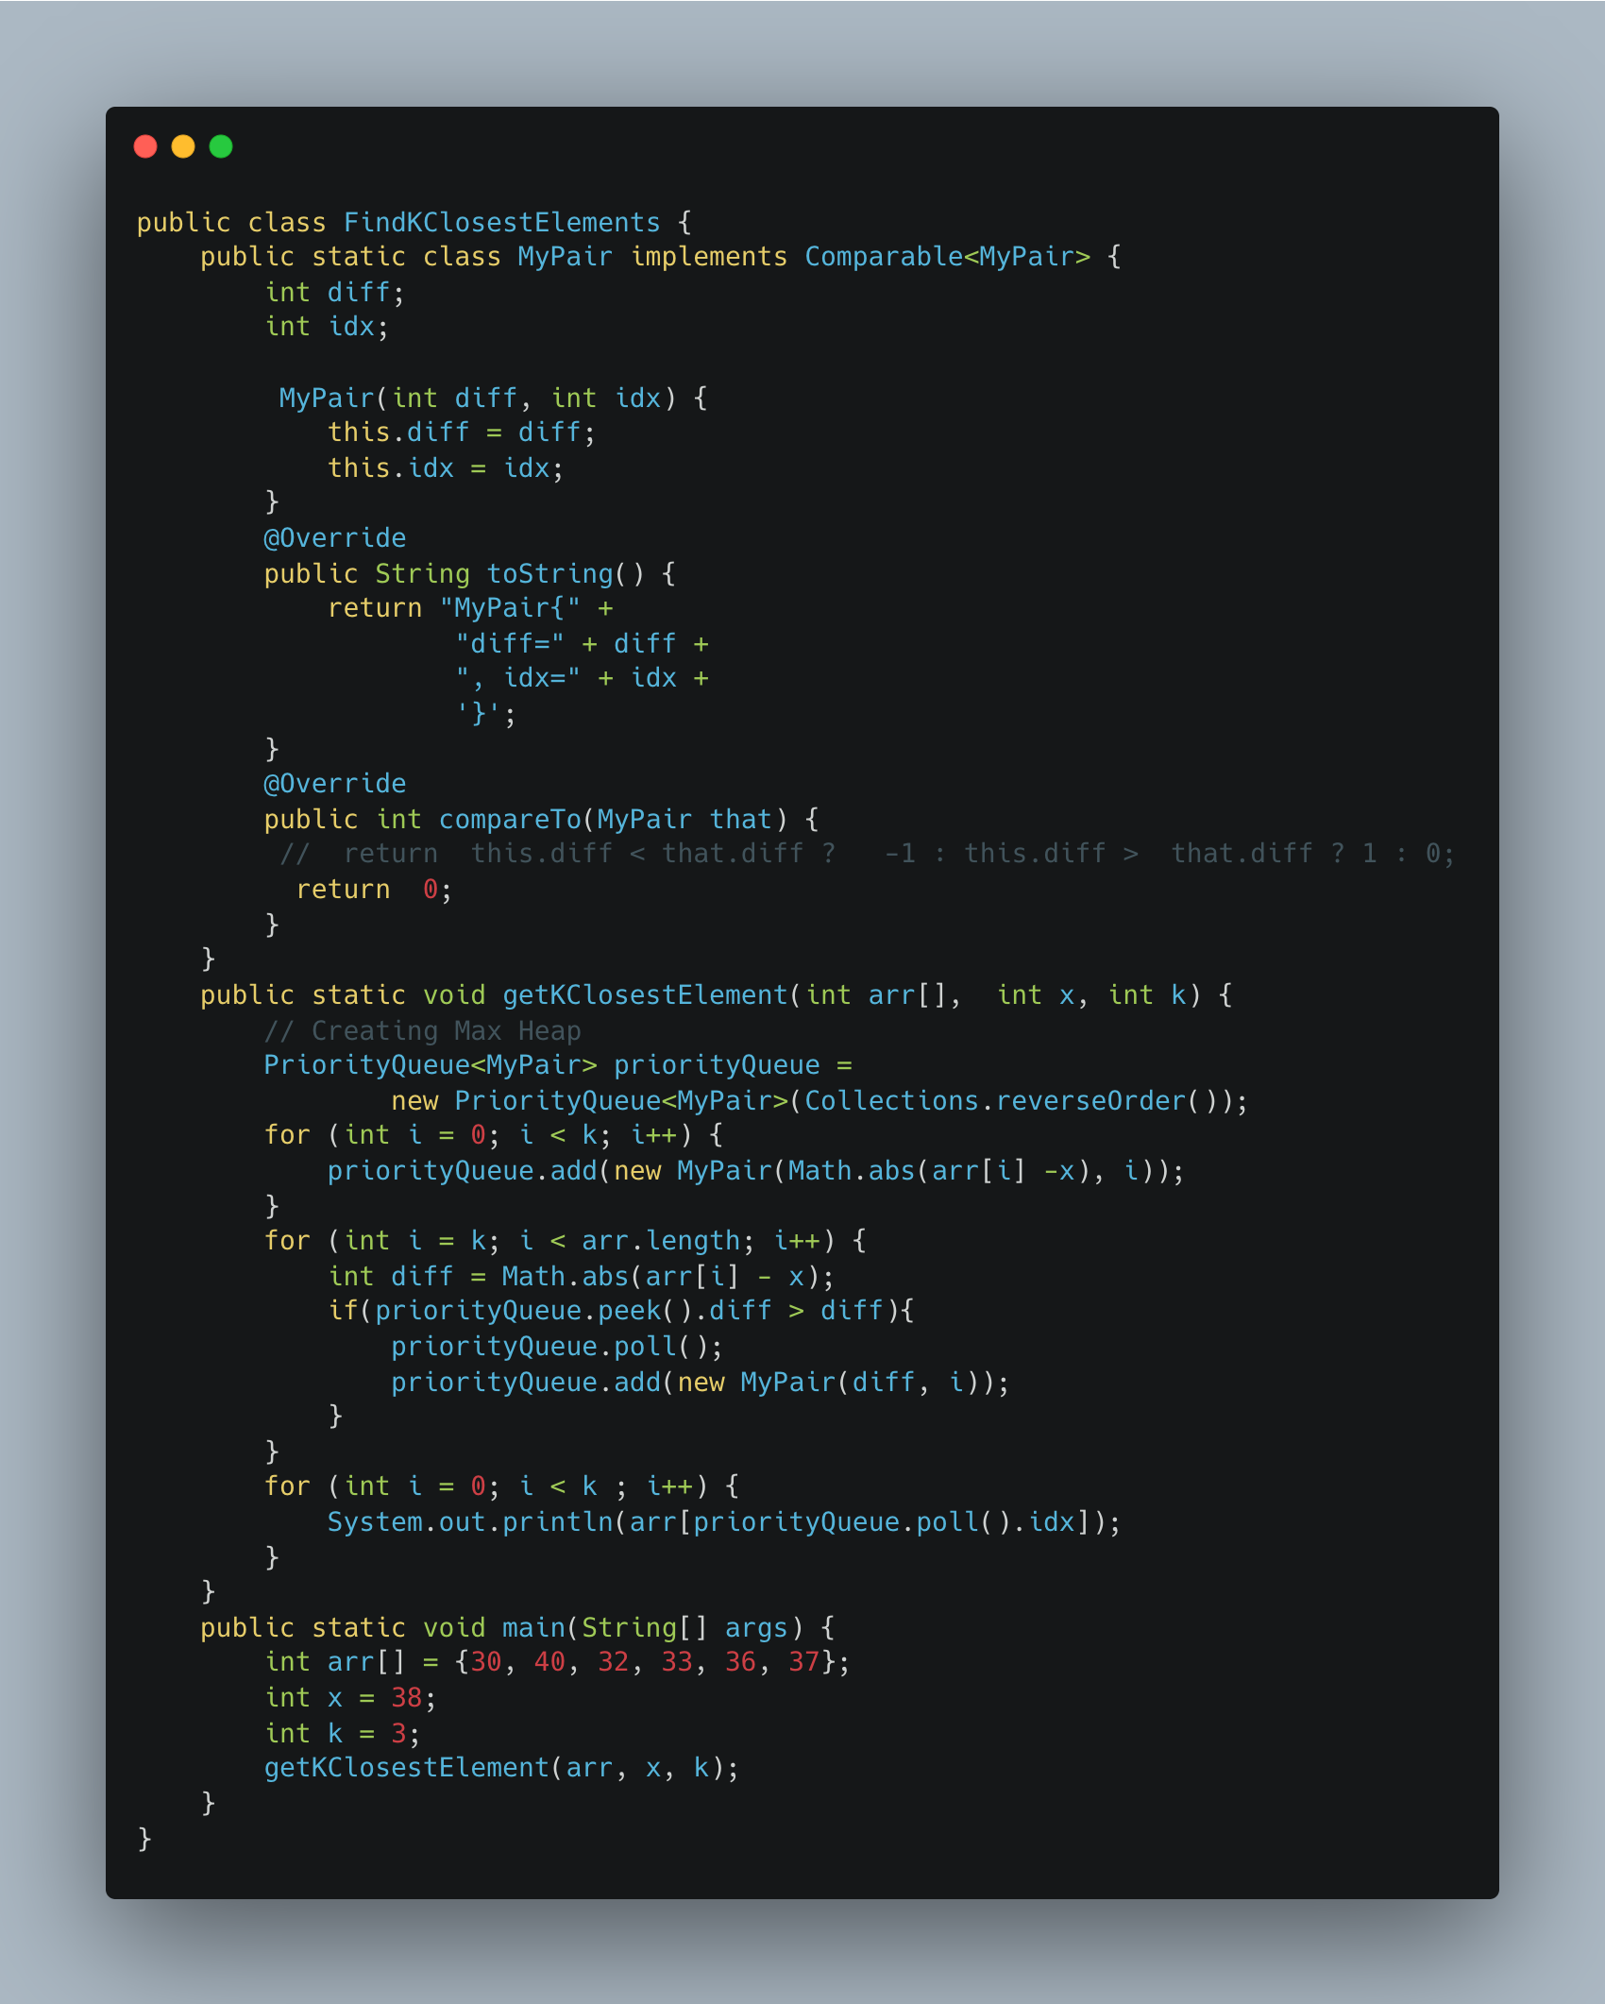

1. [Partition into Minimum Number of Deci -Binary Numbers](https://leetcode.com/problems/partitioning-into-minimum-number-of-deci-binary-numbers/)

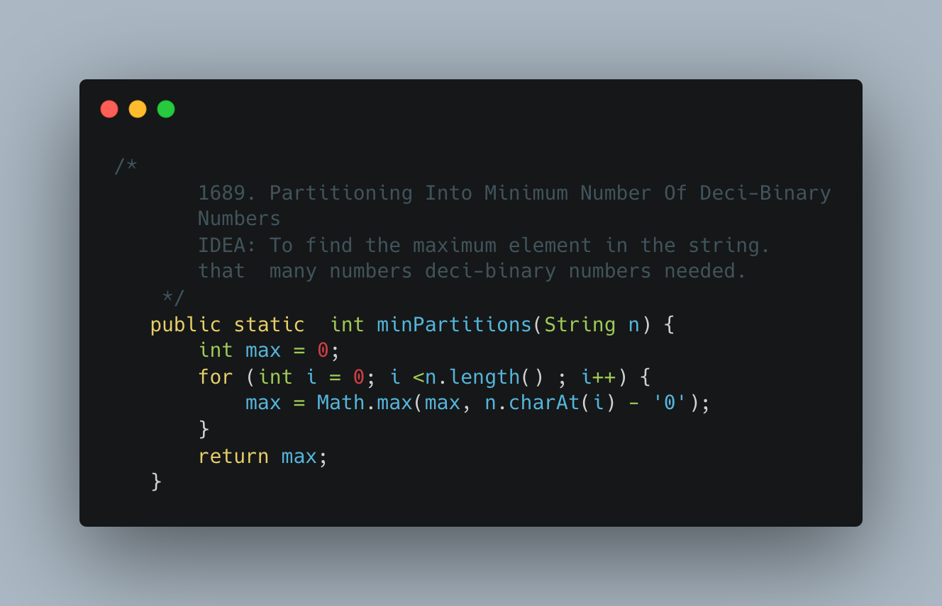

1. [Number of Closed Islands](https://leetcode.com/problems/number-of-closed-islands/)

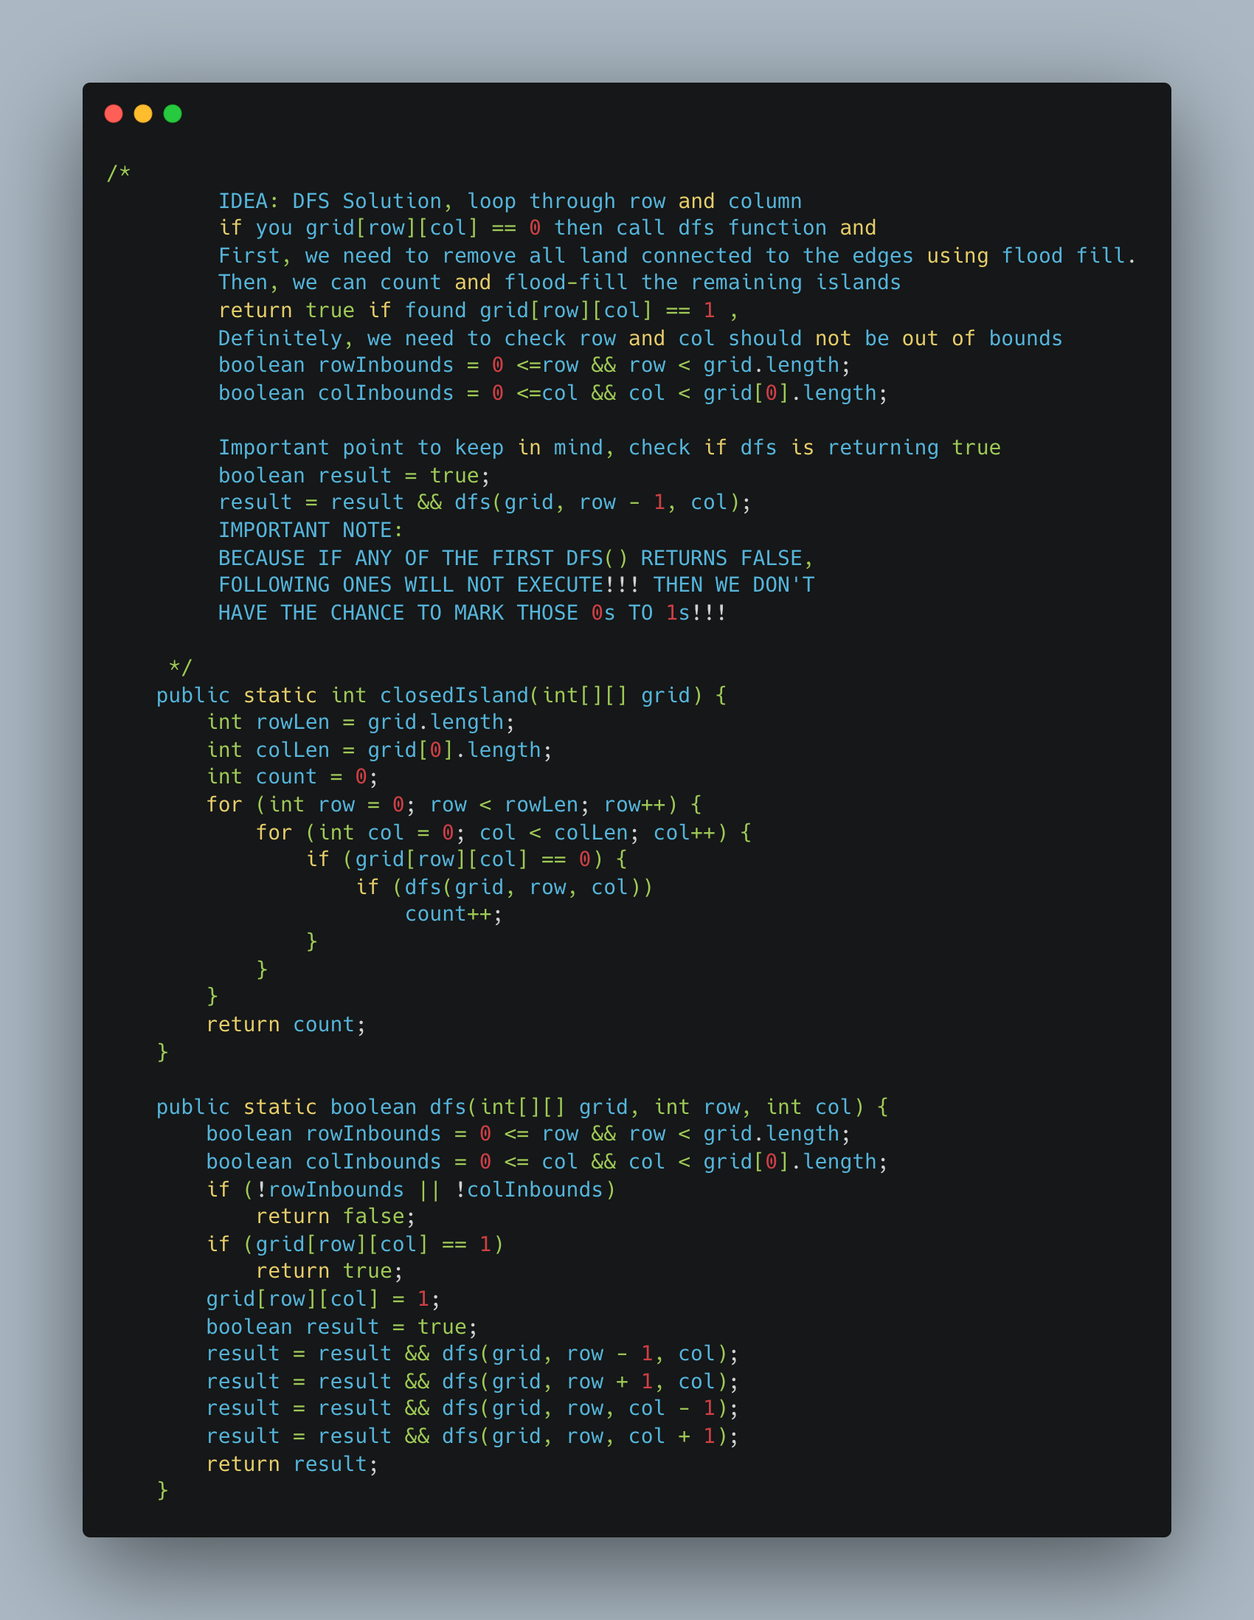

1. [Rank Transform of an Array](https://leetcode.com/problems/rank-transform-of-an-array/)

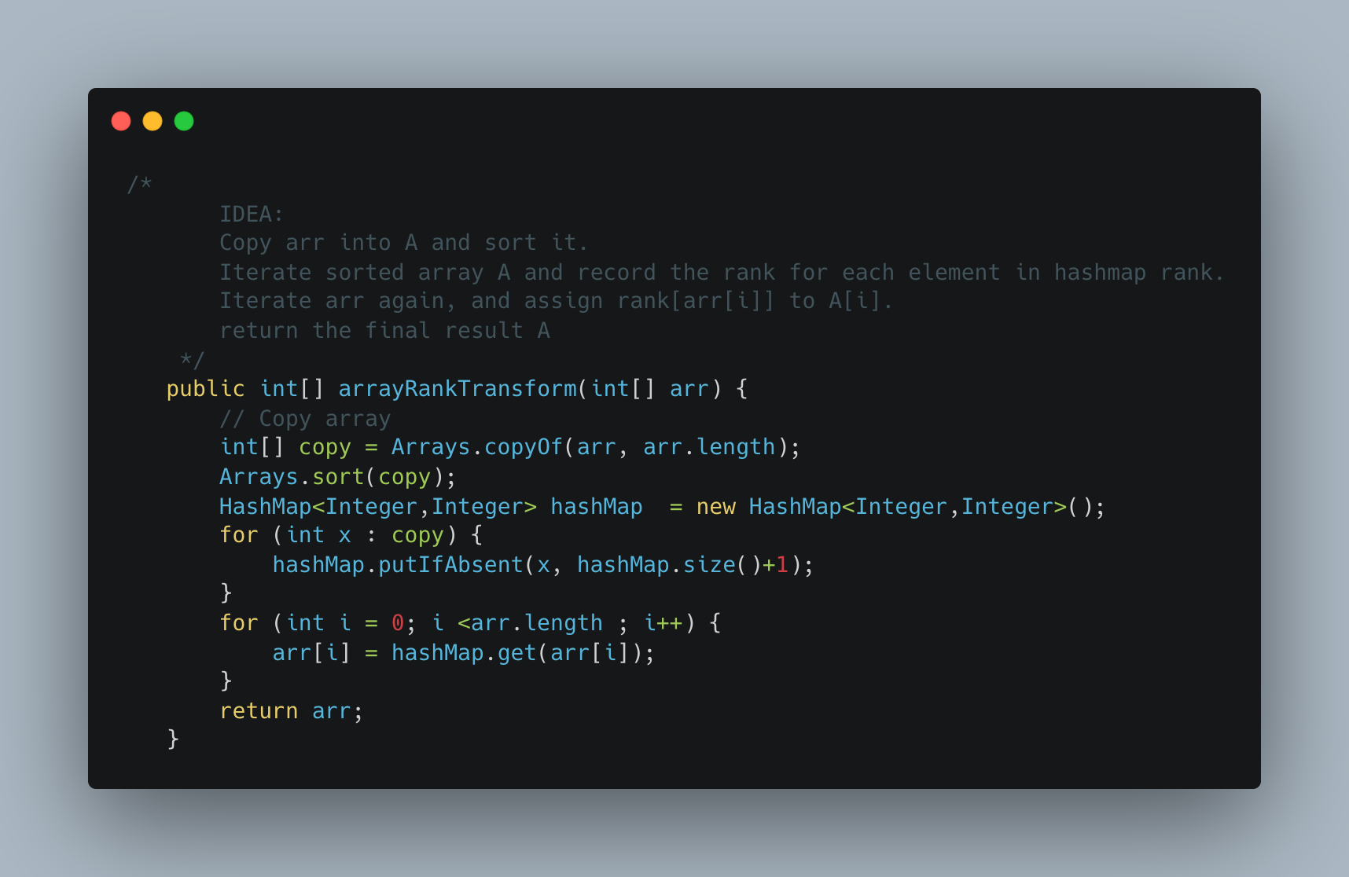

1. [Numbers with Same consecutive differences](https://leetcode.com/problems/numbers-with-same-consecutive-differences/)

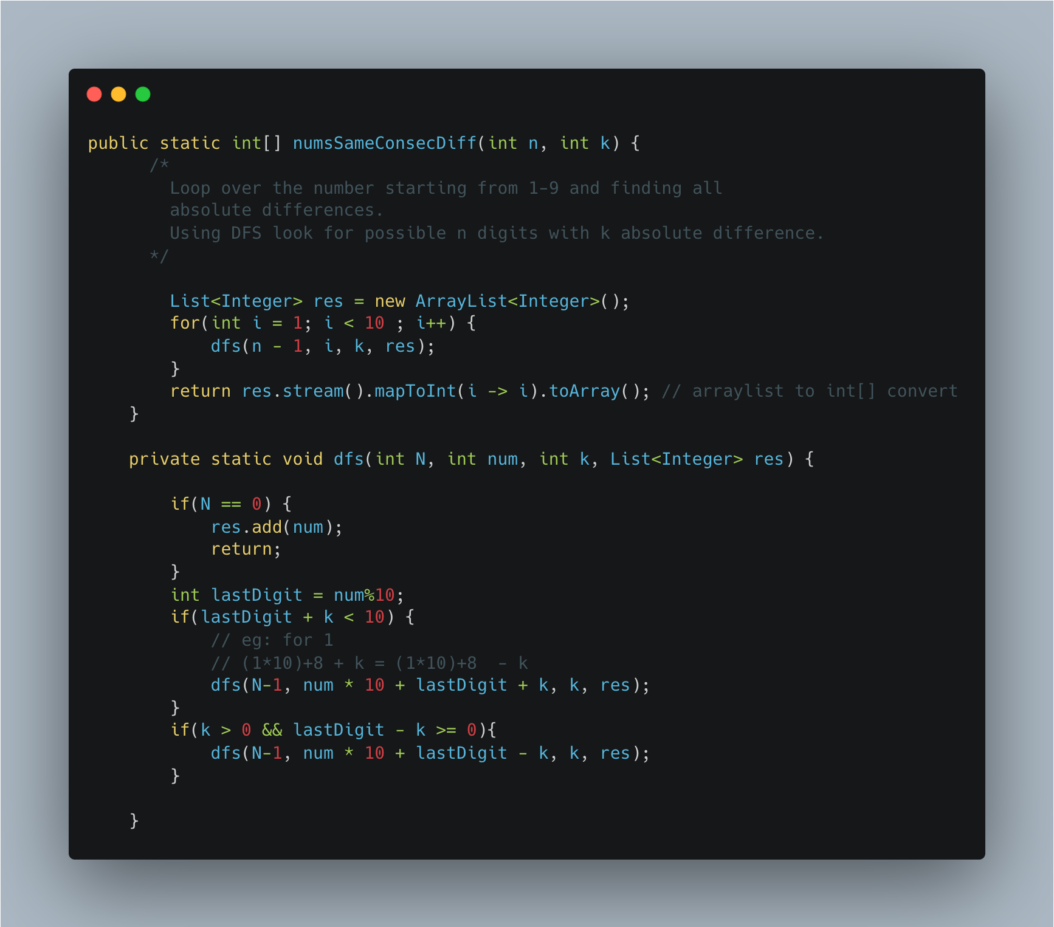

1. [Word Search](https://leetcode.com/problems/word-search/submissions/)

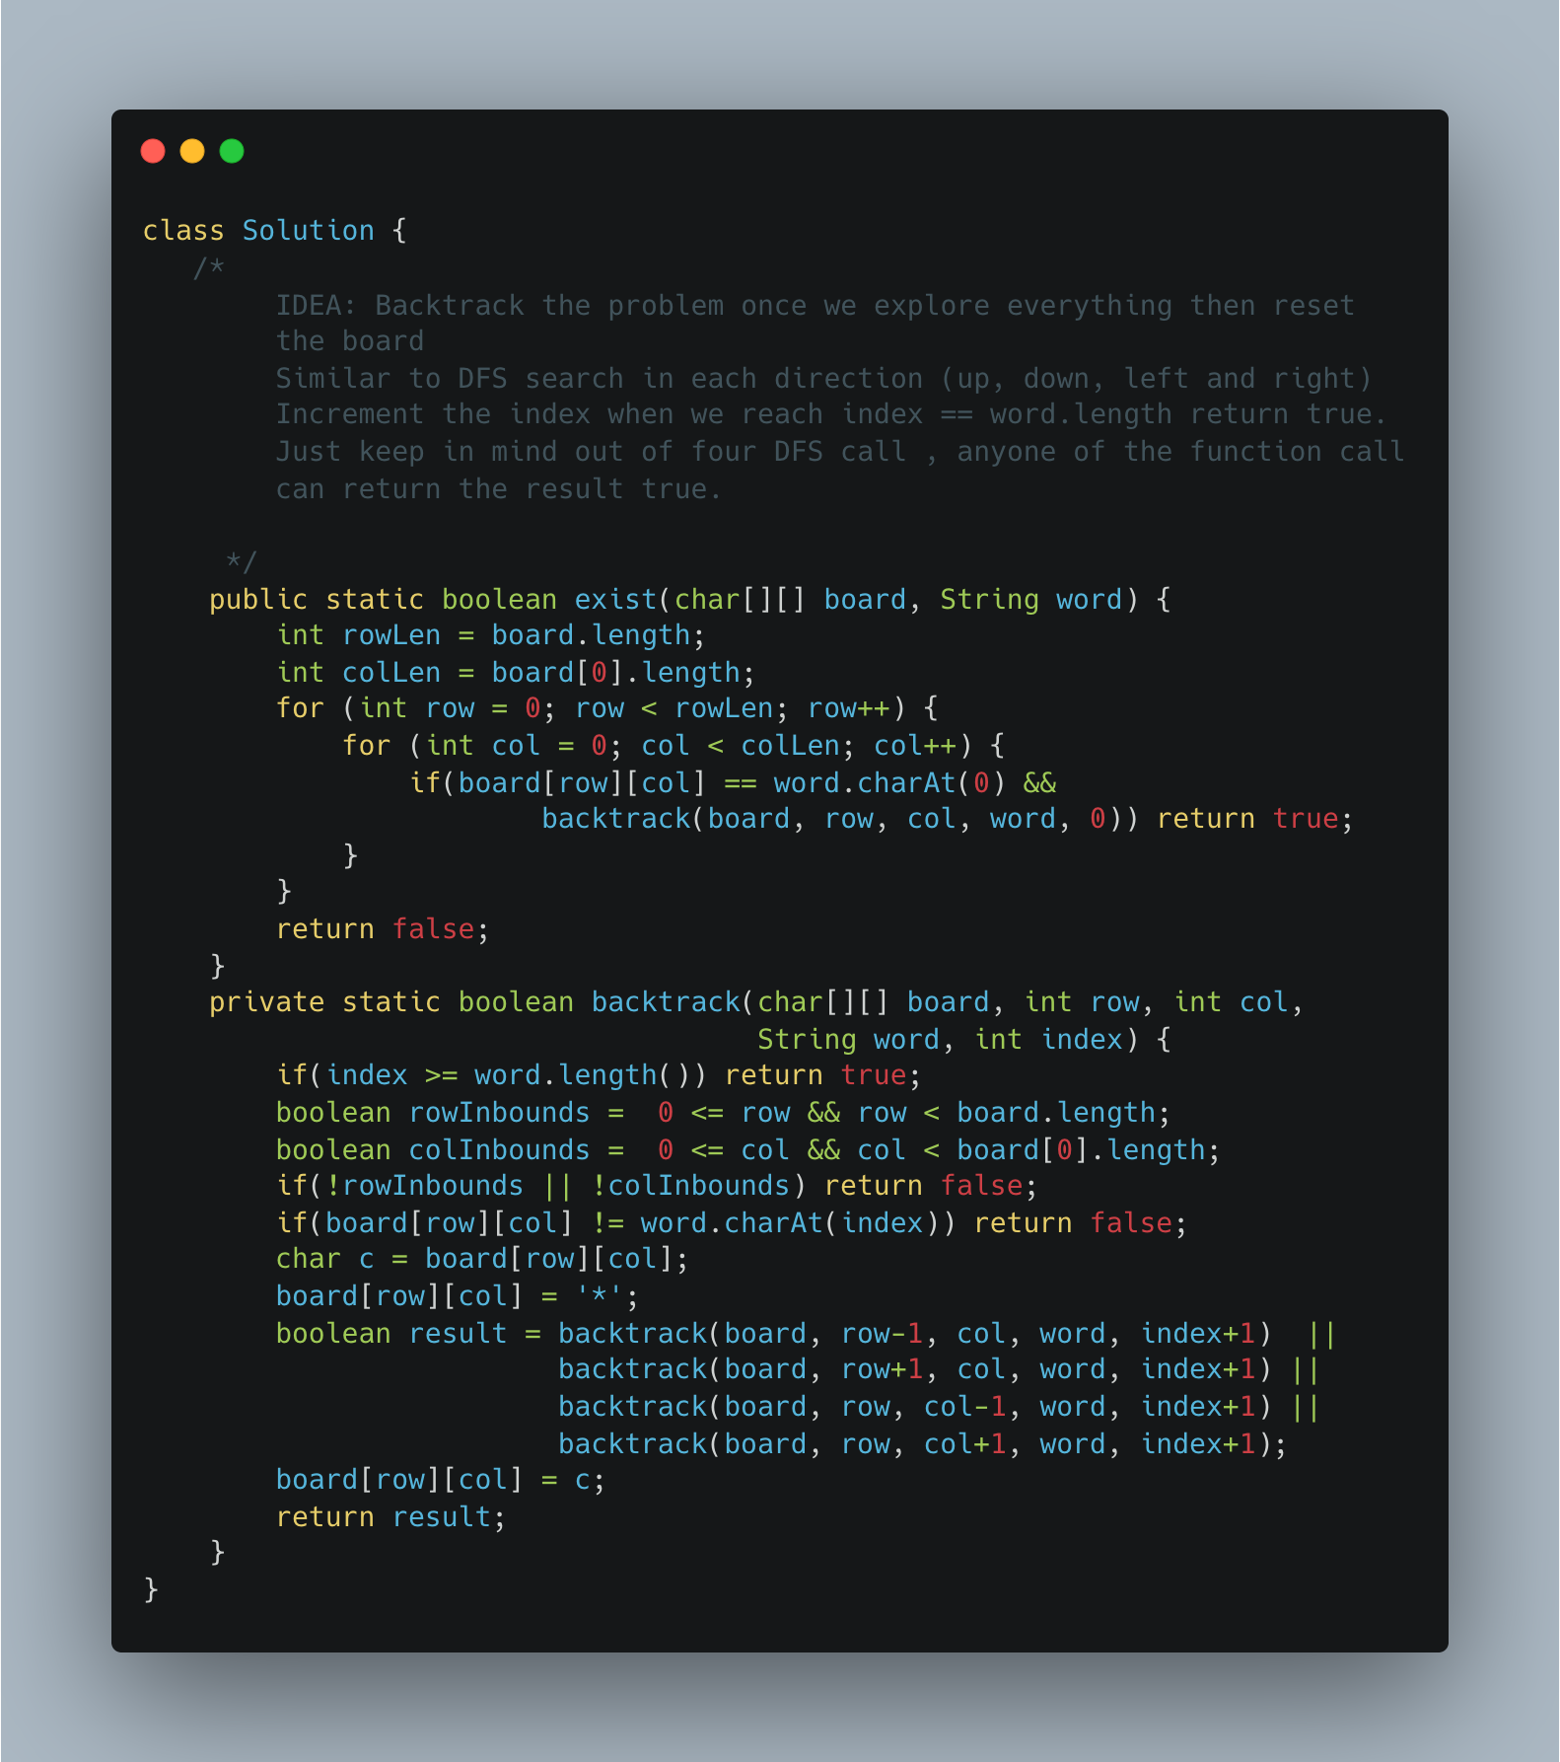

1. [Find Minimum in Rotated Sorted Array](https://leetcode.com/problems/find-minimum-in-rotated-sorted-array/)

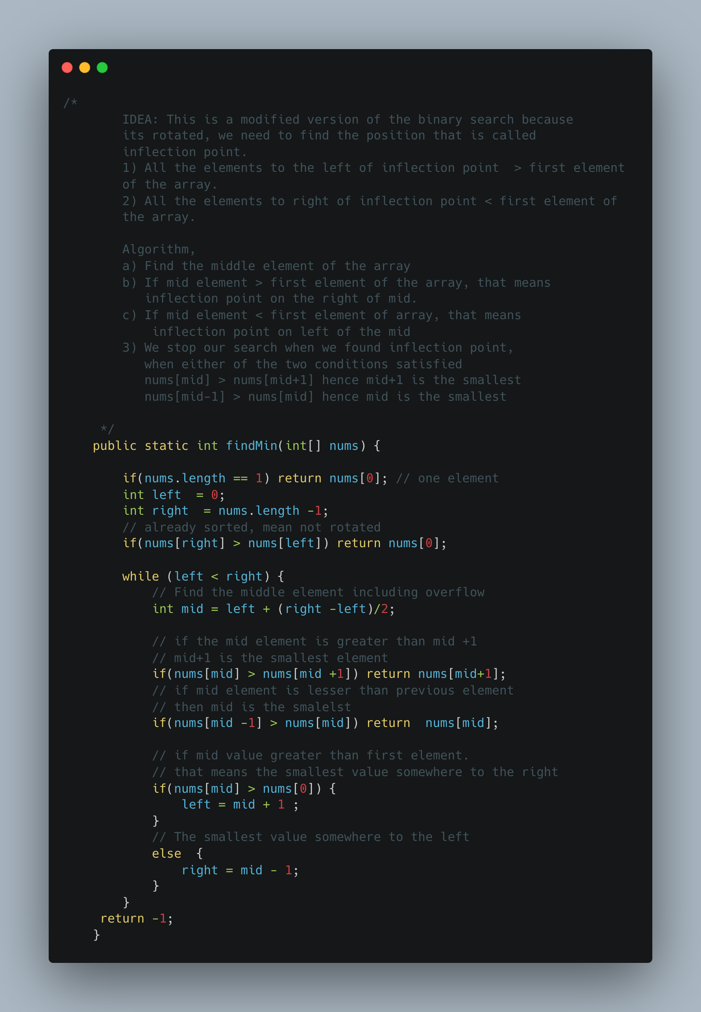

1. [Relative Sort Array](https://leetcode.com/problems/relative-sort-array/)

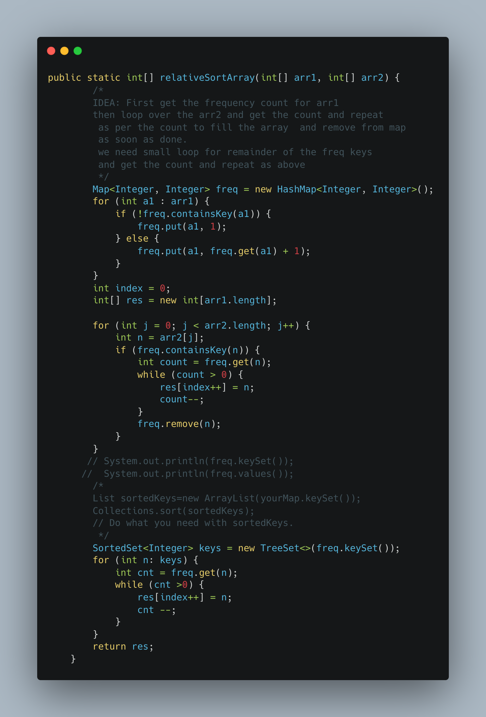

1. [Remove K Digits](https://leetcode.com/problems/remove-k-digits/)

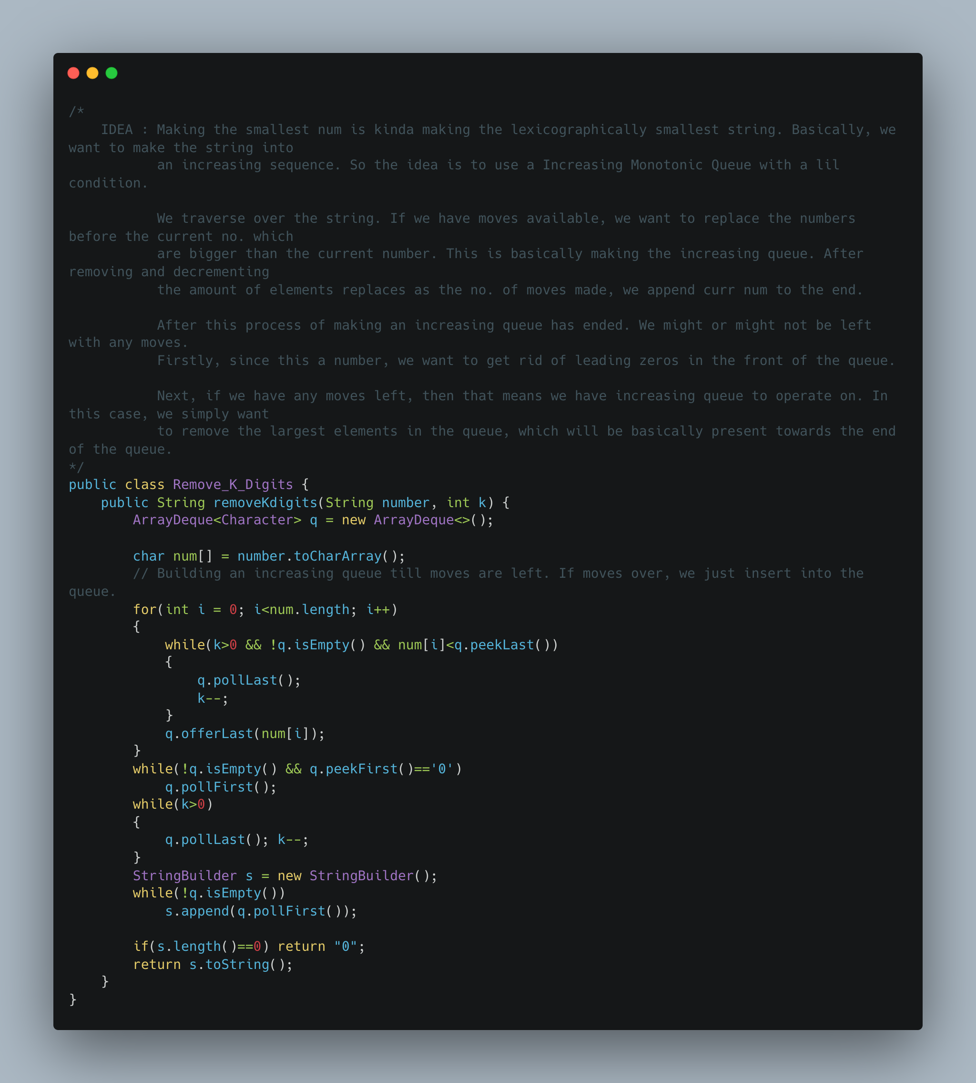

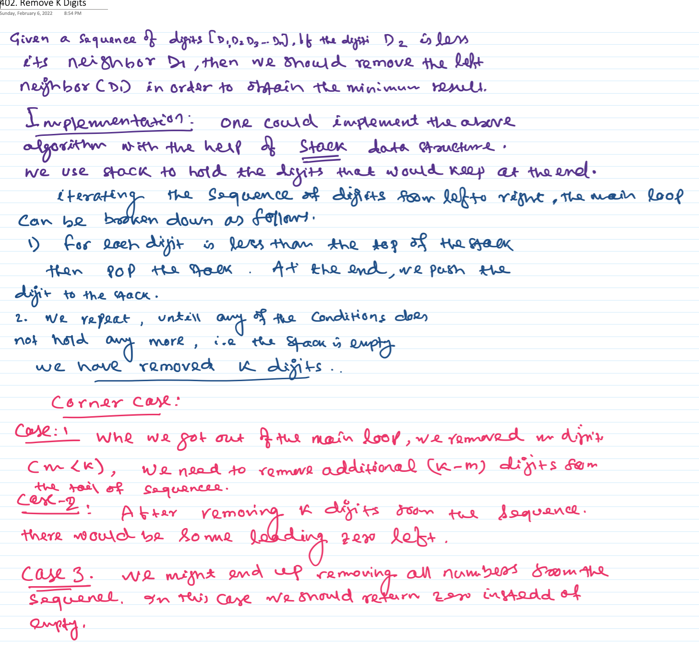

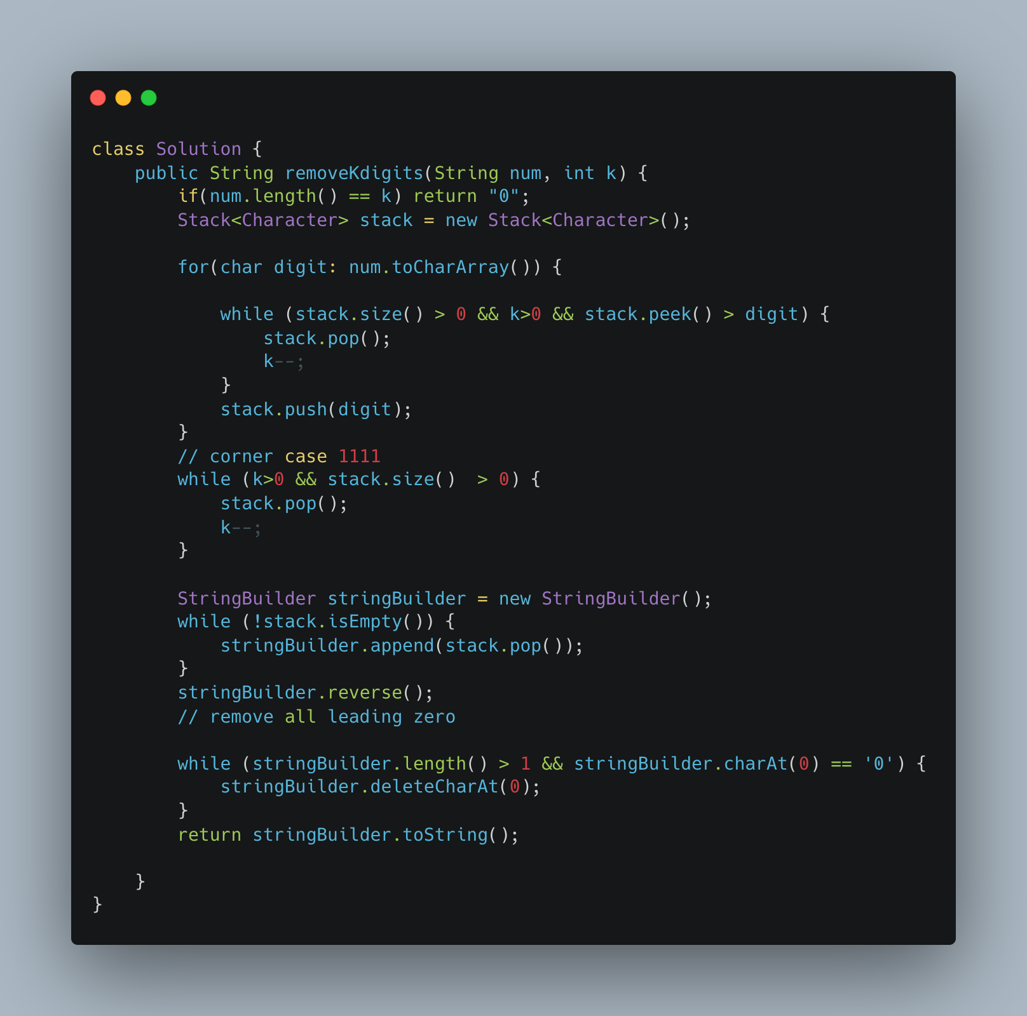

1. [Partition Labels](https://leetcode.com/problems/partition-labels/)

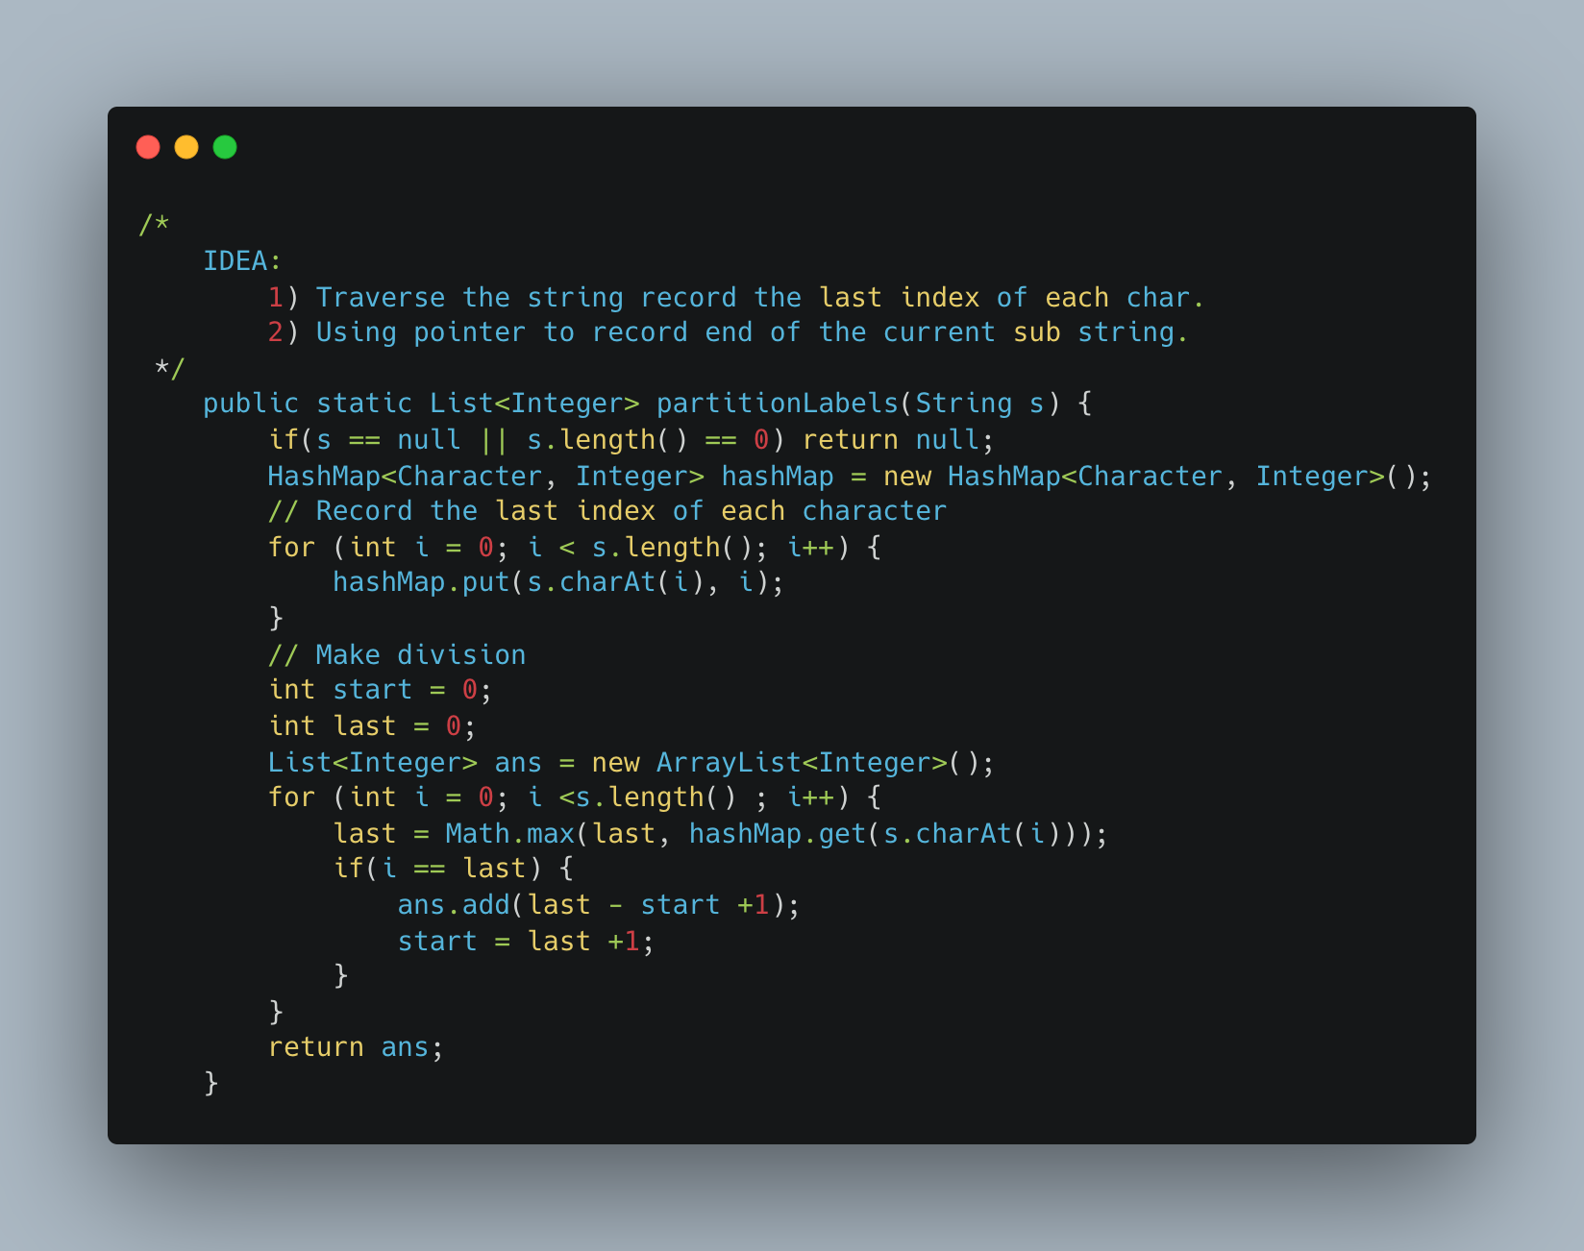

1. Fibonacci Dynamic Programming

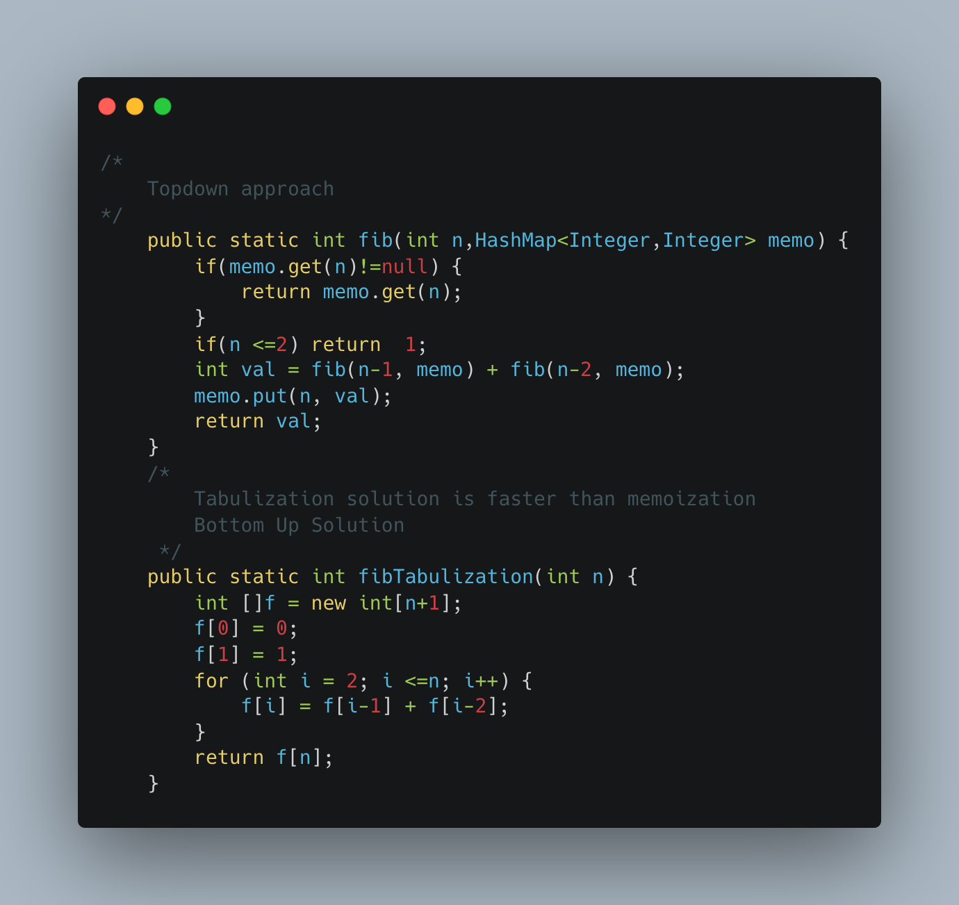

1. Distribute Coins in Binary Tree

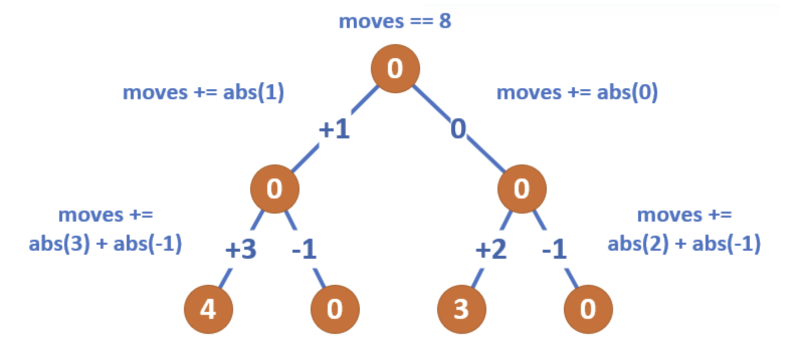

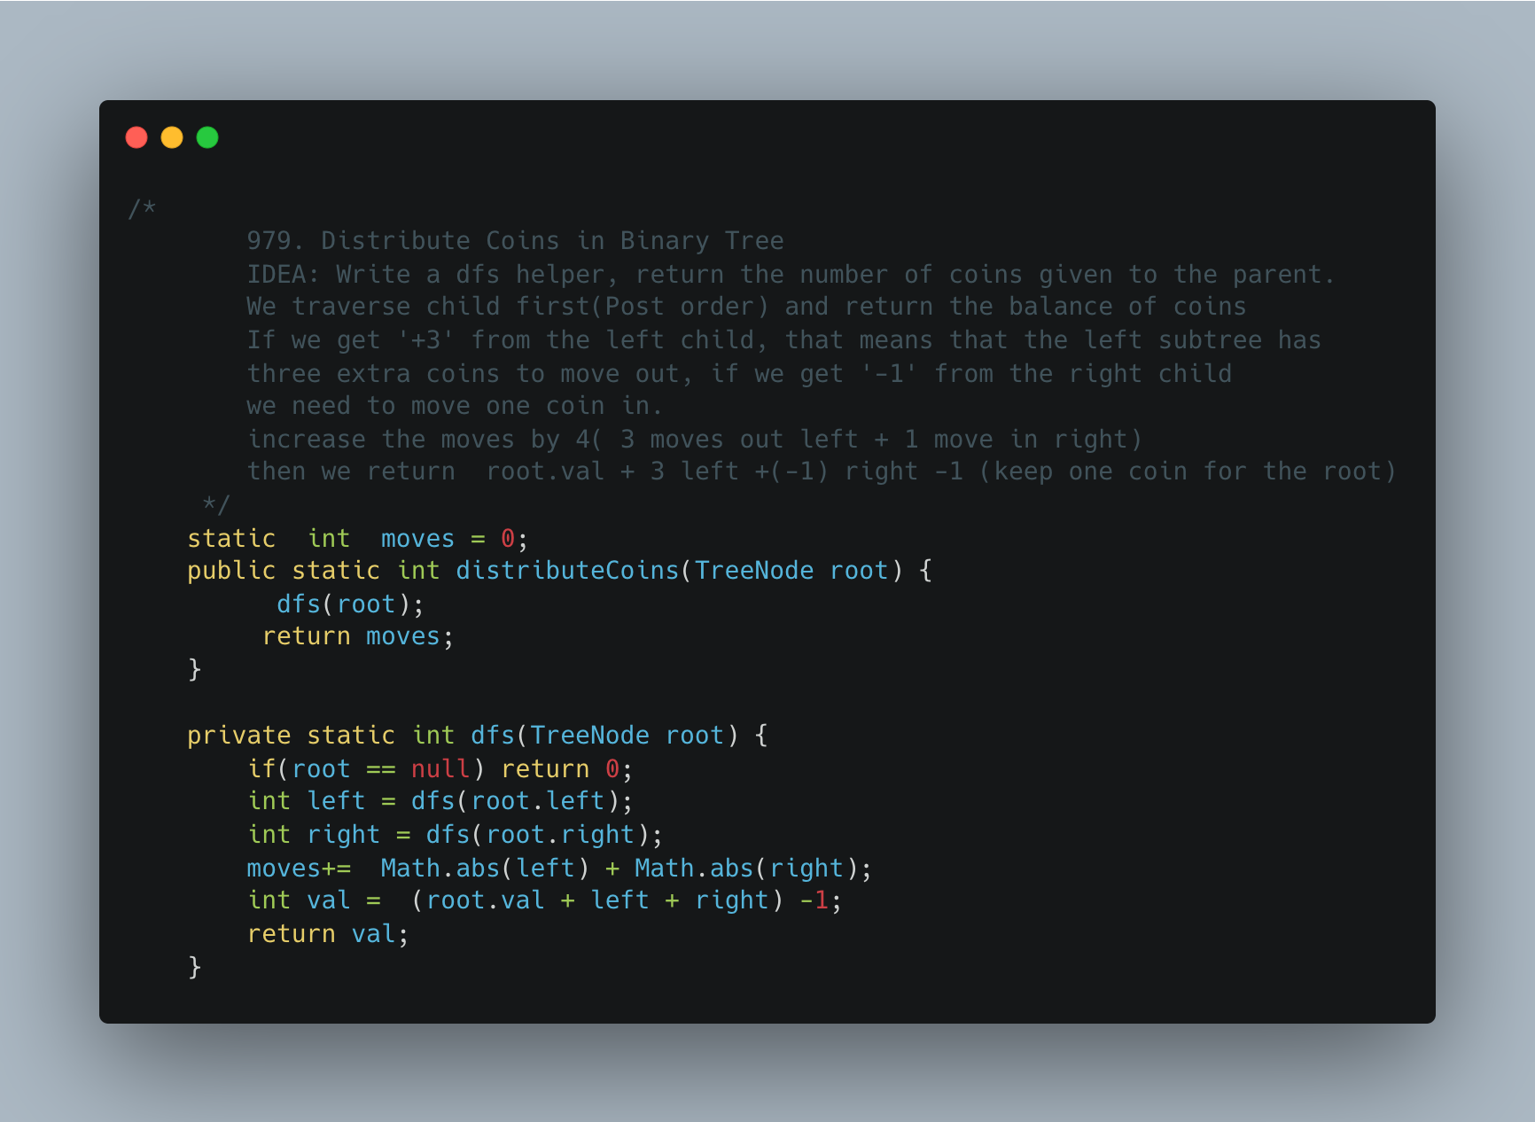

1. [Sorted Matrix](https://practice.geeksforgeeks.org/problems/sorted-matrix2333/1)

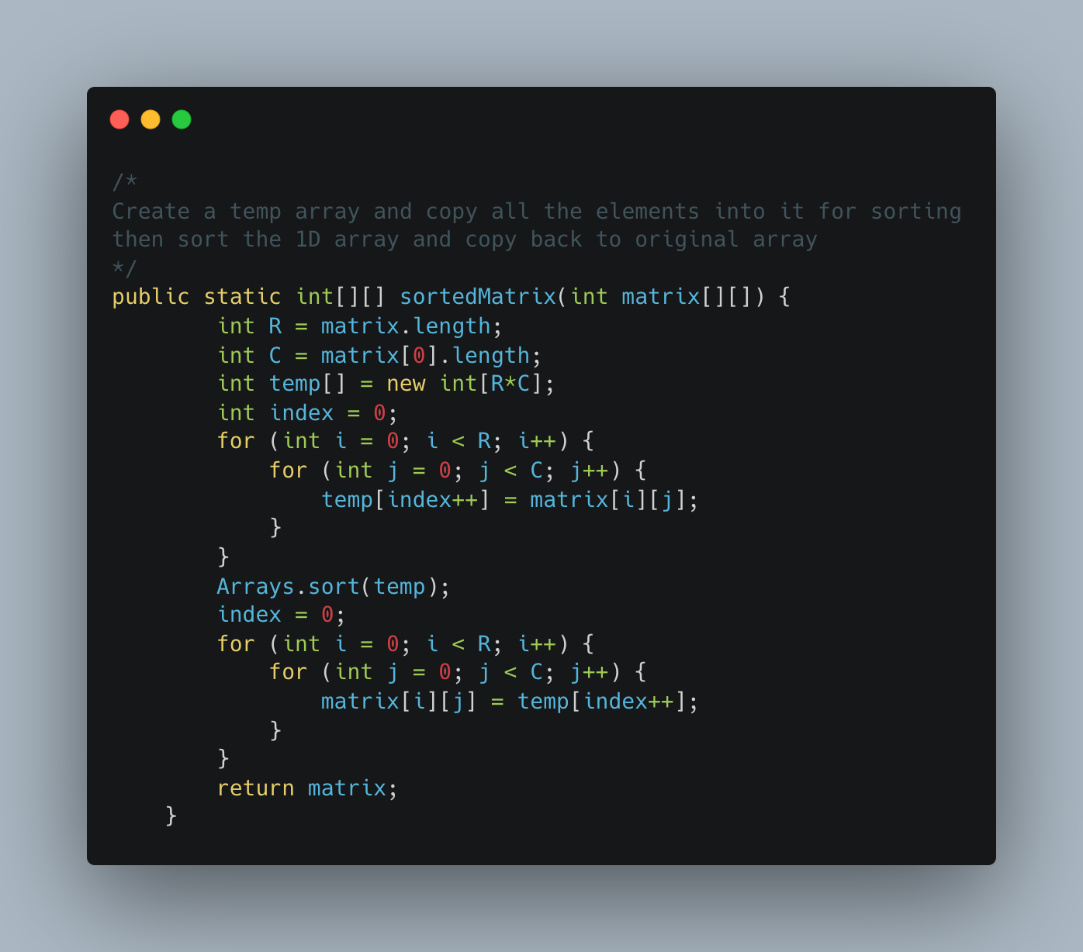

1. [Row with Max 1s](https://practice.geeksforgeeks.org/problems/row-with-max-1s0023/1)

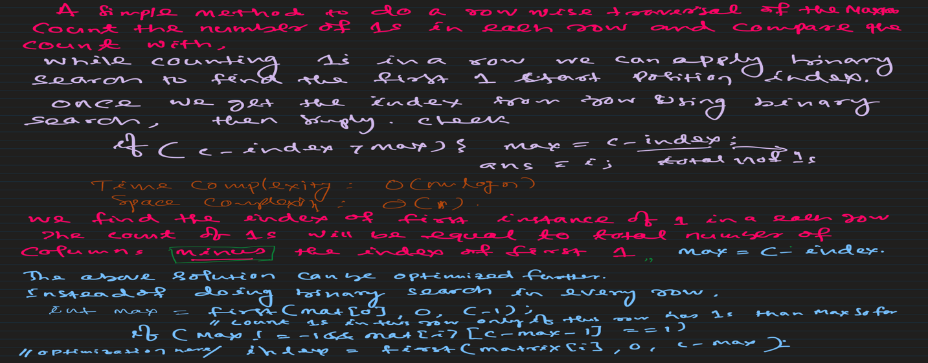

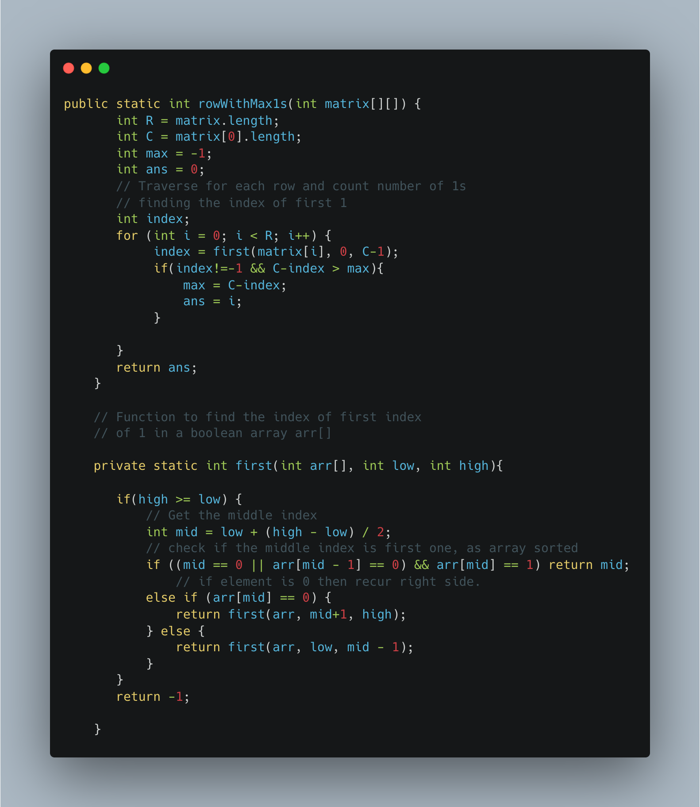

1. [Search a 2D Matrix](https://leetcode.com/problems/search-a-2d-matrix/)

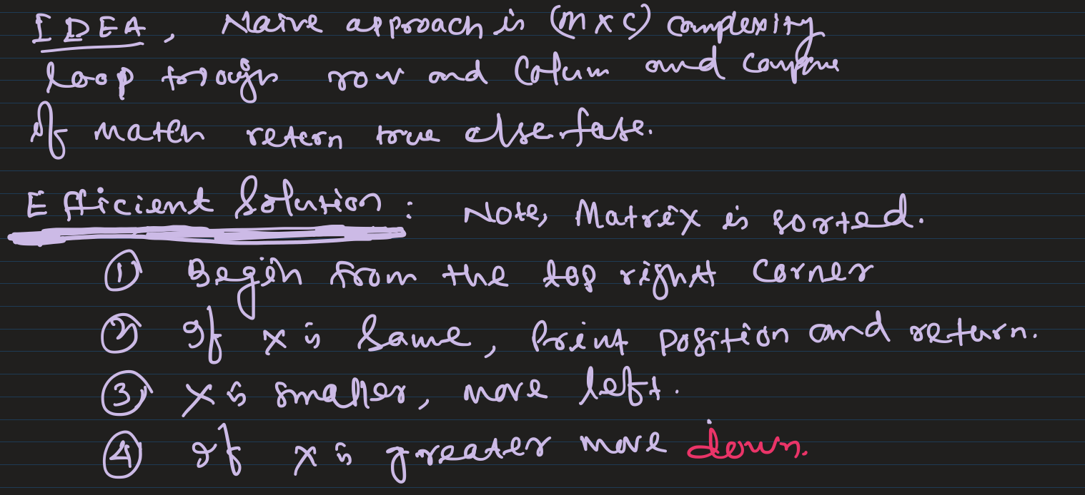

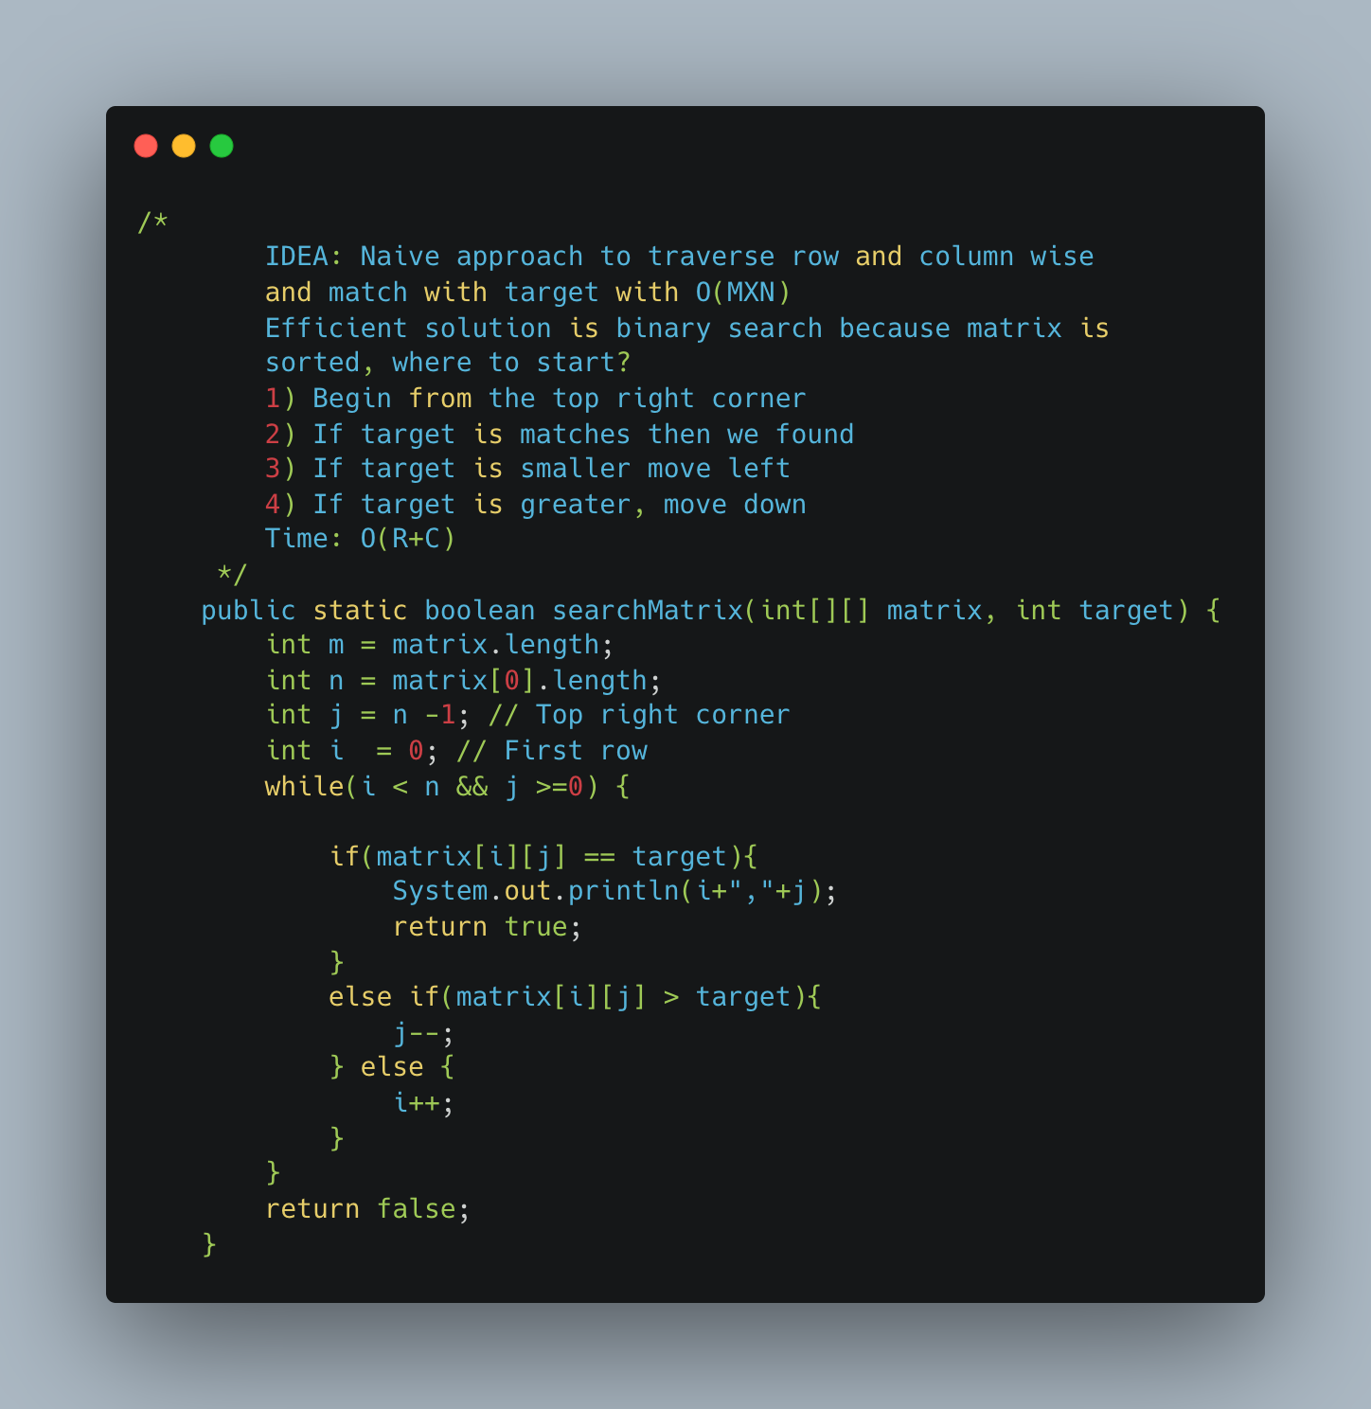

1. [Spirally Traversing a Matrix](https://practice.geeksforgeeks.org/problems/spirally-traversing-a-matrix-1587115621/1)

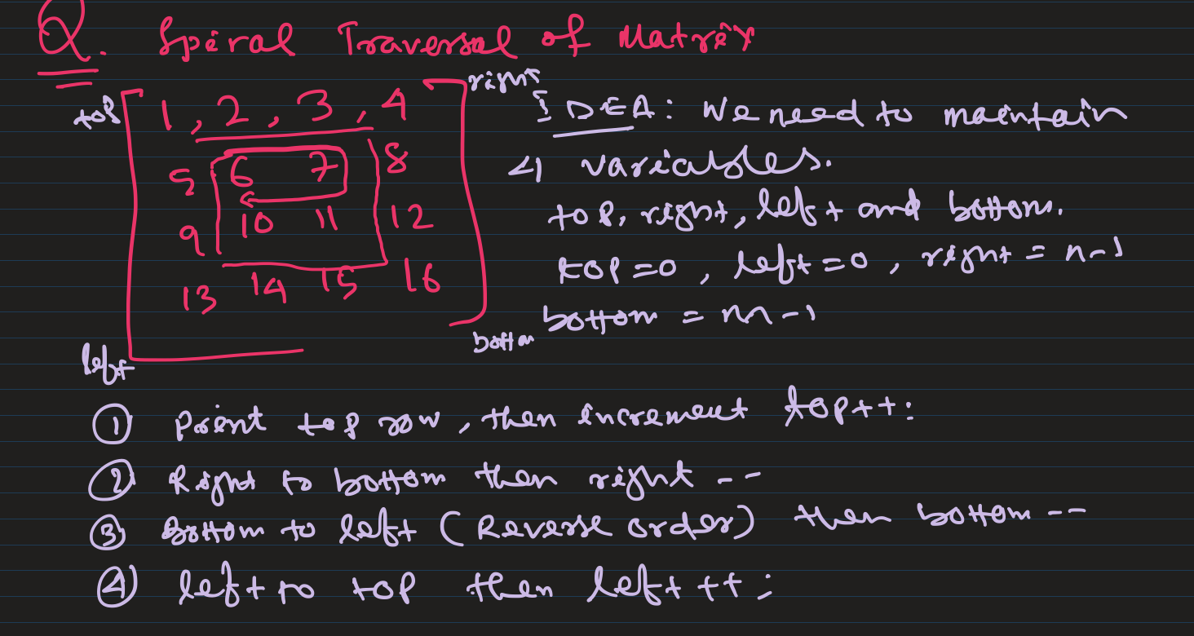

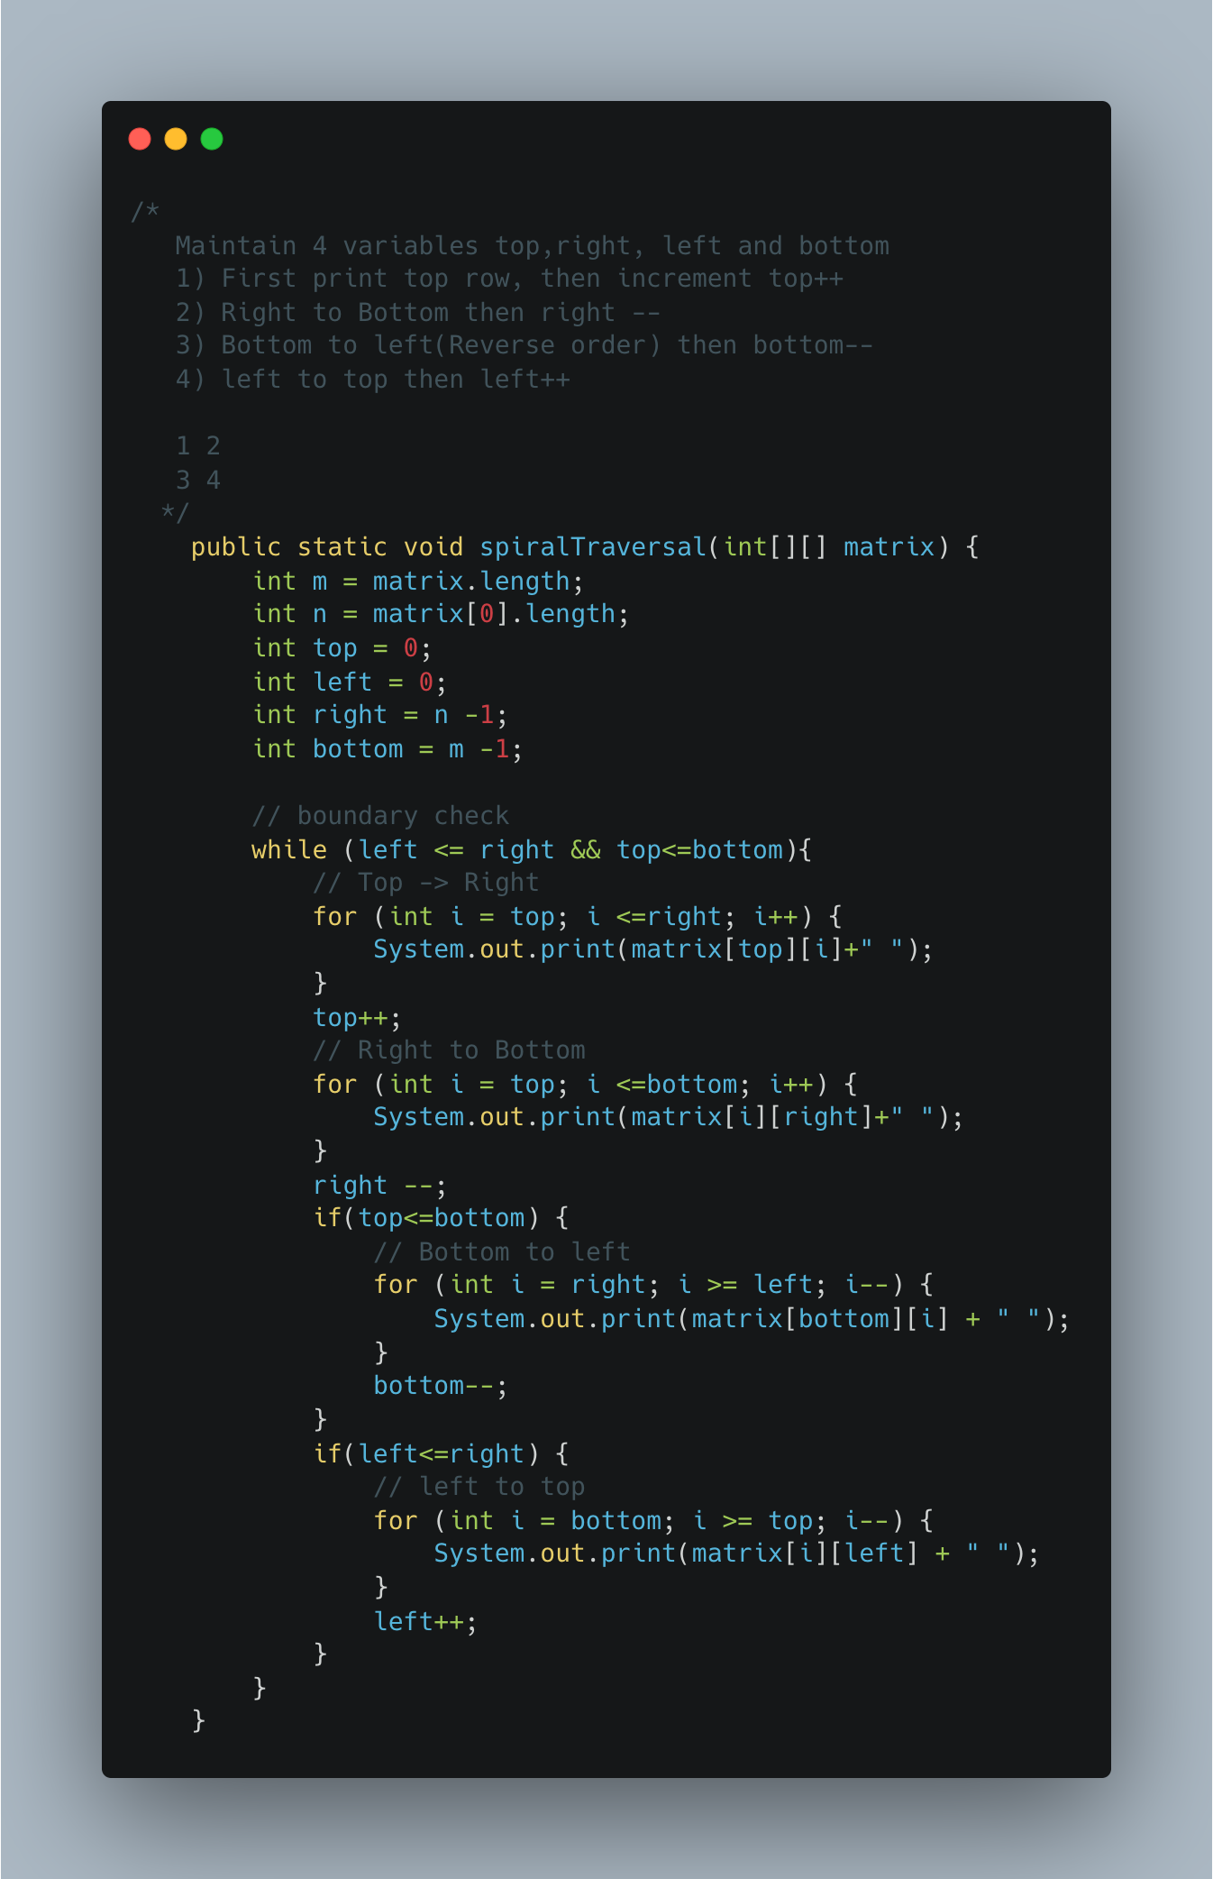

1. Transpose a Matrix

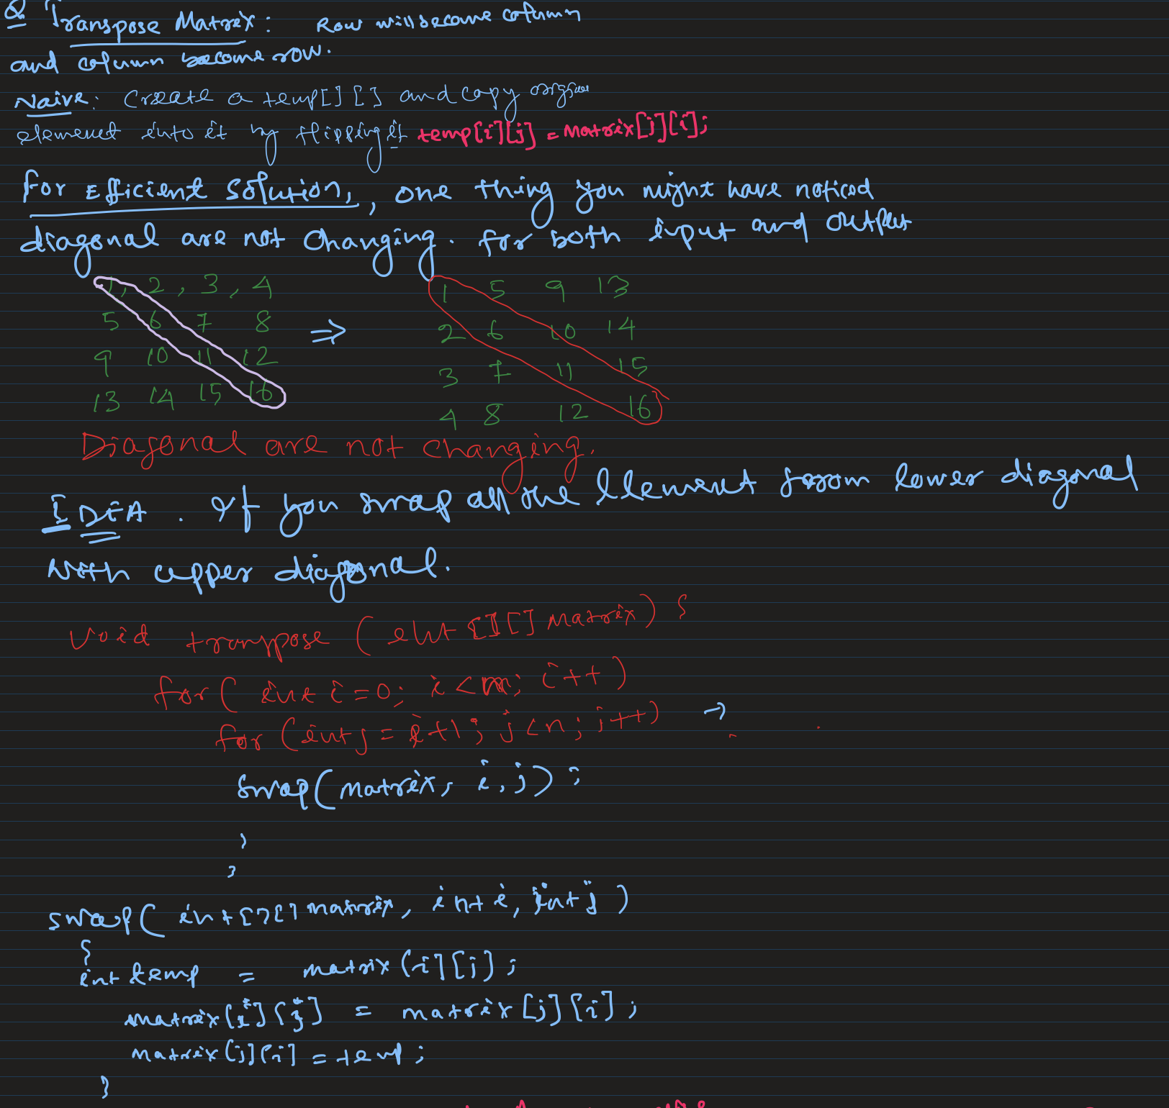

1. Rotate Matrix by 90* Anticlockwise

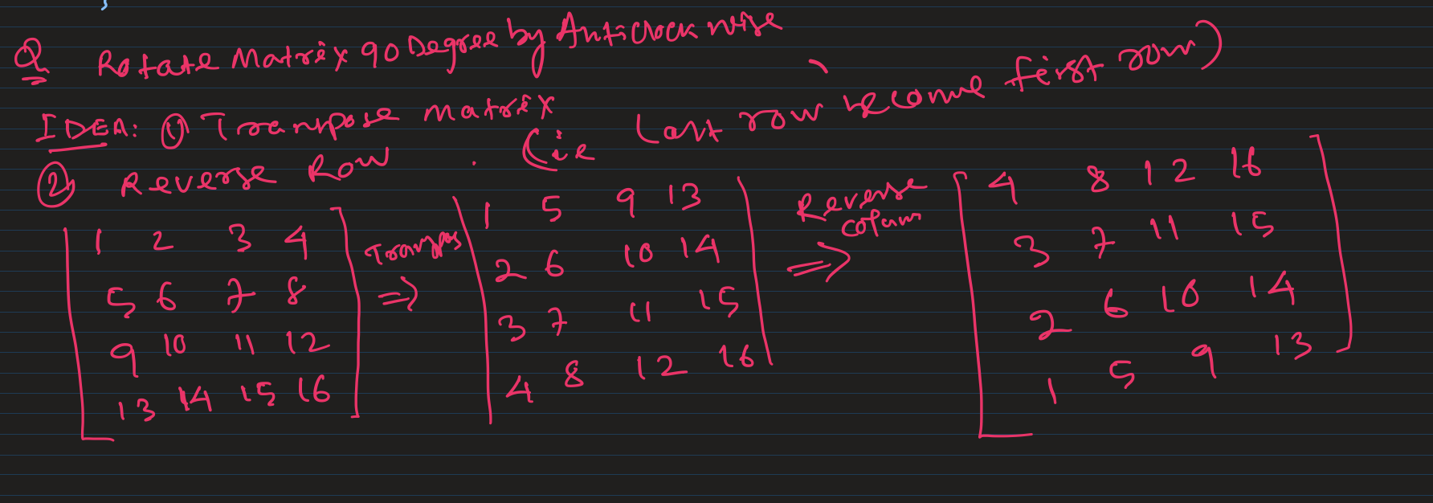

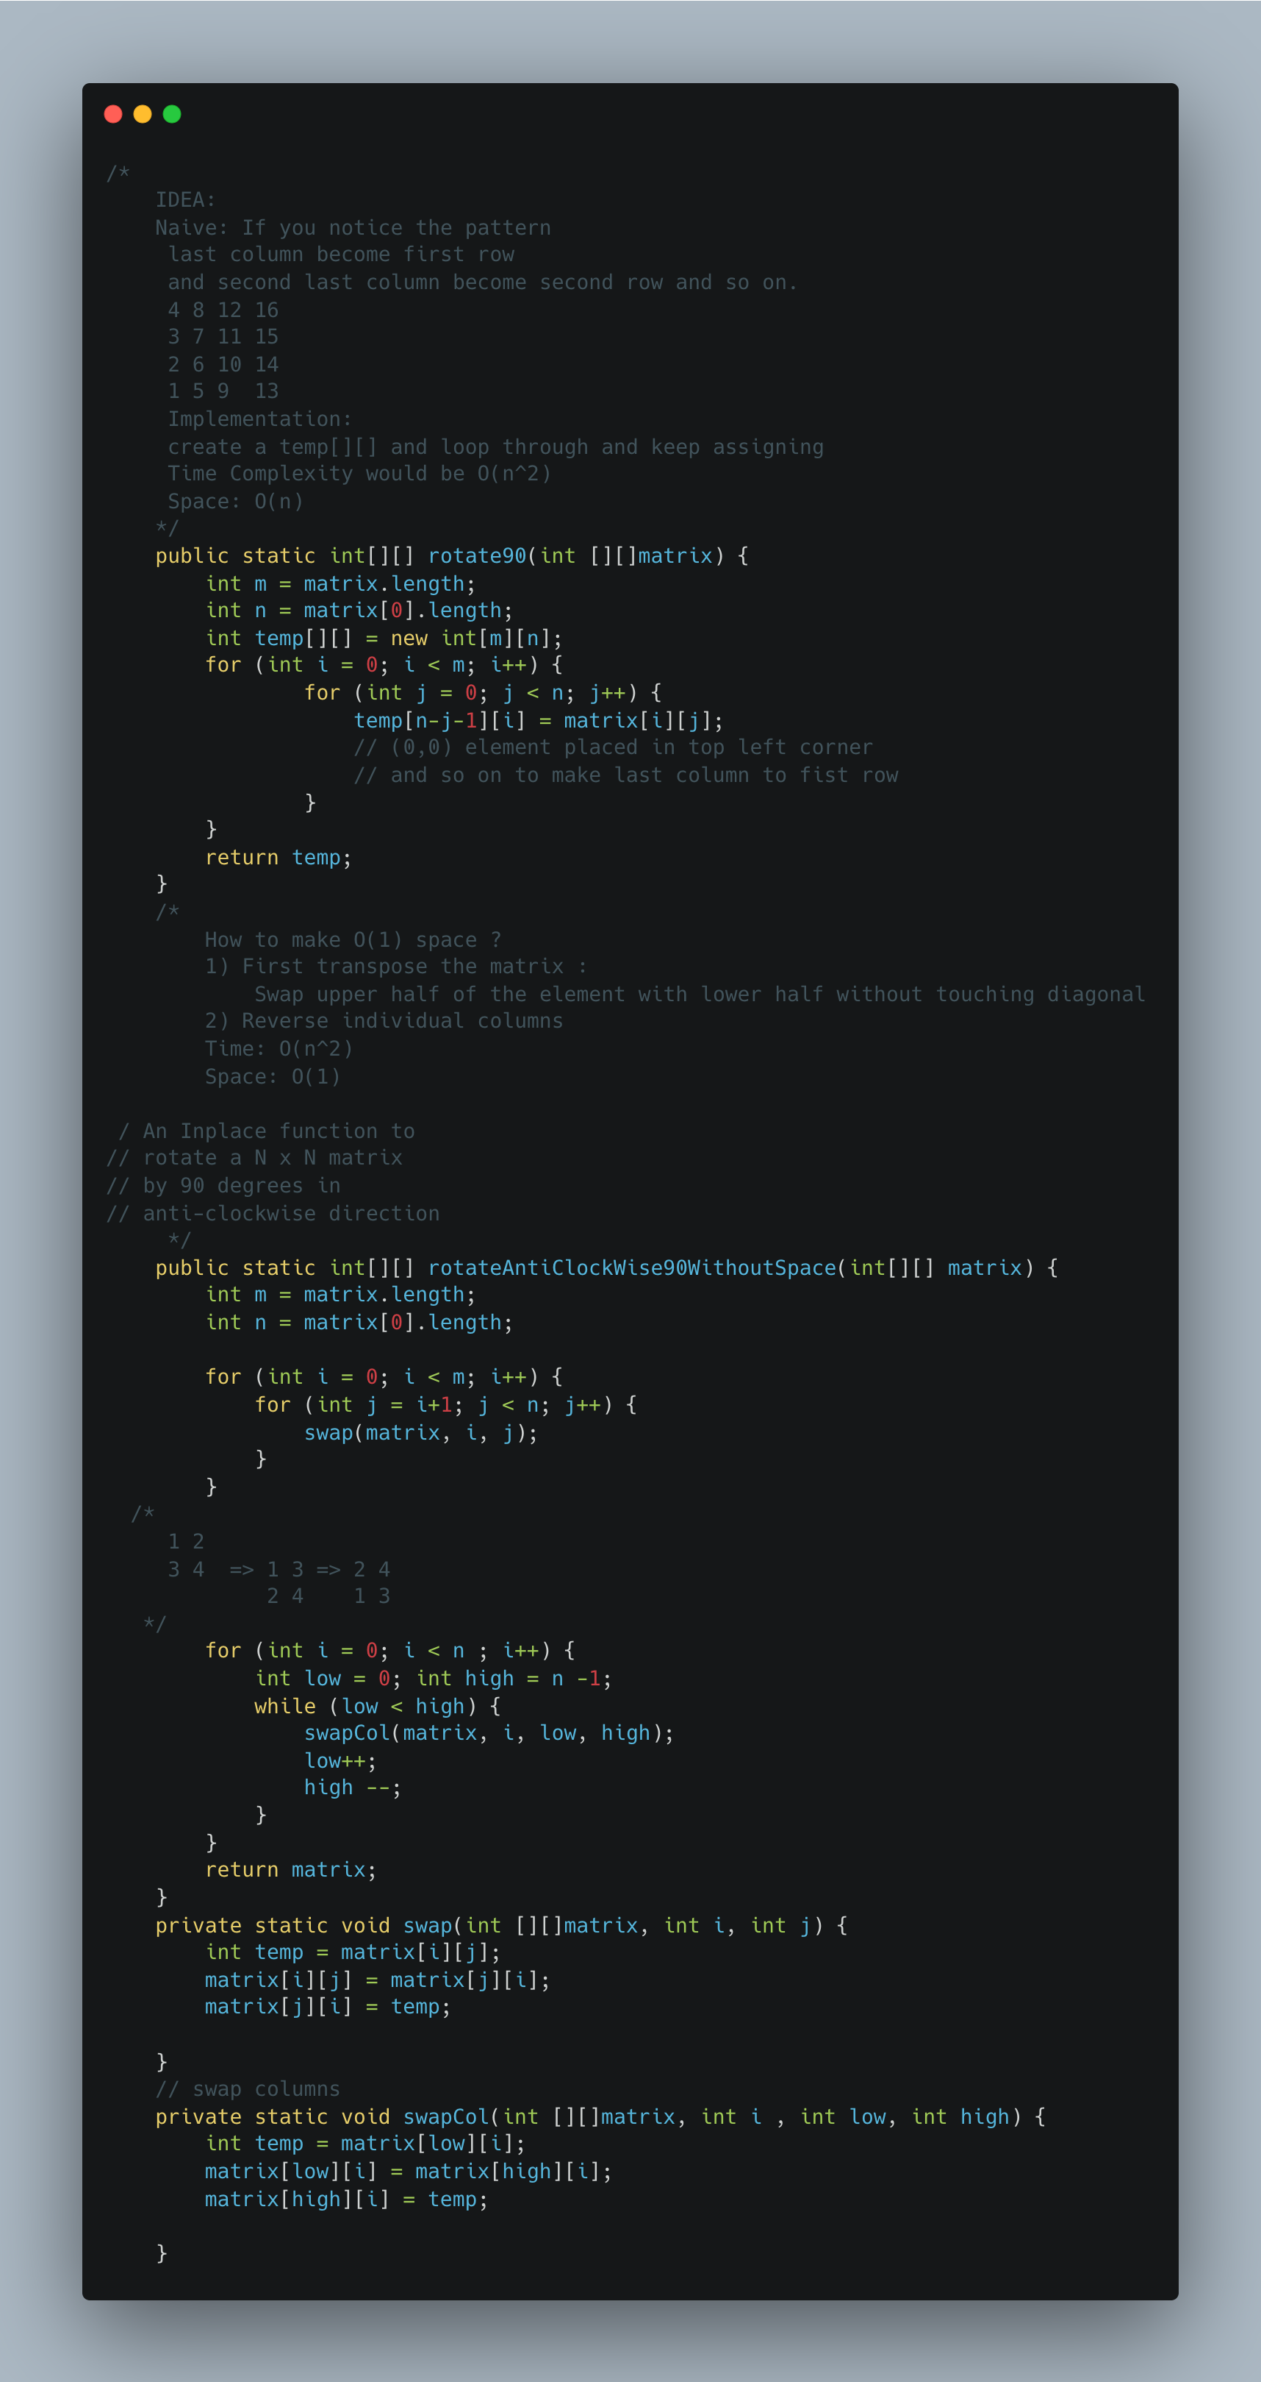

1. [Rotate a matrix by 90 Degree Clockwise](https://www.geeksforgeeks.org/rotate-a-matrix-by-90-degree-in-clockwise-direction-without-using-any-extra-space/)

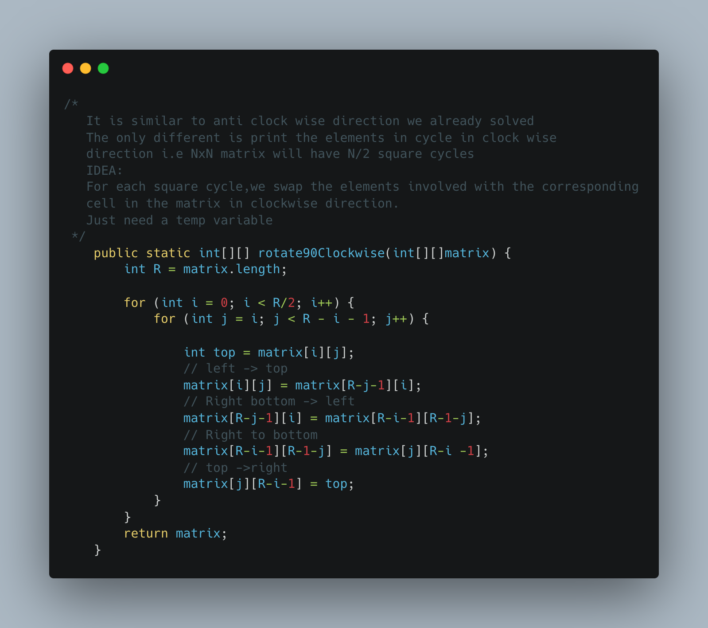

1. [Lemonade Change](https://leetcode.com/problems/lemonade-change/)

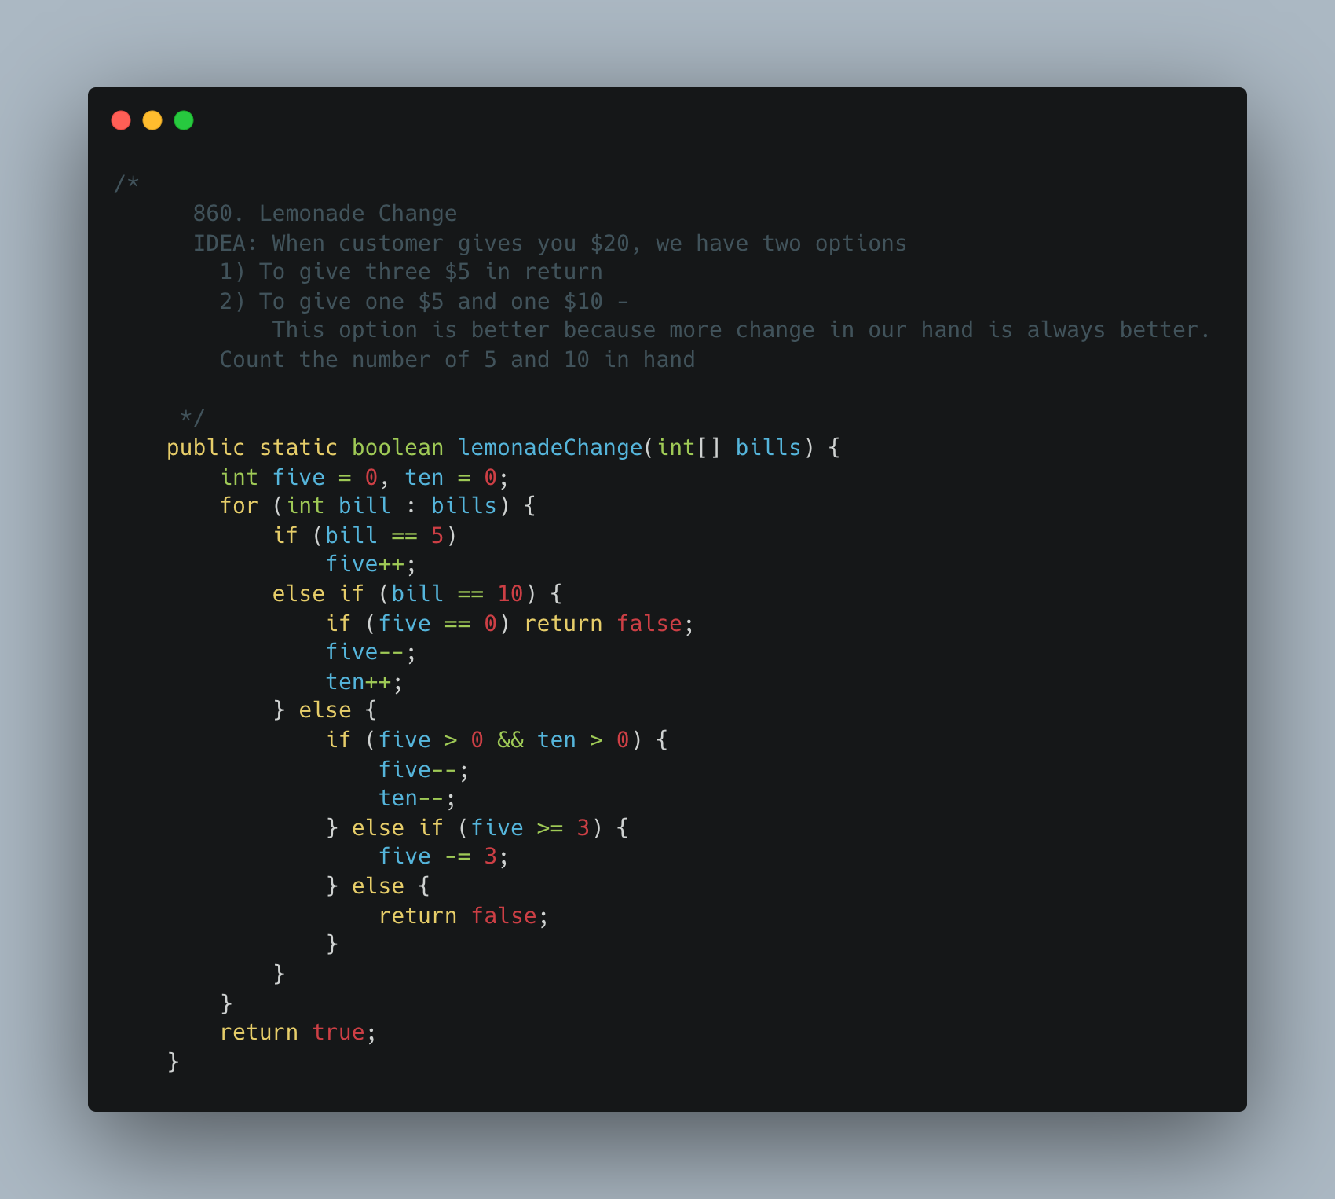

1. [Keys and Rooms](https://leetcode.com/problems/keys-and-rooms/)

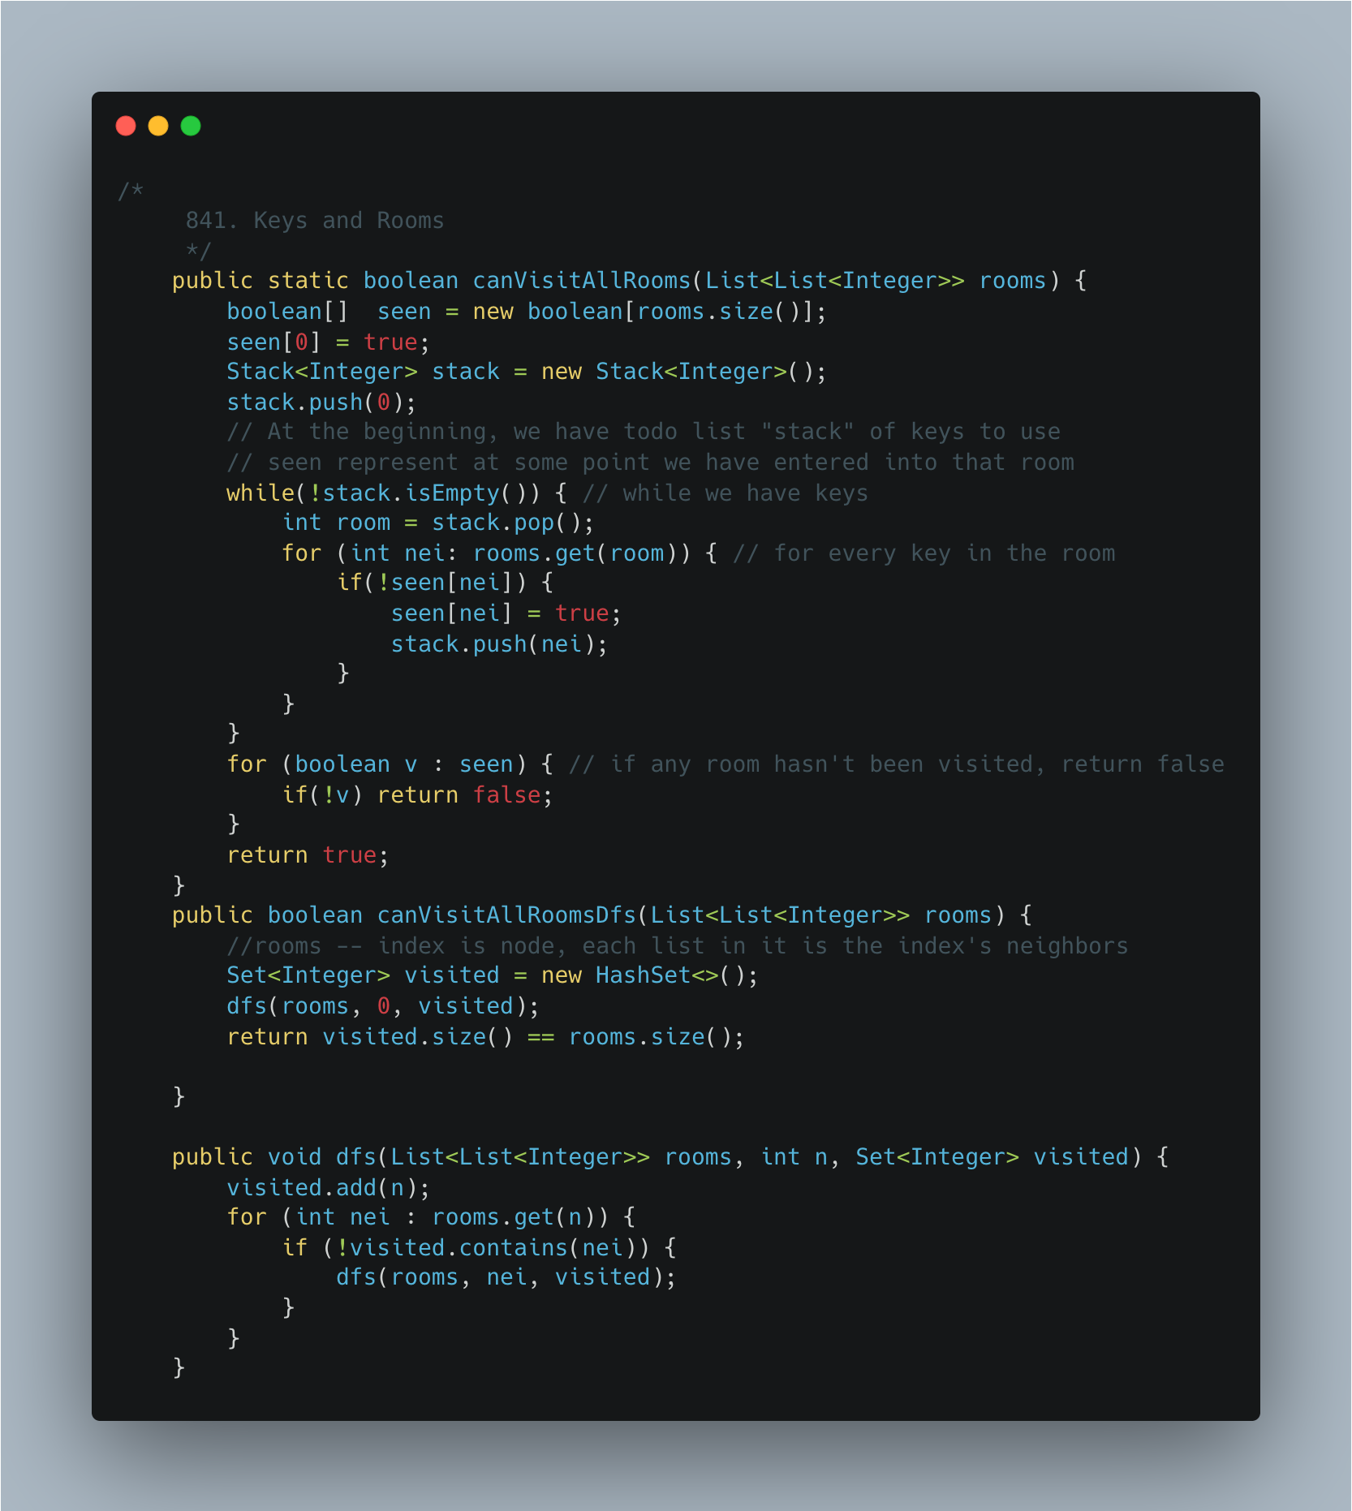

1. [Largest Rectangle](https://leetcode.com/problems/largest-rectangle-in-histogram/)

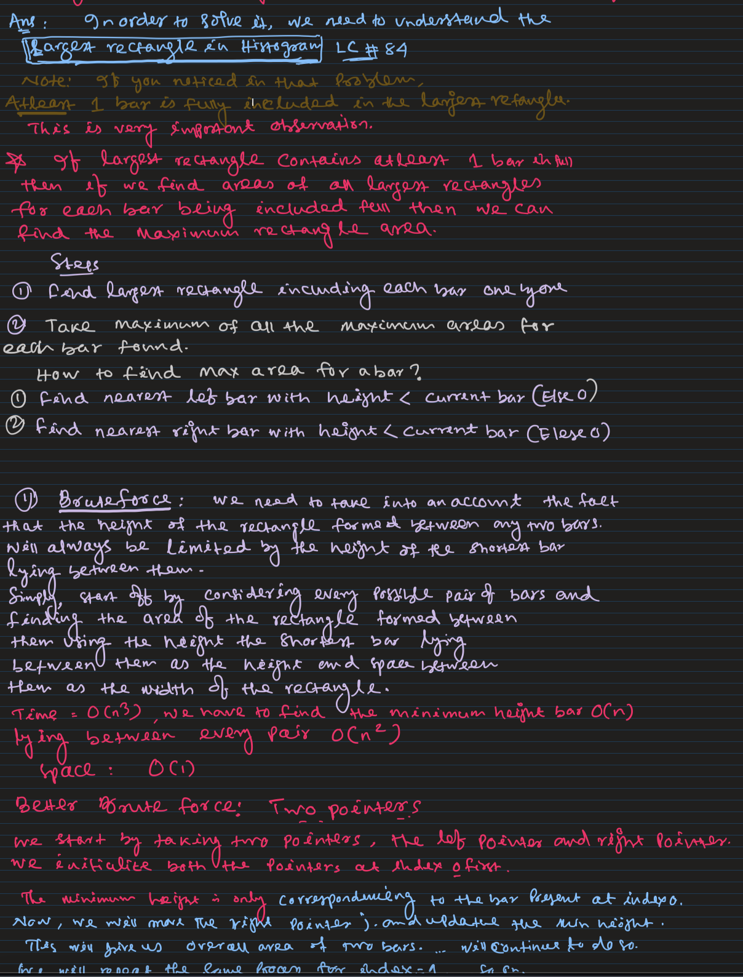

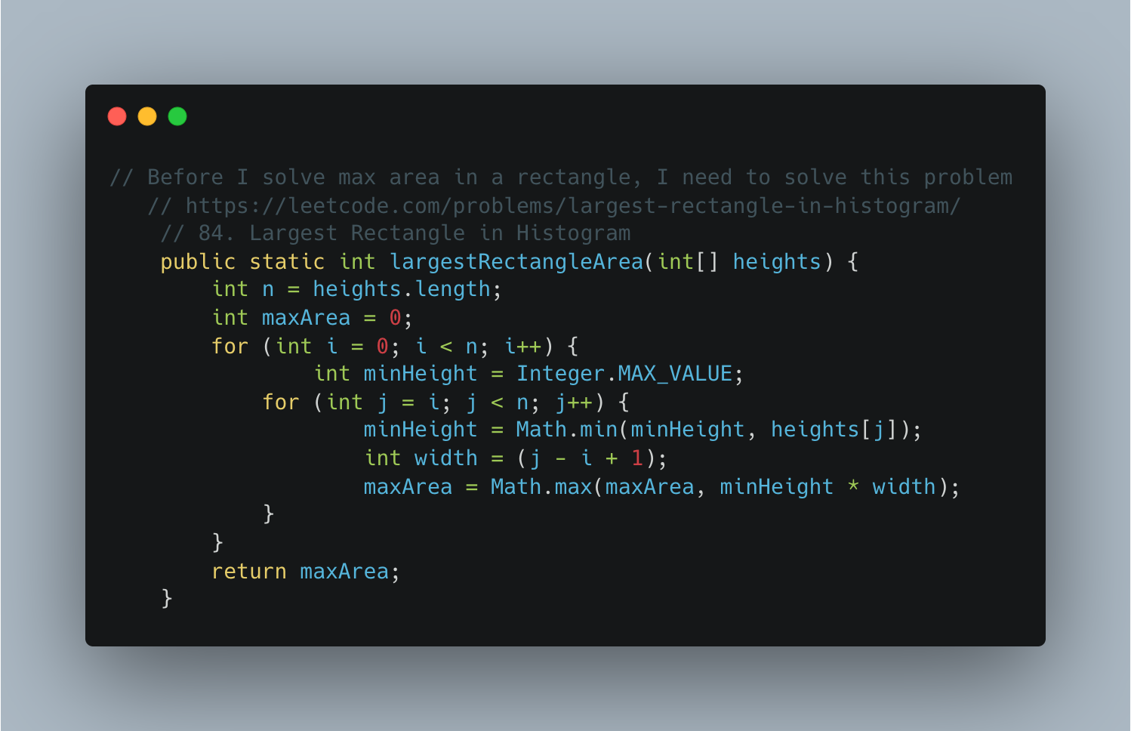

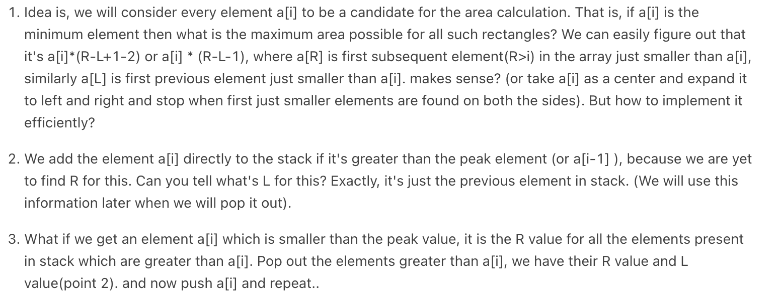

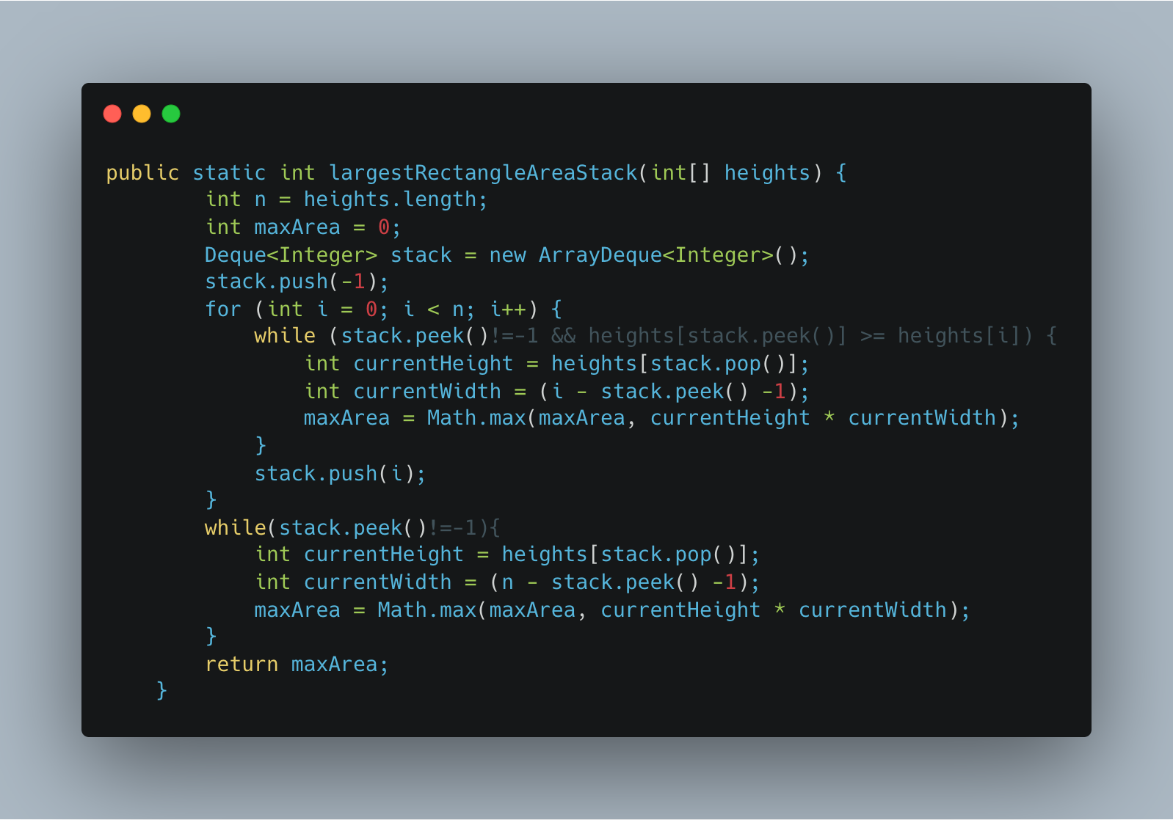

1. [Max Rectangle](https://practice.geeksforgeeks.org/problems/max-rectangle/1)

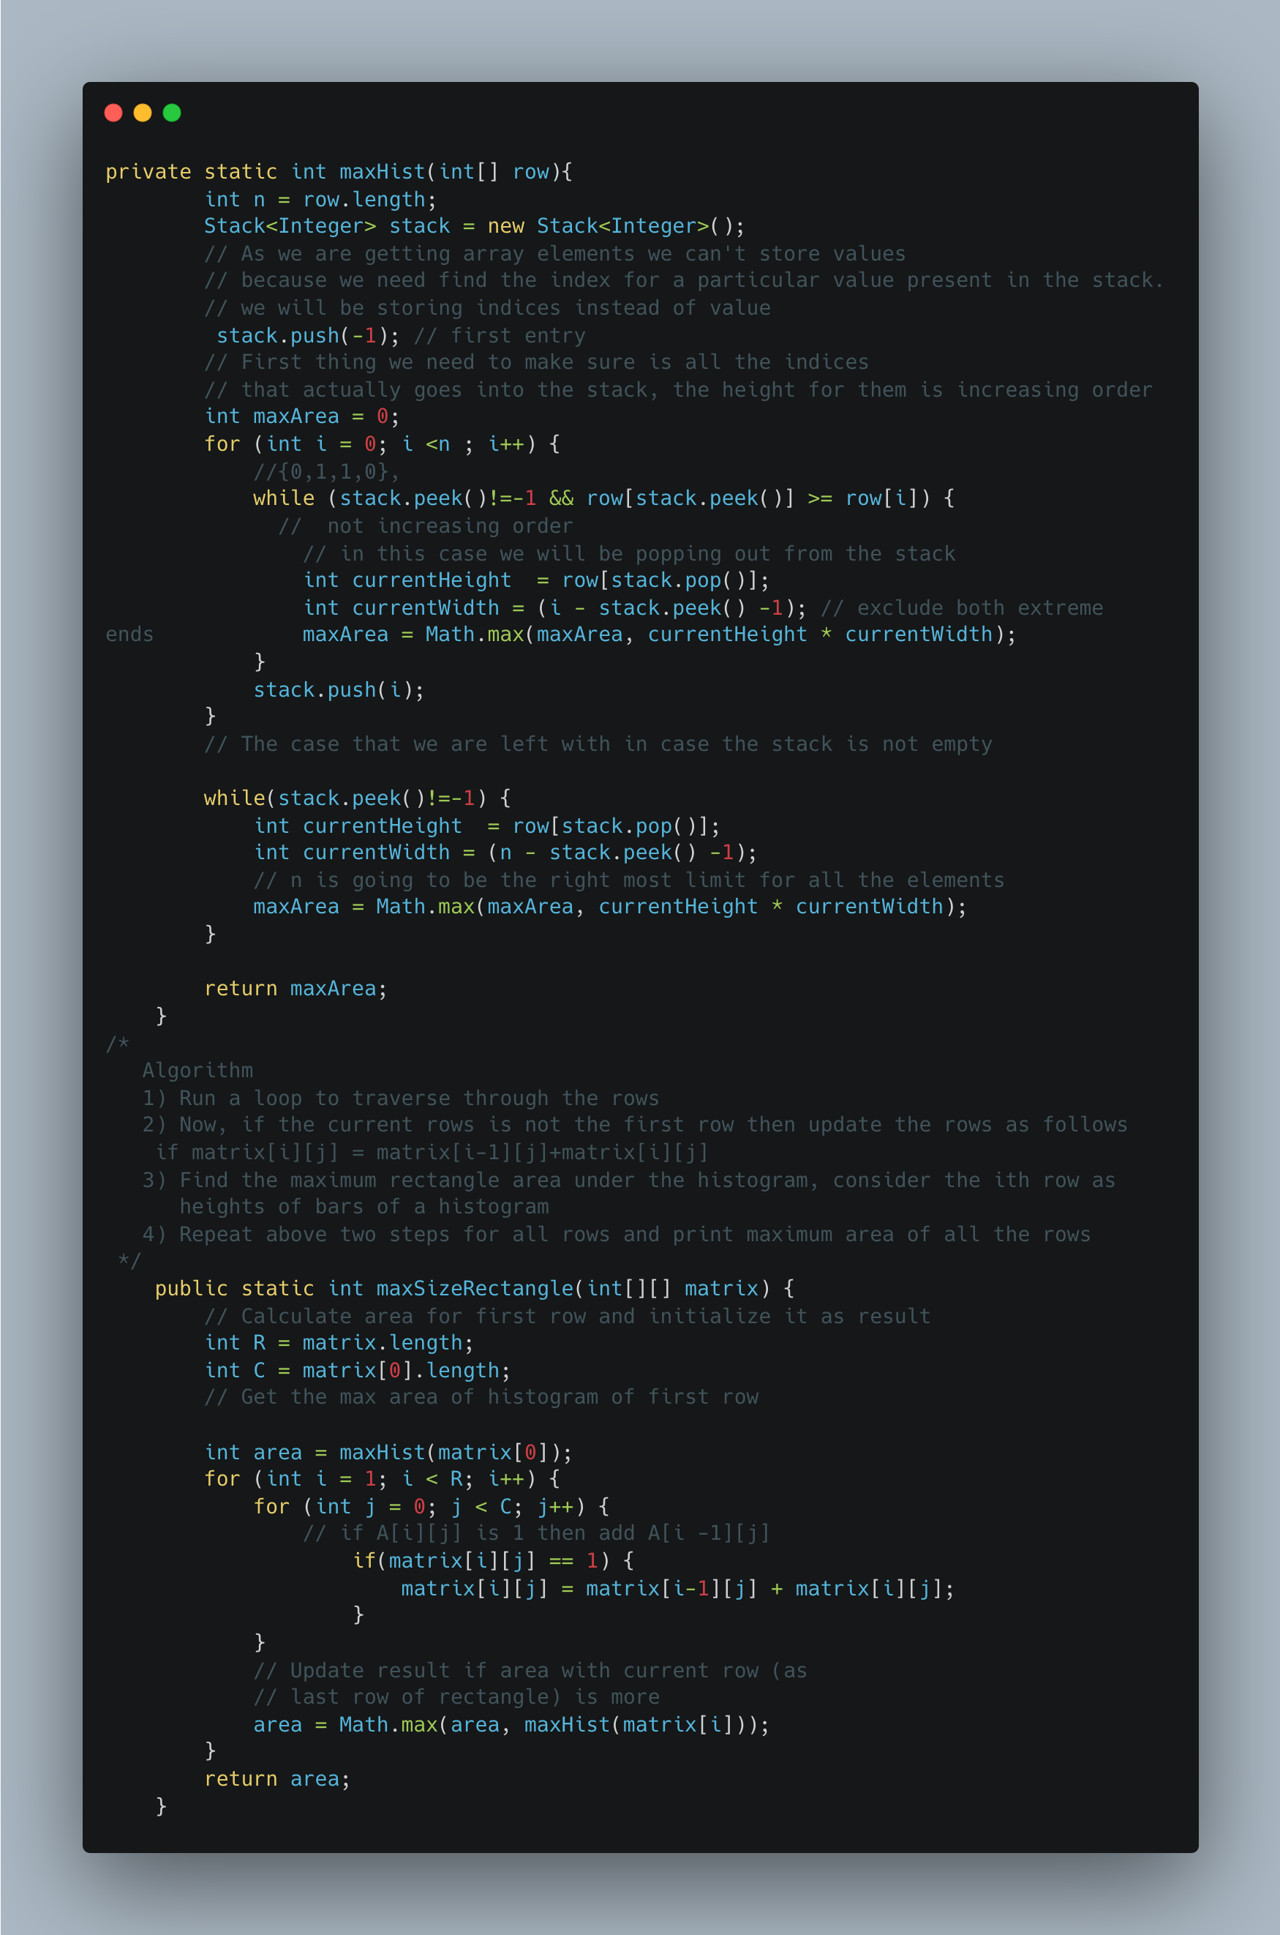

1. Find Median of row wise sorted matrix

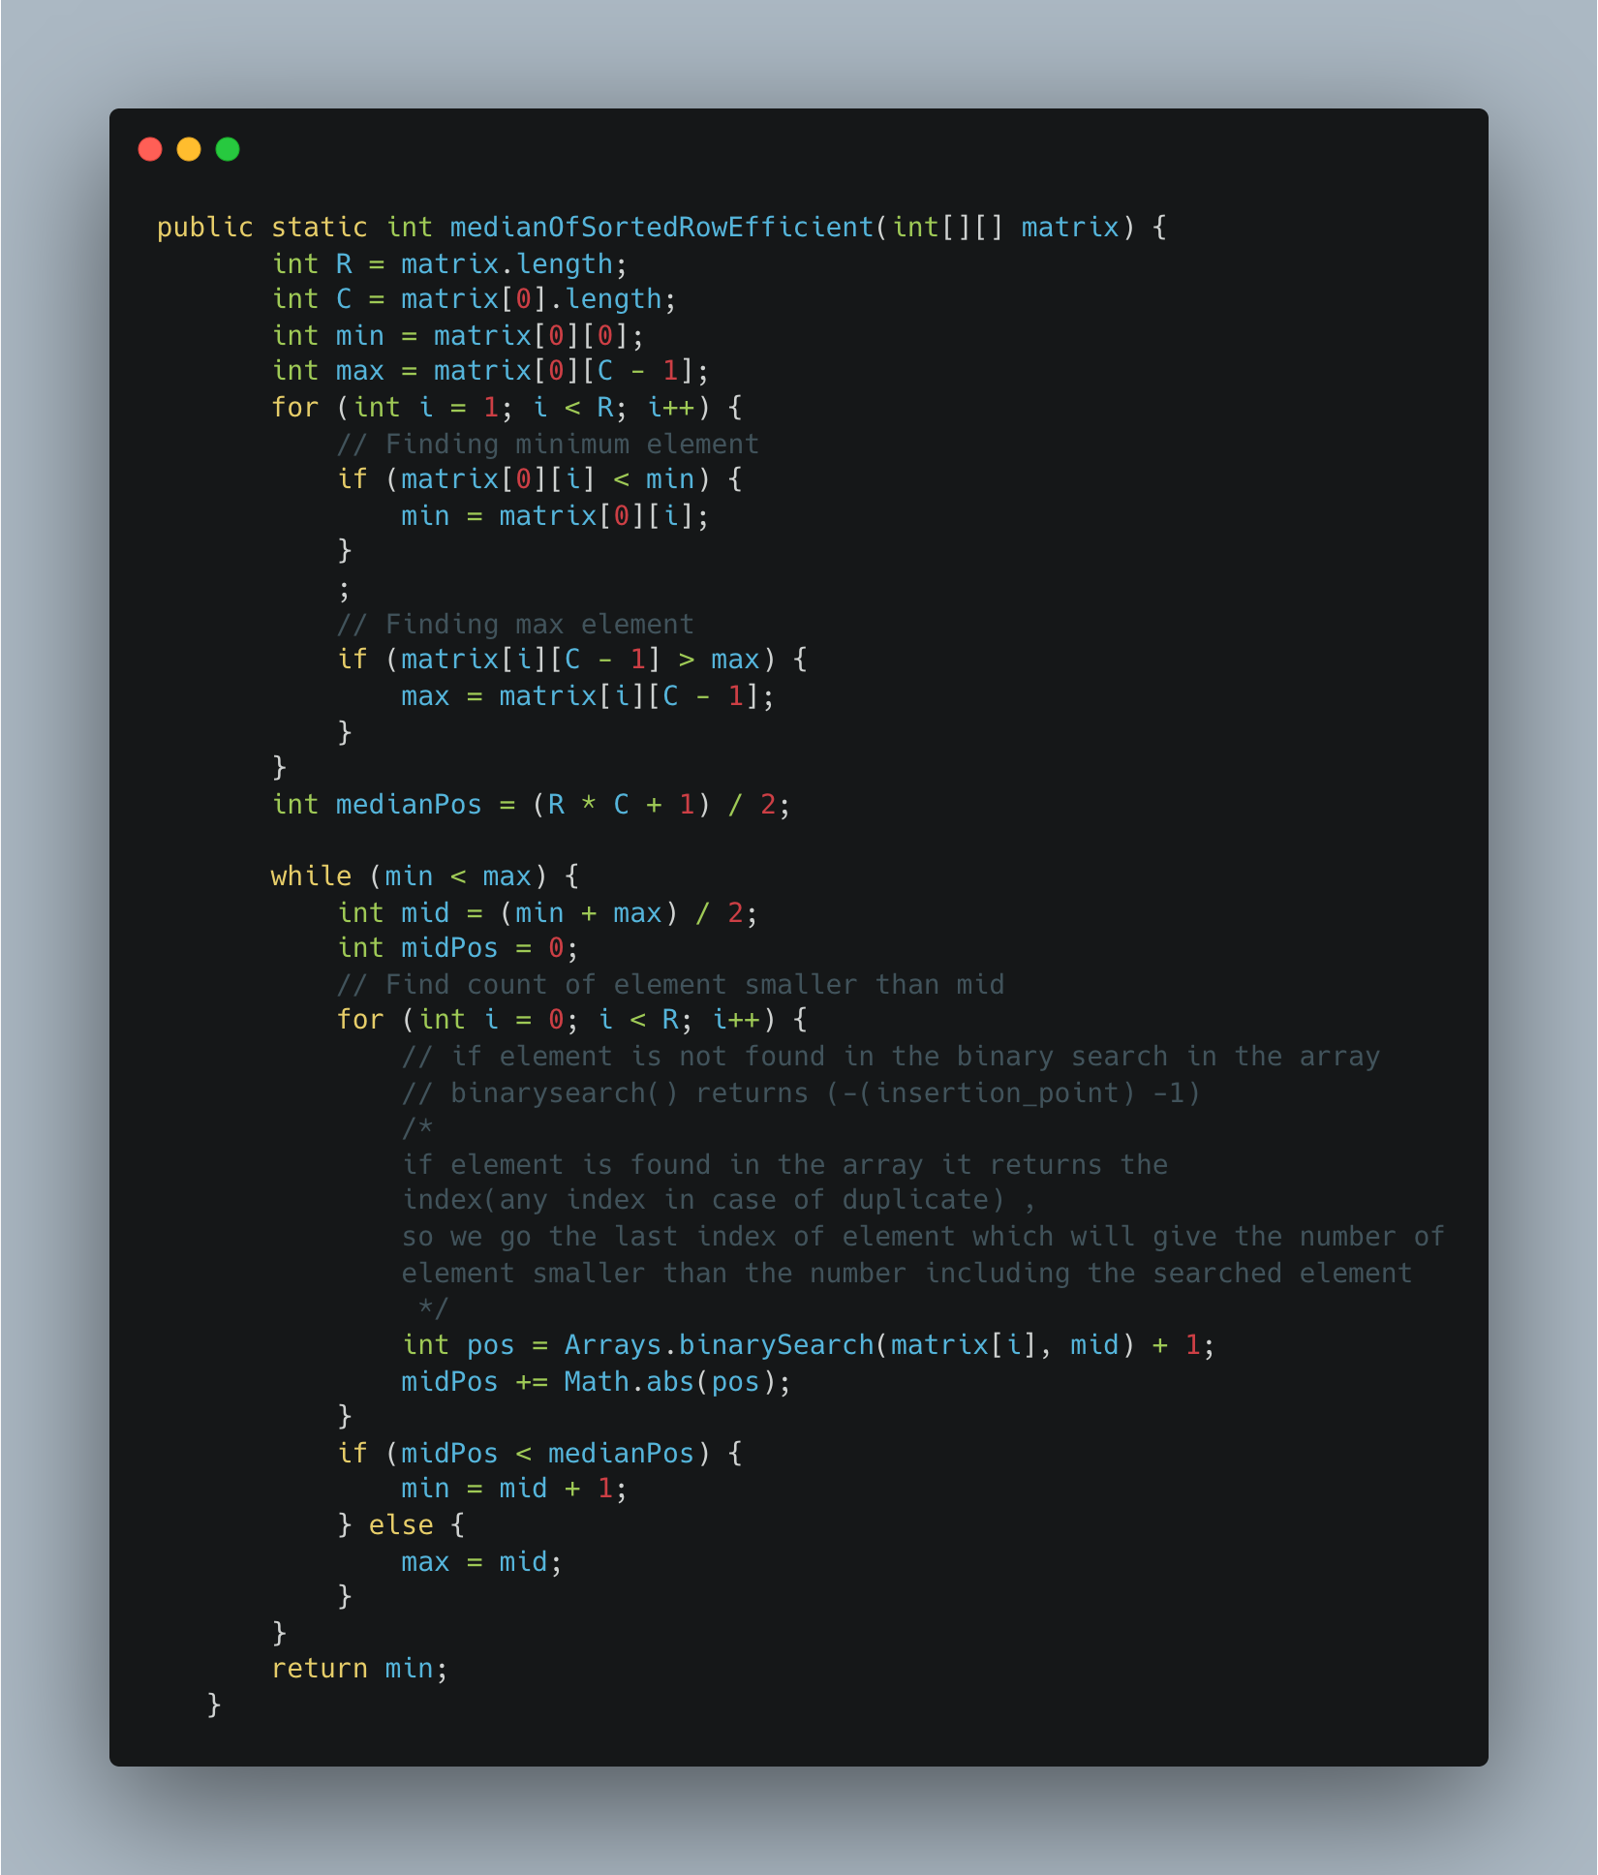

1. Find a subarray with given sum

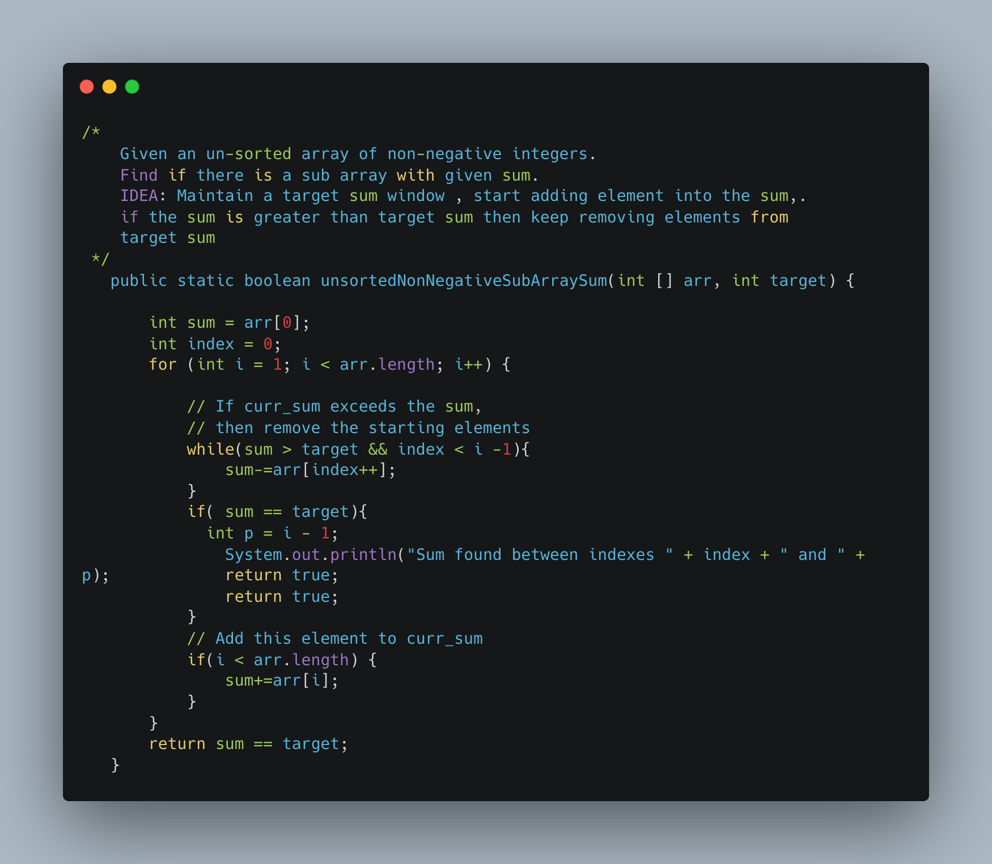

1. [Find Valid Matrix Given Row and Column Sums](https://leetcode.com/problems/find-valid-matrix-given-row-and-column-sums/)

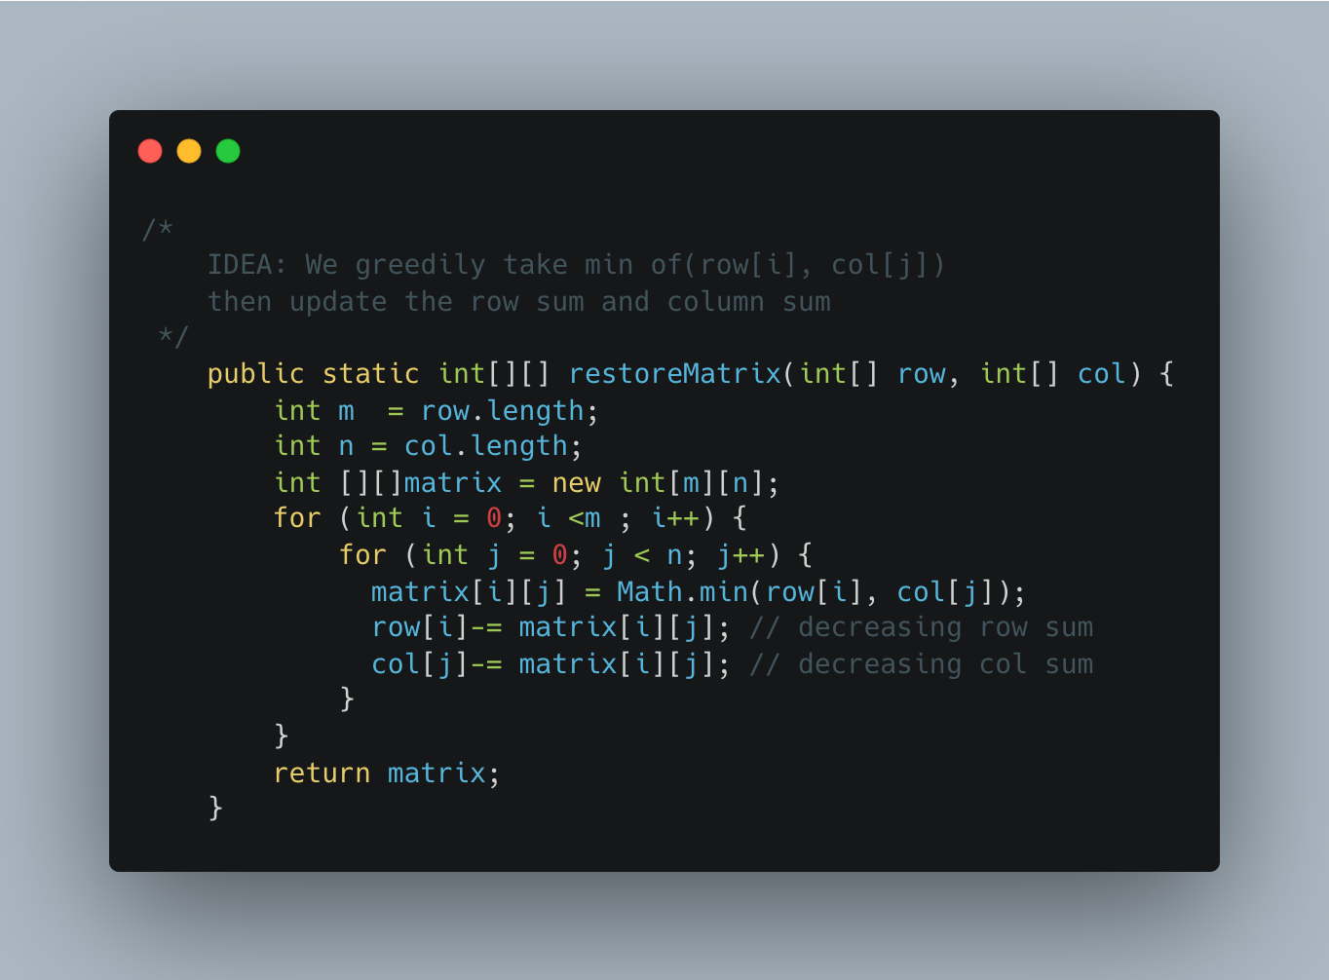

1. [Reorder Data in log Files](https://leetcode.com/problems/reorder-data-in-log-files/)

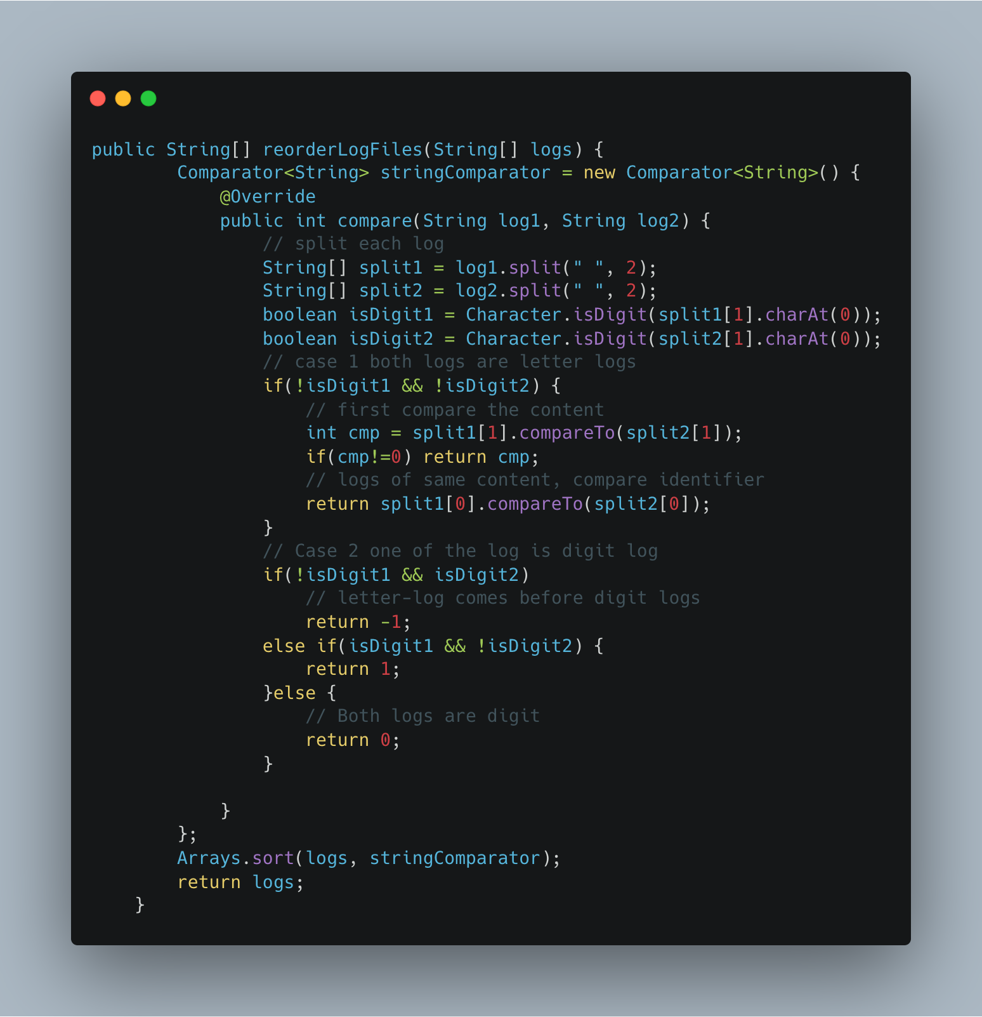

1. [Capacity to Ship Packages Within D Days](https://leetcode.com/problems/capacity-to-ship-packages-within-d-days/)

